EQUIPMENT IN THE NORTHERN IRELAND CLINICAL RESEARCH FACILITY

Index:

- General Clinical Equipment

- Laboratory Equipment

- Specialist Clinical Equipment

- Nutrition
- Respiratory
- Vision
- Cardiac / Vascular

General Clinical Equipment:

Genius Tympanic Thermometer:

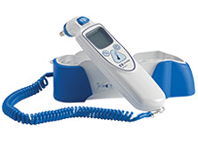

The Genius Tympanic Thermometer is a fast, accurate and convenient clinical instrument for measuring patient temperatures by using its proprietary Peak Select System technology to determine the body's accurate temperature directly from the tympanic membrane. It is an ear canal thermometer with measurement-site equivalence modes including oral, core and rectal equivalent temperatures.

Graseby Volumetric Infusion Pump:

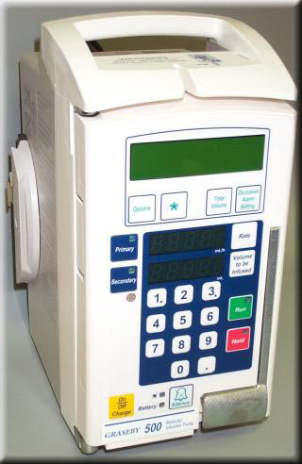

Graseby Volumetric Infusion Pumps are for use in the intravenous and intra-arterial delivery of fluid and medications. In addition, they may be used for epidural delivery. Offering versatility and high levels of accuracy, they meet a broad range of infusion applications including blood transfusion. The unique air-in-line removal system provides safe and effective fluid delivery.

MAC 1600 ECG Analysis System:

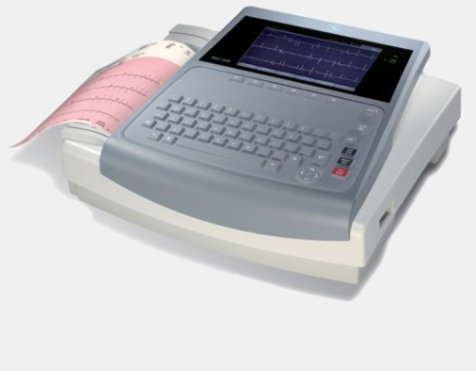

Used to record ECG signals from surface ECG electrodes. This device can analyse, record and store electrocardiographic information from adult and paediatric populations. This data can then be computer analysed with various algorithms such as interpretive ECG and signal averaging for presentation to the user.

MAC 2000 ECG Analysis System:

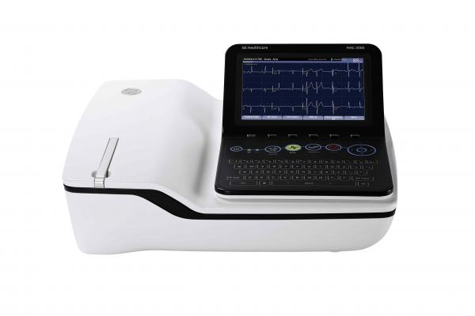
Used to record ECG signals from surface ECG electrodes. This device can analyse, record and store electrocardiographic information from adult and paediatric populations. This data can then be computer analysed with various algorithms such as interpretive ECG and signal averaging for presentation to the user

Omron Automatic Blood Pressure Monitor:

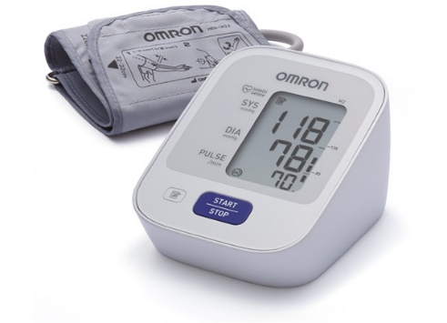
Fully automatic, clinically validated monitor with dual-sized cuff for comfortable, quick and accurate blood pressure monitoring along with intellisense technology that detects the right inflation pressure automatically. Hypertension indicator displays a symbol on screen if the unit takes a reading that is higher than the recommended level of 135/85 mmHg.

Zoll R-Series Defibrillator:

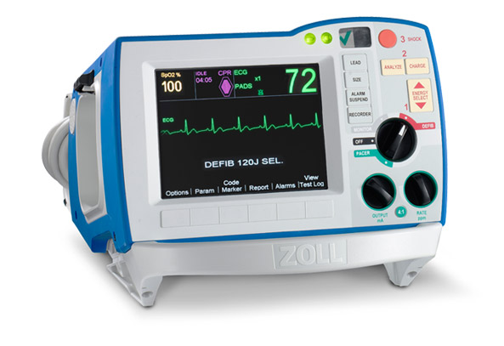
R-Series Defibrillators are designed with easy-to-use technologies to help consistently deliver high-quality CPR, provide optimal defibrillation and pacing treatments for all patients, and manage data to address critical quality improvements.

Welch Allyn Spot Vital Signs Monitor:
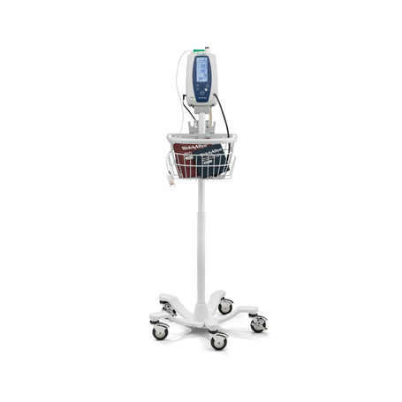

The Welch Allyn Spot Vital Signs monitor provides vital signs in seconds with hospital-grade technology that is easy to use and accurate.

Nihon Kohded Vismo Vital Signs Monitor:

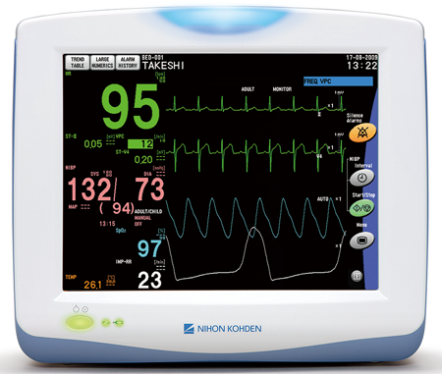

The concept of PVM-2701 is "supreme ease of use." The PVM-2701 provides a solution for hospitals that want to improve quality and streamline operation. PVM-2701 combines high accuracy and simple operation to satisfy every caregiver from expert to trainee.

Laboratory Equipment

-20°C Labcold Freezer:

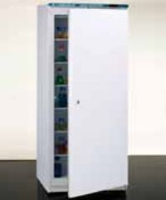

-20°C Labcold Freezer is designed to store samples at low temperatures with precise temperature control.

-80°C New Brunswick Freezer:

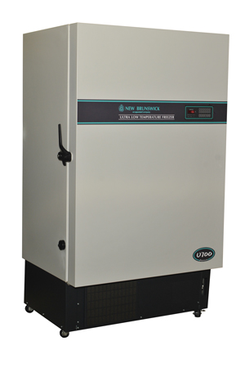
Designed to provide precise, ultra-low temperature environments for cold storage of scientific materials for research purposes.

Lab Dancer – vortex:

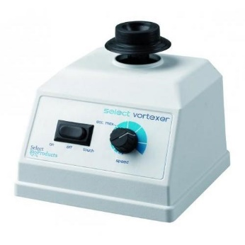
Attractively designed test tube shaker designed for mixing small test samples (small containers up to 30 mm in diameter, e.g. test tubes, centrifuge tubes, Eppendorf beakers) with a touch function
Laboratory Roller Mixer:

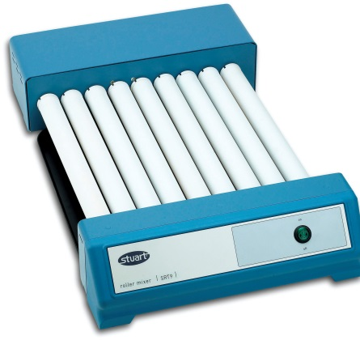

Roller mixers are designed for use in the laboratory to gently roll bottles to provide mixing at a steady even rate. They are ideal mixers to prevent sedimentation of samples.

LEC Laboratory Freezer:
LEC Laboratory Freezer is perfect for short-term sample storage.

Rotina 380 R Centrifuge:

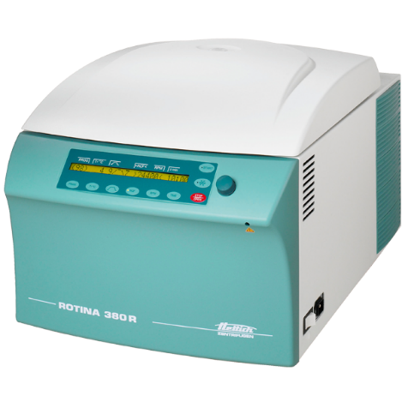
The Rotina 380 R delivers good separation results rapidly and reliably and can be used for thermolabile samples at the required temperature.

Sartorius Laboratory Scales:

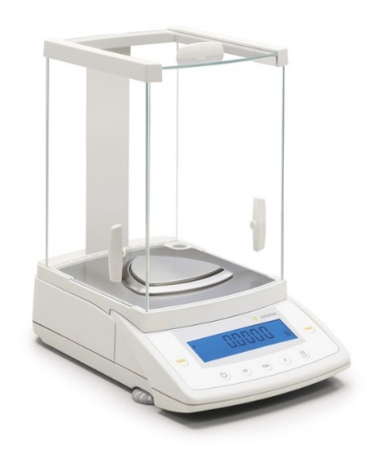

Sartorius is a German company and maker of some of the world's finest balances since 1871. The scales excel in speed, accuracy and quality backed by years of experience.

Scotsman Ice Dispenser:

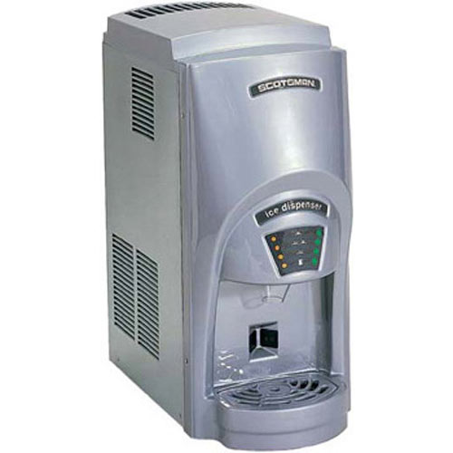

The Scotsman Ice Dispenser is a push-button ice dispenser.

Nutrition

Bodystat Bioelectrical Impedence Monitor (body composition):

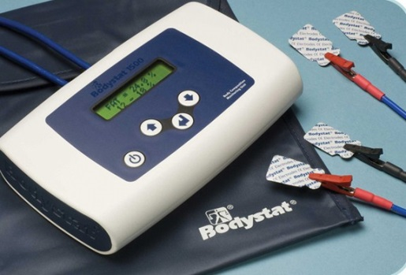

Measures body composition by sending a low, safe electrical current through the body. The current passes freely through the fluids contained in muscle tissue, but encounters difficulty/resistance when it passes through fat tissue.
This resistance of the fat tissue to the current is termed 'bioelectrical impedance', and is accurately measured by the bodystat machine.

DEXA System (bone mineral density and body composition):

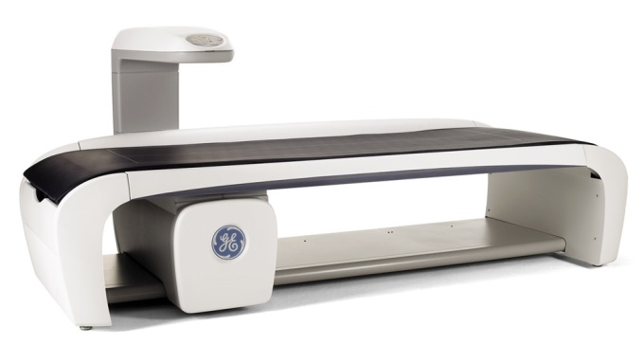
Dual-energy X-ray absorptiometry (DXA) offers precise, comprehensive body composition analysis including bone, lean and fat tissue distribution, as well as bone mineral density (BMD).

Holtain Skinfold Callipers (skinfold thickness):

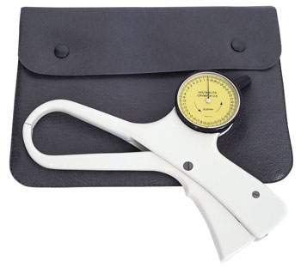
This instrument has been specifically designed for the accurate measurement of subcutaneous tissue.

Seca Flexible Tapes (waist and hip circumference):

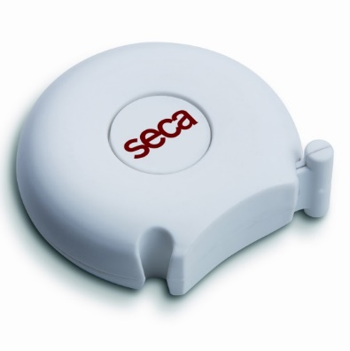
SECA 201 ergonomic circumference measuring tape – retractable. Able to measure girth with millimetre precision. Unwinds easily and locks in place precisely.

Stadiometers and Weighing Scales (height and weight):

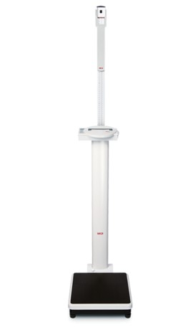
Versatile, low-maintenance and site-independent with economic battery operation.

Venous Occlusion Plethysmograph (forearm blood flow): Not currently in use. Will update to website, if in need.

**No Photo**

SphygmoCor (central blood pressure and arterial stiffness measurement):

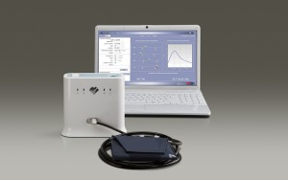

SphygmoCor® technology is used clinically for central arterial pressure waveform analysis to better inform blood pressure management.

Respiratory

Bronchoscopy: Olympus EVIS LUCERA CV 260 SL:

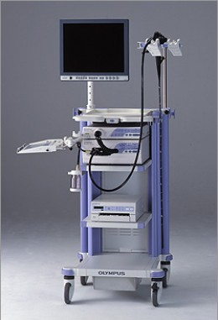

The Olympus EVIS LUCERA SPECTRUM video system has set a new standard for endoscopic imaging, offering outstanding image quality.

Cardio Pulmonary Exercise Stress Testing Equipment:

Care Fusion JLAB:

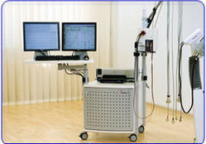

Performs breath-by-breath CPET and energy expenditure quickly and easily CPX features automated calibrations, interpretative support, and is extendable to a mobile system.

h/p/COSMOS LE 200 CE treadmill:
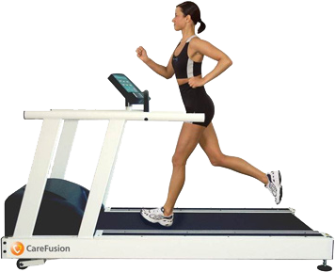

The classic treadmill for performing cardiopulmonary exercise physiology tests in the least amount of room of the LE series.

Ergoline Ergoselect:

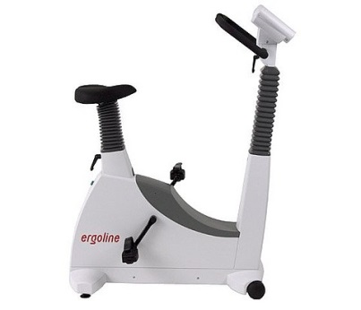

The classic ergometer for exercise ECGs. Free programming of exercise protocols, intuitive operation and universal interfaces (digital, analog, remote start) for connecting to all ECG recorders and PC ECGs on the market.

Devilbiss 646 Nebuliser:

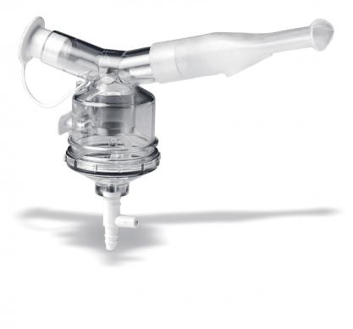
Model 646 nebuliser converts liquid into aerosol via a high velocity, compressed air stream. Used in conjunction with a compressor, it delivers consistent aerosol particles to the lungs of asthmatic patients. It has a 5cc capacity and an MMAD of 5 microns. The break-resistant nebuliser easily disassembles for sterilisation and is autoclavable.

Dosimeter (MB3 Markos Mefar):

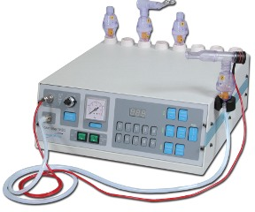

The MB3 provides an accurate, easy-to-use and reliable method for the study, diagnosis and prevention of bronchial asthma.

FeNo (NIOX MINO):

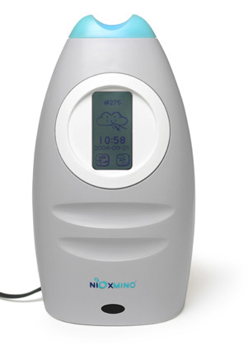
NIOX MINO® is the first point-of-care medical device for measuring fractional exhaled nitric oxide (FeNO), thus offering personalized asthma management. It enables healthcare providers to obtain an accurate, quantitative measure of airway inflammation to more effectively diagnose and manage asthma.

Lung Clearance Index/N₂ Washout:

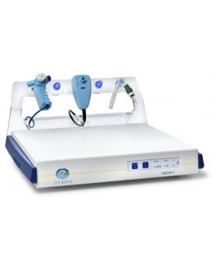

The EXHALYZER D offer various different kind of spirometry test for neonatal to adult patients. The modular system is easy upgradeable and fully compliant with the ATS / ERS recommendations for infant / paediatric pulmonary function testing.

Oximeter (Pulsox-300i):

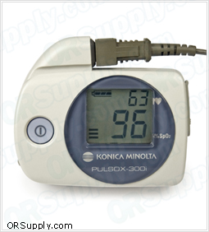

The Pulsox-300i offers the performance, comfort and memory you demand from a pulse oximeter.
Spirometer Microlab MK8:

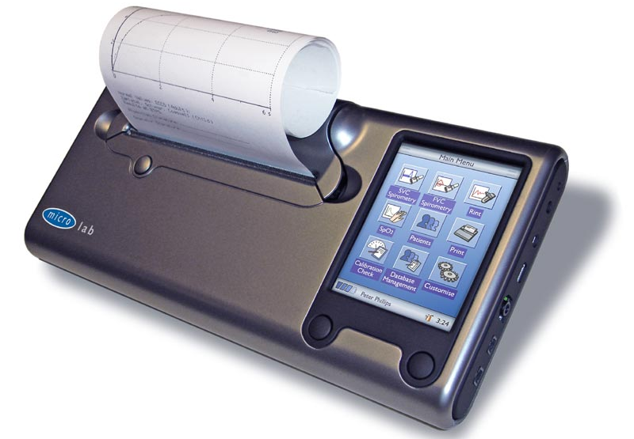

The Microlab spirometer is lightweight, portable and easy-to-use. Spirometry testing of FVC and SVC.

Vision

AdaptDX Adaptometer (measures dark adaptation in participants at risk of developing age-related macular degeneration):

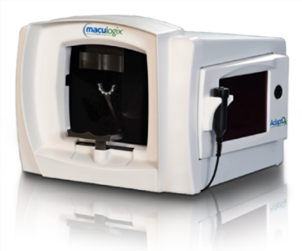
AdaptDx provides a practical and objective way to measure dark adaptation with a test that can be completed in just a few minutes. Dark adaptation function, the recovery of vision when going from daylight to darkness, is the only biomarker of age-related macular degeneration (AMD).

Bailey-Lovie Word Reading Chart:

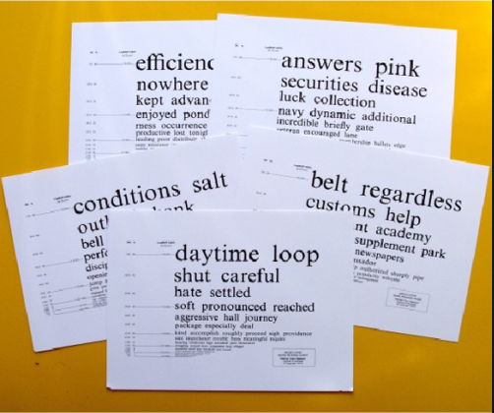
The Bailey Lovie Reading Chart Set includes five charts which show different word sequences on a plain white surface and features over 17 different sizes of text equivalents from N2 to N80.

Binocular Indirect Ophthalmoscope (Keeler):

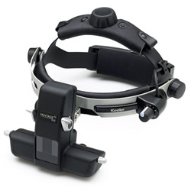
Constitutes a light attached to a headband, in addition to a small handheld lens. It provides a wider view of the inside of the eye. Furthermore, it allows a better view of the fundus of the eye, even if the lens is clouded by cataracts.
Canon CF-1 Colour Fundus Camera (limited availability):

Versatile 50° retinal camera with 4 photography modes; Colour. FAG, RedFree and Cobalt. Required pupil diameter as small as Ø 5.2mm, even Ø 4.3 mm in SP Mode!

ETDRS LogMAR Chart:

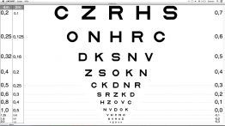

ETDRS acuity testing has become the worldwide standard for visual acuity testing, designed to eliminate inaccuracies in the Snellen tests.

Goldmann Tonometer:

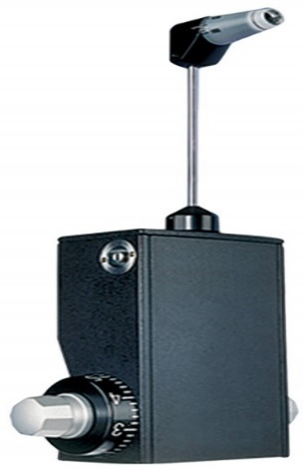

Device fixed to a slit-lamp microscope that is used to measure intraocular pressure.

Heidelberg Spectralis HRA and OCT (limited availability):
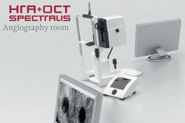

Multi-modality imaging with SPECTRALIS® is helping drive the development of novel therapeutics and changing the course of patient management in eye care. Using an upgradeable platform approach, SPECTRALIS has enhanced the role of spectral domain OCT by integrating it with confocal scanning laser ophthalmoscopy (cSLO). The combination of these two technologies has enabled new imaging capabilities, such as TruTrack™ Active Eye Tracking, and BluePeak™ blue laser autofluorescence, providing clinicians with unique views of the structure and function of the eye.

Heidelberg Spectralis HRA and OCT 2:

As above with OCT-angiography and wide-field lens.

Humphrey Field Analyser:

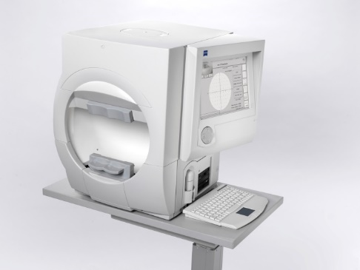

Humphrey automated visual field analysers are the gold standard in perimetric testing. They have a 25 year proven track record in visual field development and research.

Humphrey Matrix 800:

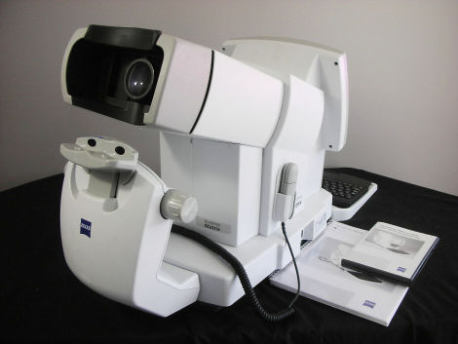

Humphrey Matrix® 800 for early visual field loss detection proven to find early visual field loss quickly and easily
Lensmeter / Focimeter GJD

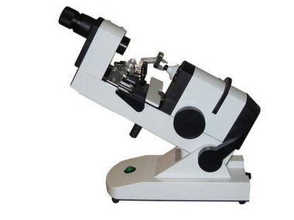

Ophthalmic instrument used by optometrists and opticians to verify the correct prescription in a pair of eyeglasses, to properly orient and mark uncut lenses, and to confirm the correct mounting of lenses in spectacle frames. Lensmeters can also verify the power of contact lenses, if a special lens support is used.

Lenstar Optical Biometer:

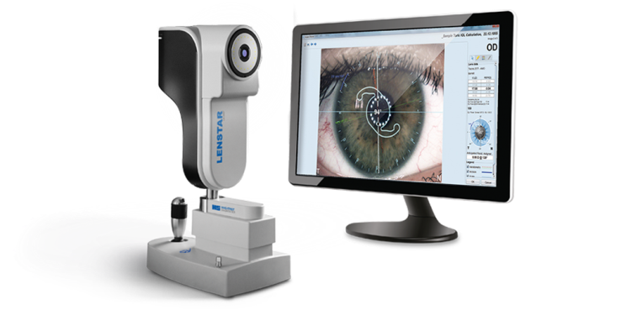
In a single measurement, provides accurate axial dimensions of all of the eye’s optical structures, and measures corneal curvature.

MAIA Microperimeter (x 2):

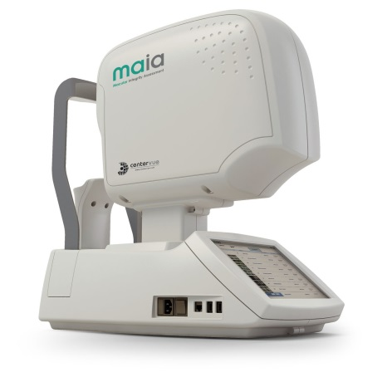
MAIA provides concurrent analysis of structural and functional aspects of the retina. Combining Scanning Laser Ophthalmology (SLO) fundus imaging, retinal sensitivity mapping and fixation analysis in one exam, MAIA microperimetry is a powerful tool to detect, describe and follow up pathologies affecting the macula, where visual acuity and conventional visual fields are inadequate.

Metrovision MonCvONE Standard Automated Perimeter:

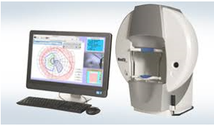

MonCvONE is a full field projection perimeter entirely compatible with the Goldmann standard and modern perimetry standard. It allows high resolution static and kinetic perimetry with automated and manual modes. It is presently the only perimeter capable of TRUE BINOCULAR exams.
It is therefore the best option to test visual aptitudes for drivers and handicapped subjects.
Its video recording capability means that it is also suitable for the assessment of ptosis, the investigation of diplopia in the visual field and for recording the cardinal positions of gaze.

Moorfields Acuity Chart:

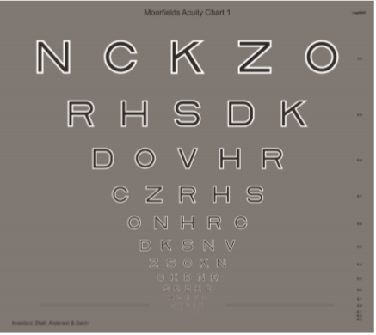
​

The Moorfields Acuity Chart (MAC) test includes two different, foldable letter charts (MAC 1 for the right eye and MAC 2 for the left eye). The letters are composed of a black core with surrounding white borders and are presented on a grey background. This leads to the appearance of the letters vanishing close to threshold, hence their description as ‘vanishing optotypes’.

The charts are constructed based on the gold standard design of the Early Treatment Diabetic Retinopathy Study (ETDRS) charts. These employ a logarithmic progression in letter size allowing for single letter scoring. This has demonstrated more accurate visual acuity measurements with lower test retest variability.

Nidek Autorefractor (limited availability):

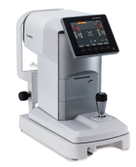

The Nidek Autorefractor provides accurate refraction and keratometry measurements.

Ocular Response Analyser (limited availability):

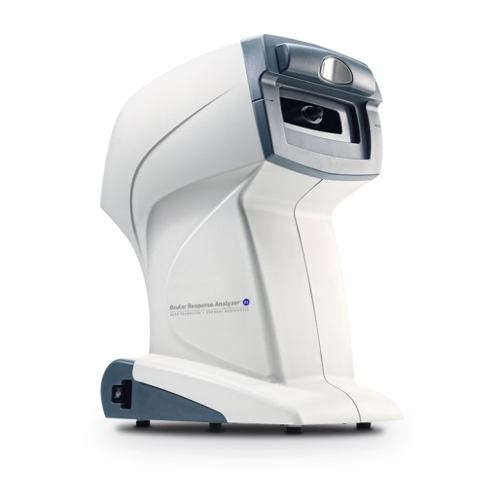
Ocular Response Analyzer® (ORA) is the only tonometer that measures Corneal Hysteresis (CH), a superior predictor of glaucoma progression. Corneal Hysteresis is an indication of the biomechanical properties of the cornea differing from thickness or topography, which are geometrical attributes. The instrument also provides the patented Corneal Compensated IOP (IOPcc) measurement, which may provide more reliable indication of pressure than other methods of tonometry.

Oculus C-Quant:

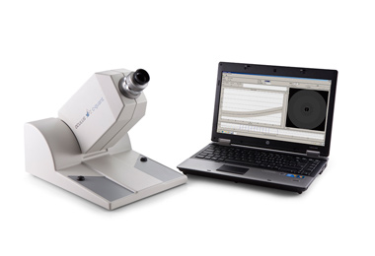
The C-Quant makes it possible to measure the amount of stray light in a human eye individually and reliably. The effect of increased stray light in the human eye can be compared to looking through a dirty windshield.

Oculus Oxymap:

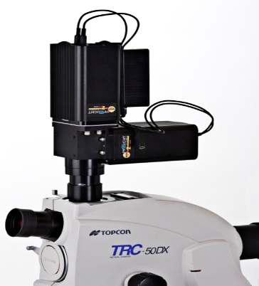

The Oxymap T1 measures relative retinal vessel oxygen saturation and vessel width. It allows metabolic and structural imaging of the retina and evaluation of the pathophysiology of common eye diseases such as retinal vascular occlusions, diabetic retinopathy, age-related macular degeneration and glaucoma.

Oculus Pentacam HR:

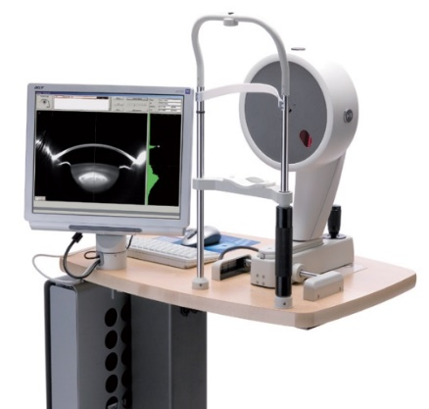

The Pentacam is a high-resolution rotating Scheimpflug camera system for anterior segment analysis. It provides clear images of the cornea, iris and crystalline lens. It also measures corneal topography, total corneal refractive power, corneal power distribution, automatic 360° chamber angle measurement, chamber depth and volume, and corneal and crystalline lens opacities.
Optos Tx200 Wide-Field Retinal Imaging and Anfiography (limited availability):

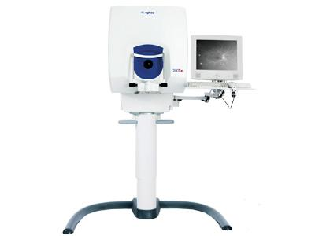

Multiple wavelength imaging, including options for color, red-free, fluorescein angiography and autofluorescence. With simultaneous non-contact pole-to-periphery views of more than 80% or 200 degrees of the retina in a single capture.

Optos California P200DTX:

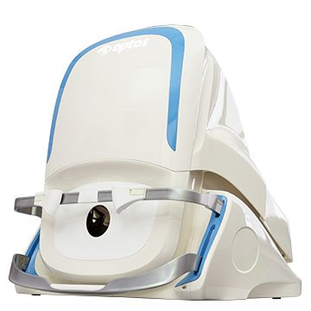

The compact desktop device offers greater imaging functionality and has introduced a new imaging modality, indocyanine green angiography, used for imaging the choroidal vasculature.

Pelli-Robson Contrast Sensitivity Chart:

.

Contrast sensitivity measurement provides a realistic assessment of how well a patient can see large, faint objects. The Pelli-Robson chart utilises letters of the same size but with reducing contrast to provide a quick means of assessing patient contrast sensitivity thresholds. For use at one metre.

Power Refractor 3:

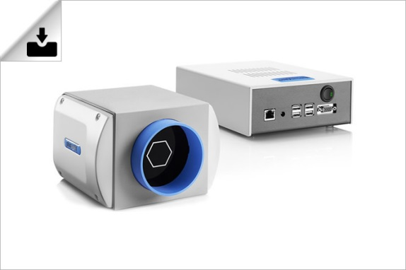

PowerRef 3 provides dynamic measurements of accommodation in sphere, convergence and pupil size changes in scotopic, mesopic and photopic conditions.

Professional Retinoscope:

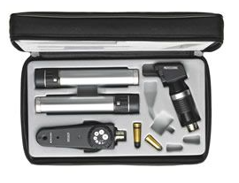

The unique optical design provides the first truly bimodal Retinoscope with just a quick bulb change. A true streak or spot - no compromises.

RTX1™ Adaptive Optics Retinal Camera:

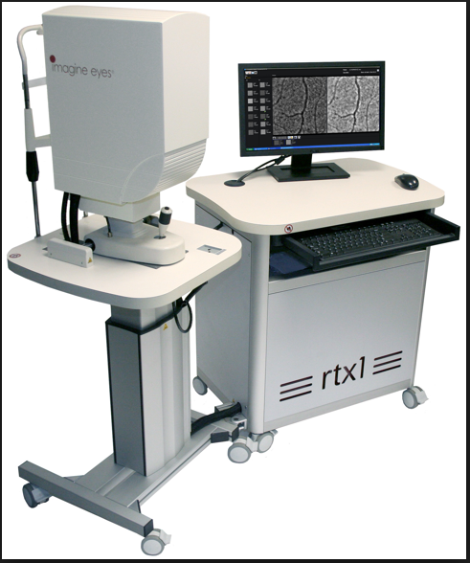
.

The RTX1™ enables visualizing the living retina at a microscopic scale. While the optical resolution of every other retinal imaging technique is limited to 15-20 µm, the rtx1’s exceptional resolving power allows examination of details of a few microns in size. Images acquired with the rtx1 reveal previously invisible retinal structures, such as cones.

Slit Lamp (CS 990):

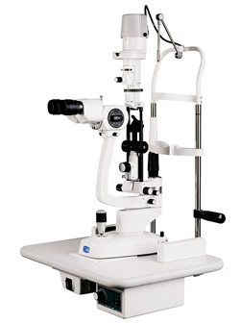

The SL 990 series is based on a system of multi layered anti-reflection lenses that ensure a more effective transmission of light, thus producing a 20% increase in optic transmission and a 10% increase in depth of field resulting in a clear and brilliant image.

Smith-Kettlewell Institute Low Luminance (SKILL) Card:

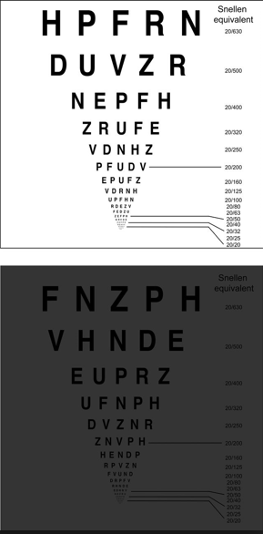

An acuity test of reduced luminance and contrast. The SKILL Card consists of two near acuity charts mounted back to back. One side has a chart with black letters on a dark gray background designed to simulate reduced contrast and luminance conditions. The other side has a high-contrast, black-on-white letter chart. The SKILL score is the acuity loss (number of letters) between the light and dark sides.

Specialist Ophthalmoscope:

Precision optics, versatile features and practical ergonomics make it the number one choice for ophthalmic practitioners. Re-engineered optics give 30% more Xenon illumination making it ideal to view through cloudy media and cataracts etc.

Topcon TRC 50DX: Mydriatic Retinal Camera:

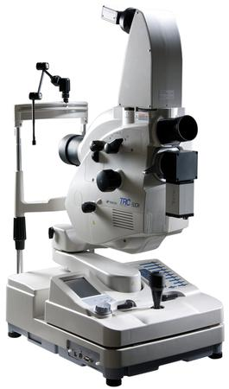

The TRC-50DX series of mydriatic retinal cameras incorporate the latest digital-ready features to provide the most complete retinal image capture device today, including colour, red free, fluorescein angiography, fundus auto fluorescein and indocyanine green angiography.

Trial Lens Set and Trial Frame x 2 sets:
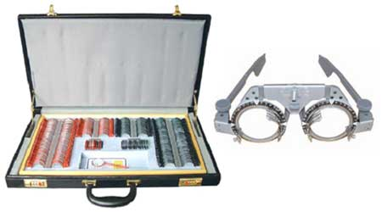

A series of spherical and cylindrical lenses, prisms and accessory lenses used in refraction.

Cardiac / Vascular:

Philips CX50 Ultrasound Platform (vascular [carotid intimal media thickness and flow mediated dilatation] and cardiac imaging):

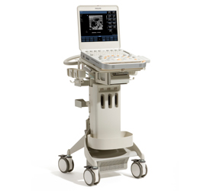

Multi-modality portable ultrasound platform with additional offline analysis package, Qlab version 9 including: IMT (Intimal Media Thickness analysis) and flow mediated dilatation assessment. CMQ (Cardiac Motion Quantification) tool for assessment of cardiac strain deformation.

Philips CX50 Ultrasound Platform: Cardiac imaging with online Qlab version 9 including CMQ (Cardiac Motion Quantification tool):

Echocardiography dedicated ultrasound platform with built in Qlab version 9 analysis package. CMQ (Cardiac Motion Quantification) functionality for assessment of strain deformation.

