VOLUNTEERS NEEDED
For a research study assessing lung function
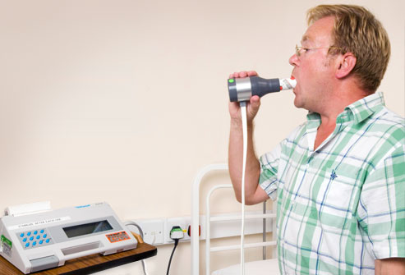

We aim to find out the lung function of healthy adults to help us with our research into a respiratory disease.

Participants must
- Be aged 18-80 years;
- Not have a respiratory condition (for example; asthma);
- Not taking any respiratory medication (for example; inhalers) or antibiotics.

Participants will:
- Attend the Northern Ireland Clinical Research Facility, located in Belfast City Hospital, University Floor. The visit will last about 1 hour 30 minutes.
- Complete 2 lung function tests.

This study involves simple assessments only and does not involve taking any treatments.

All participants in the first year of the study
will be entered into a draw to win an iPad

If you are interested, please telephone or email the researcher below.

Contact Information: Judy Bradley/Katherine O'Neill

NICRF@qub.ac.uk
Tel: 028 950 40342

