Impact of Covid-19 on incidence, survival and mortality of oral cancer in Northern Ireland
(A comparison between April-December of 2020 and 2018-2019)

Further information
Further information is available at: www.qub.ac.uk/research-centres/nicr
Phone: +44 (0)28 9097 6028
e-mail: nicr@qub.ac.uk
Acknowledgements
The Northern Ireland Cancer Registry (NICR) is funded by the Public Health Agency and is based in Queen's University, Belfast.
NICR uses data provided by patients and collected by the health service as part of their care and support.
The incidence, prevalence and survival statistics in this publication are designated as official statistics signifying that they comply with the Code of Practice for Official Statistics.
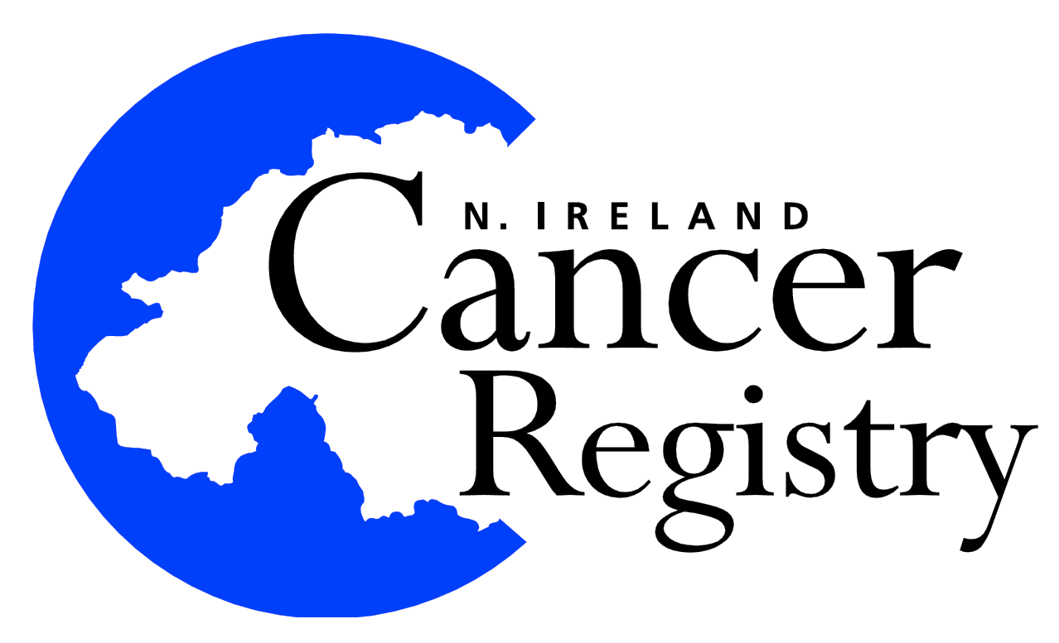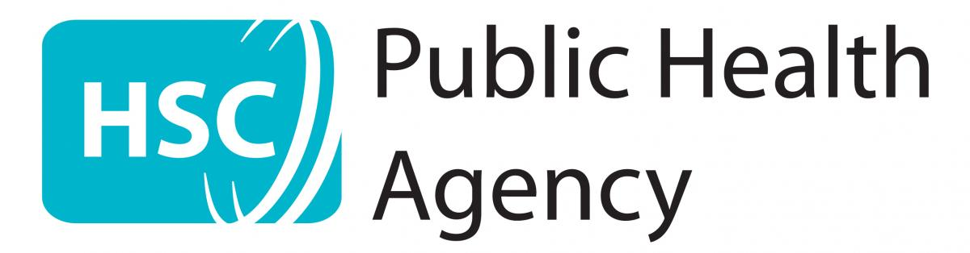

Incidence
During the April-December period when Covid-19 was present the number of cases of oral cancer diagnosed decreased by 35.6% (78 patients) from 219 per year in 2018 - 2019 to 141 in 2020.
Table 1: Number of oral cancer cases diagnosed in 2018-2020 by month and year of diagnosis
Period of diagnosis | Annual total | Month diagnosed
 |  | Jan | Feb | Mar | Apr | May | Jun | Jul | Aug | Sept | Oct | Nov | Dec
2018-2019* | 282 | 24 | 22 | 17 | 22 | 30 | 22 | 18 | 27 | 24 | 28 | 28 | 22
2020 | 196 | 22 | 18 | 15 | 6 | 14 | 17 | 13 | 19 | 15 | 18 | 17 | 22
* Average cases per year rounded to the nearest integer. Row sums may thus differ slightly from the total.

Figure 1: Number of oral cancer cases diagnosed in 2018-2020 by month and year of diagnosis
(a) Number of cases diagnosed
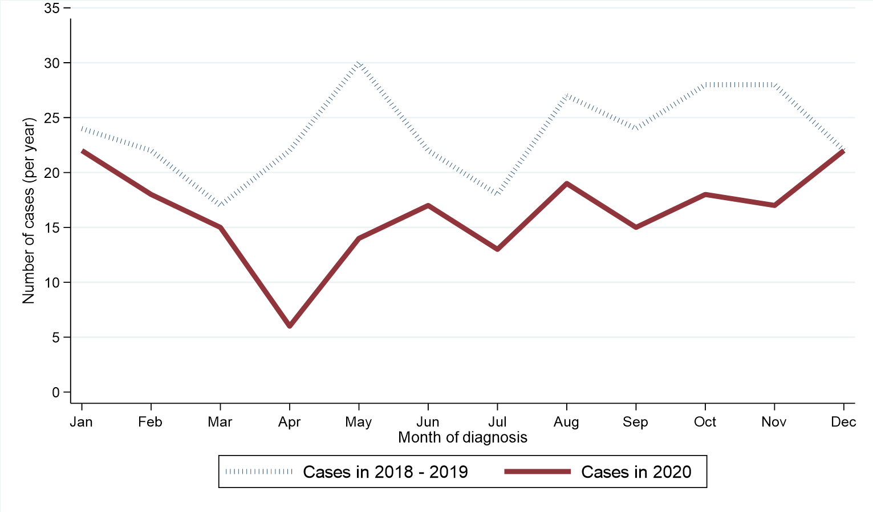
(b) Percentage change from 2018-2019 to 2020 in number of oral cancer cases by month of diagnosis
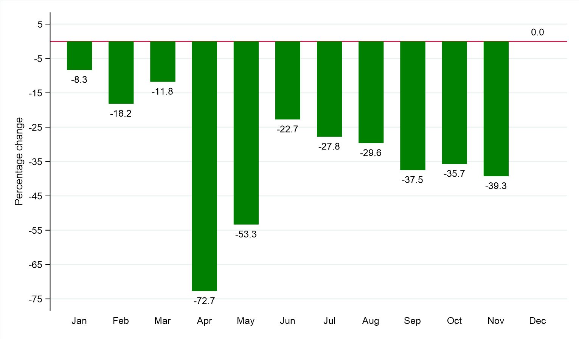

GENDER
Excluding the first quarter of each year among males the number of cases of oral cancer diagnosed decreased by 37.5% from 144 per year in 2018 - 2019 to 90 in 2020. Between the same two time periods the number of cases among females decreased by 32.0% from 75 per year to 51. The change in case distribution by gender between 2018 - 2019 and 2020 was not statistically significant.
Table 2: Number and proportion of oral cancer cases diagnosed in April-December of 2018-2020 by gender and period of diagnosis
Gender | Period of diagnosis (Apr-Dec) |  | Percentage
 | 2018-2019* | 2020 | change
Male | 144 (65.8%) | 90 (63.8%) | -37.5% (54 patients)
Female | 75 (34.2%) | 51 (36.2%) | -32.0% (24 patients)
All persons | 219 | 141 | -35.6% (78 patients)
* Average cases per year rounded to the nearest integer. Column sums may thus differ slightly from the total.

Figure 2: Oral cancer cases diagnosed in April-December of 2018-2020 by gender and period of diagnosis
(a) Number of cases diagnosed
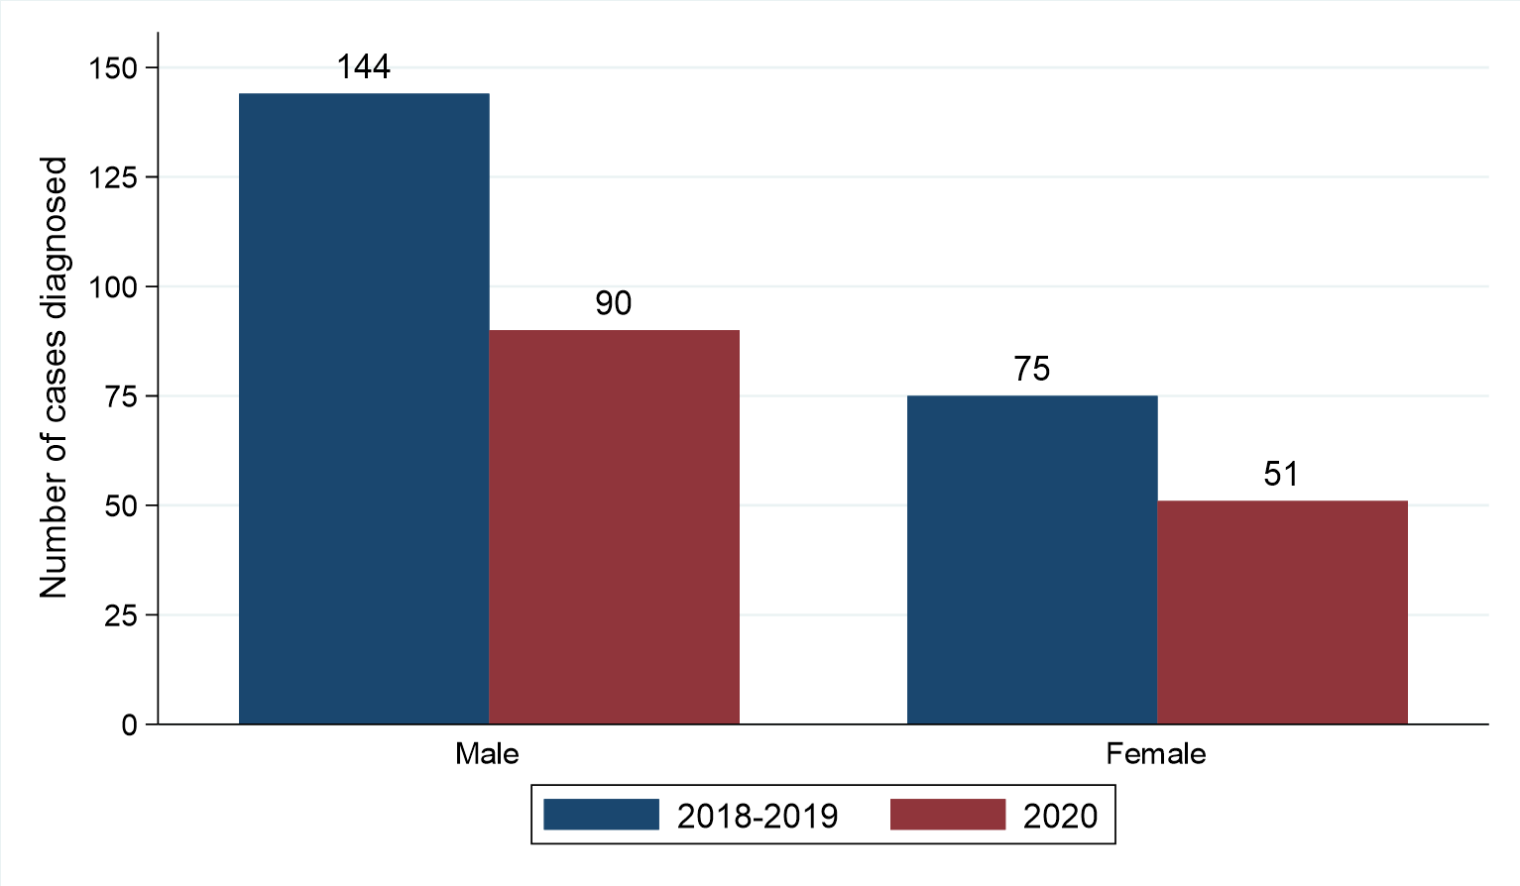
(b) Percentage change from 2018-2019 to 2020 in number of oral cancer cases by gender
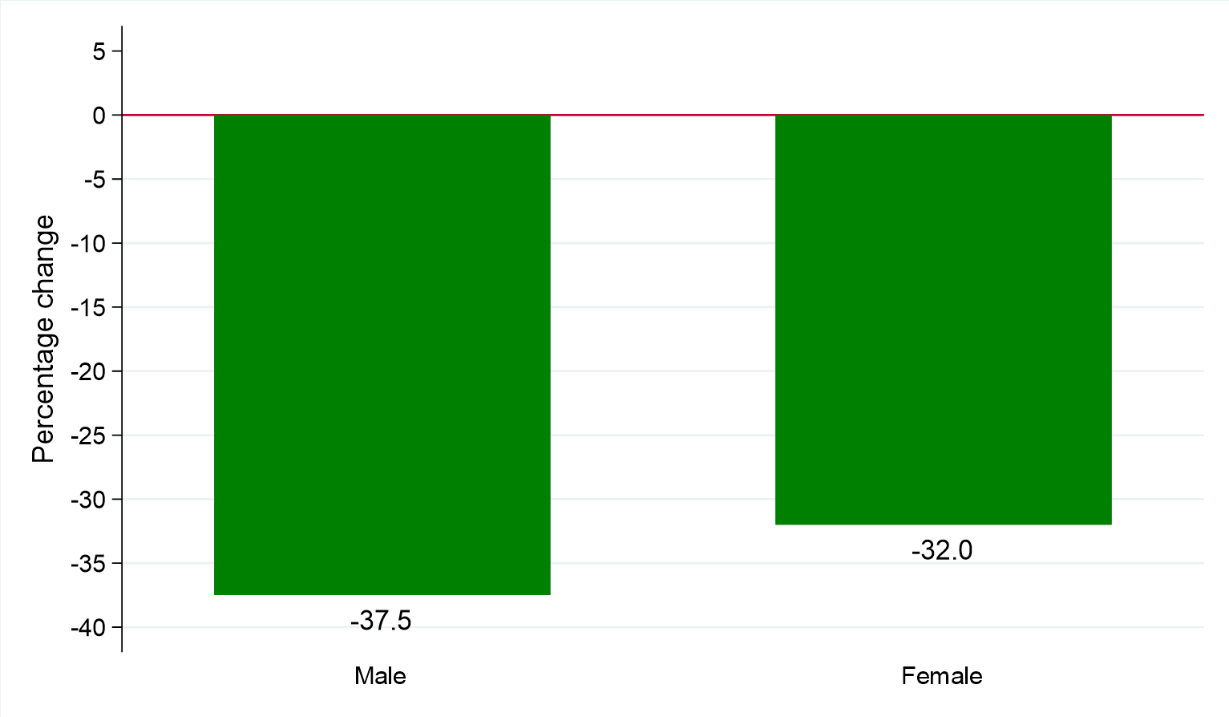

AGE
Excluding the first quarter of each year among people aged 0 to 54 the number of cases of oral cancer diagnosed decreased by 44.4% from 54 per year in 2018 - 2019 to 30 in 2020. Between the same two time periods, the number of cases among people aged 75 and over decreased by 18.4% from 38 per year to 31. The change in case distribution by age between 2018 - 2019 and 2020 was not statistically significant.
Table 3: Number and proportion of oral cancer cases diagnosed in April-December of 2018-2020 by age and period of diagnosis
Age group | Period of diagnosis (Apr-Dec) |  | Percentage
 | 2018-2019* | 2020 | change
0 to 54 | 54 (24.7%) | 30 (21.3%) | -44.4% (24 patients)
55 to 64 | 73 (33.3%) | 42 (29.8%) | -42.5% (31 patients)
65 to 74 | 56 (25.6%) | 38 (27.0%) | -32.1% (18 patients)
75 and over | 38 (17.4%) | 31 (22.0%) | -18.4% (7 patients)
All ages | 219 | 141 | -35.6% (78 patients)
* Average cases per year rounded to the nearest integer. Column sums may thus differ slightly from the total.

Figure 3: Oral cancer cases diagnosed in April-December of 2018-2020 by age and period of diagnosis
(a) Number of cases diagnosed
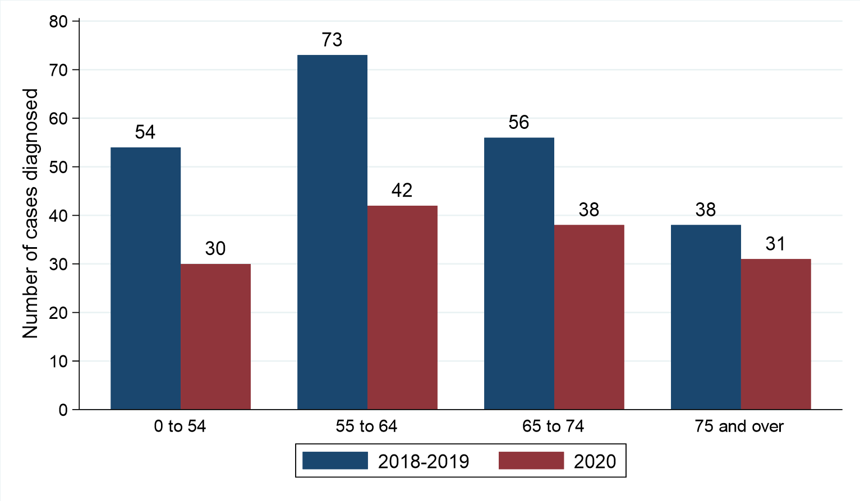
(b) Percentage change from 2018-2019 to 2020 in number of oral cancer cases by age at diagnosis
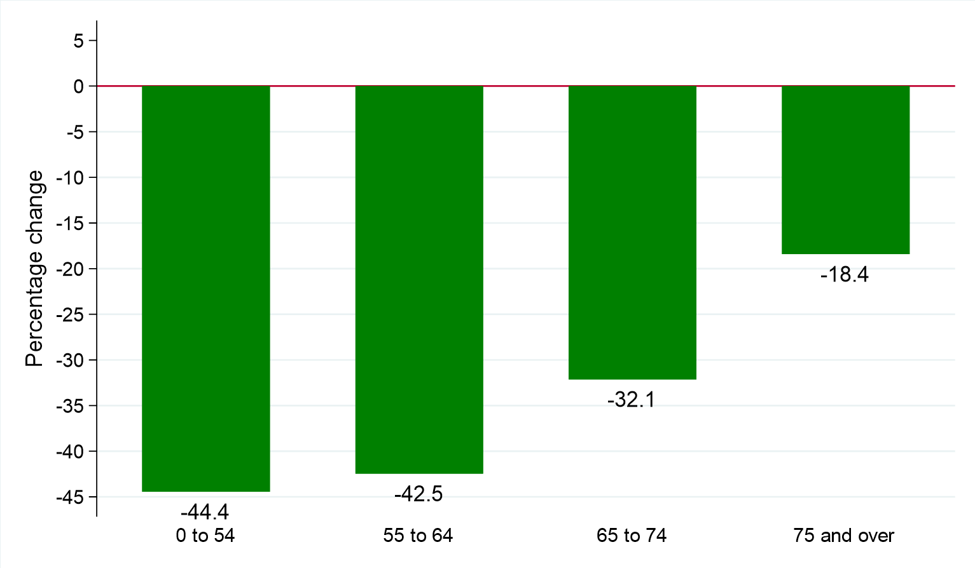

HEALTH AND SOCIAL CARE TRUST
Excluding the first quarter of each year among residents of Western HSCT the number of cases of oral cancer diagnosed decreased by 44.1% from 34 per year in 2018 - 2019 to 19 in 2020. Between the same two time periods the number of cases among residents of Southern HSCT decreased by 20.0% from 35 per year to 28. The change in case distribution by HSCT between 2018 - 2019 and 2020 was not statistically significant.
Table 4: Number and proportion of oral cancer cases diagnosed in April-December of 2018-2020 by Health and Social Care Trust and period of diagnosis
Health and Social Care Trust | Period of diagnosis (Apr-Dec) |  | Percentage
 | 2018-2019* | 2020 | change
Belfast HSCT | 55 (25.1%) | 31 (22.0%) | -43.6% (24 patients)
Northern HSCT | 49 (22.4%) | 35 (24.8%) | -28.6% (14 patients)
South Eastern HSCT | 47 (21.5%) | 28 (19.9%) | -40.4% (19 patients)
Southern HSCT | 35 (16.0%) | 28 (19.9%) | -20.0% (7 patients)
Western HSCT | 34 (15.5%) | 19 (13.5%) | -44.1% (15 patients)
Northern Ireland | 219 | 141 | -35.6% (78 patients)
* Average cases per year rounded to the nearest integer. Column sums may thus differ slightly from the total.
Note: Cases with unknown Health and Social Care Trust are included in totals

Figure 4: Oral cancer cases diagnosed in April-December of 2018-2020 by Health and Social Care Trust and period of diagnosis
(a) Number of cases diagnosed
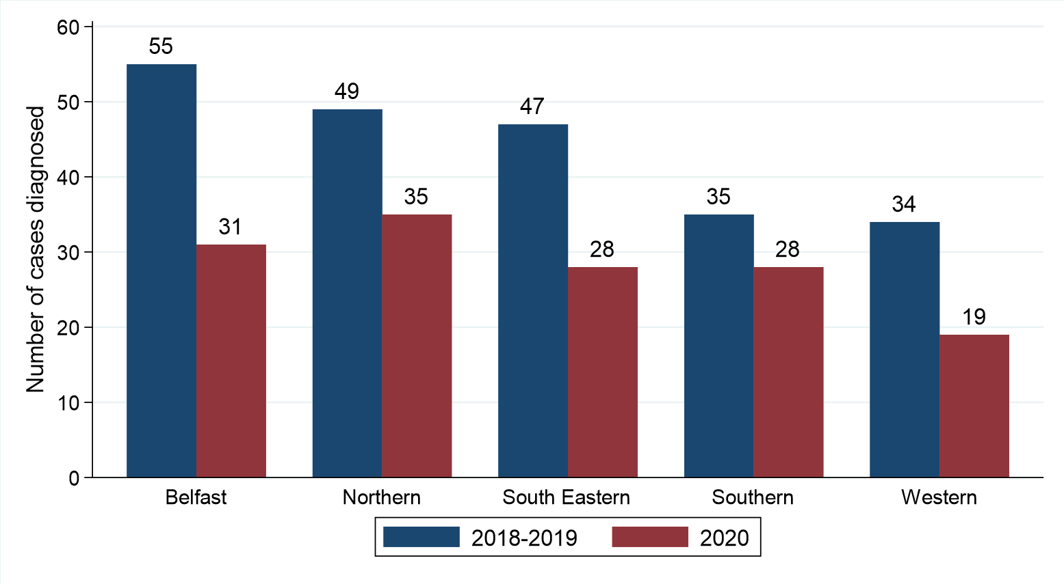
(b) Percentage change from 2018-2019 to 2020 in number of oral cancer cases by Health and Social Care Trust
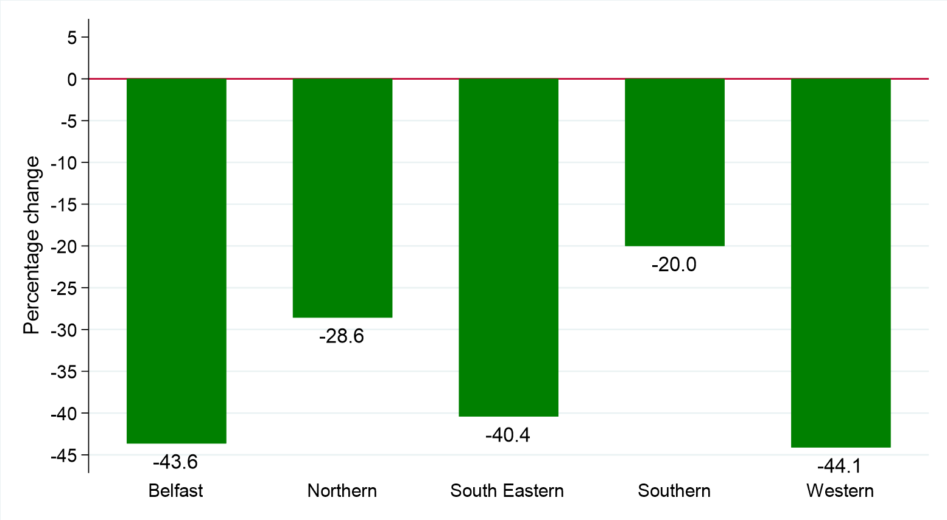

DEPRIVATION
Excluding the first quarter of each year among residents of the most deprived areas the number of cases of oral cancer diagnosed decreased by 36.8% from 57 per year in 2018 - 2019 to 36 in 2020. Between the same two time periods the number of cases among residents of the least deprived areas decreased by 44.2% from 43 per year to 24. The change in case distribution by deprivation quintile between 2018 - 2019 and 2020 was not statistically significant.
Table 5: Number and proportion of oral cancer cases diagnosed in April-December of 2018-2020 by deprivation quintile and period of diagnosis
Deprivation quintile | Period of diagnosis (Apr-Dec) |  | Percentage
 | 2018-2019* | 2020 | change
Most deprived | 57 (26.0%) | 36 (25.5%) | -36.8% (21 patients)
Quintile 2 | 37 (16.9%) | 32 (22.7%) | -13.5% (5 patients)
Quintile 3 | 43 (19.6%) | 22 (15.6%) | -48.8% (21 patients)
Quintile 4 | 40 (18.3%) | 27 (19.1%) | -32.5% (13 patients)
Least deprived | 43 (19.6%) | 24 (17.0%) | -44.2% (19 patients)
Northern Ireland | 219 | 141 | -35.6% (78 patients)
* Average cases per year rounded to the nearest integer. Column sums may thus differ slightly from the total.
Note: Cases with unknown deprivation quintile are included in totals

Figure 5: Oral cancer cases diagnosed in April-December of 2018-2020 by deprivation quintile and period of diagnosis
(a) Number of cases diagnosed
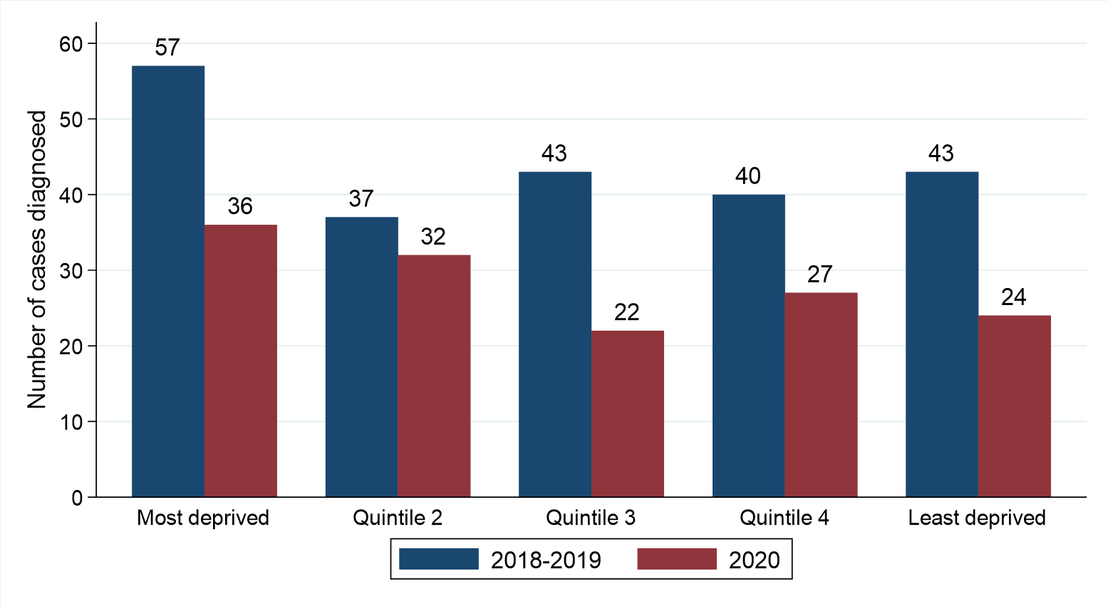
(b) Percentage change from 2018-2019 to 2020 in number of oral cancer cases by deprivation quintile
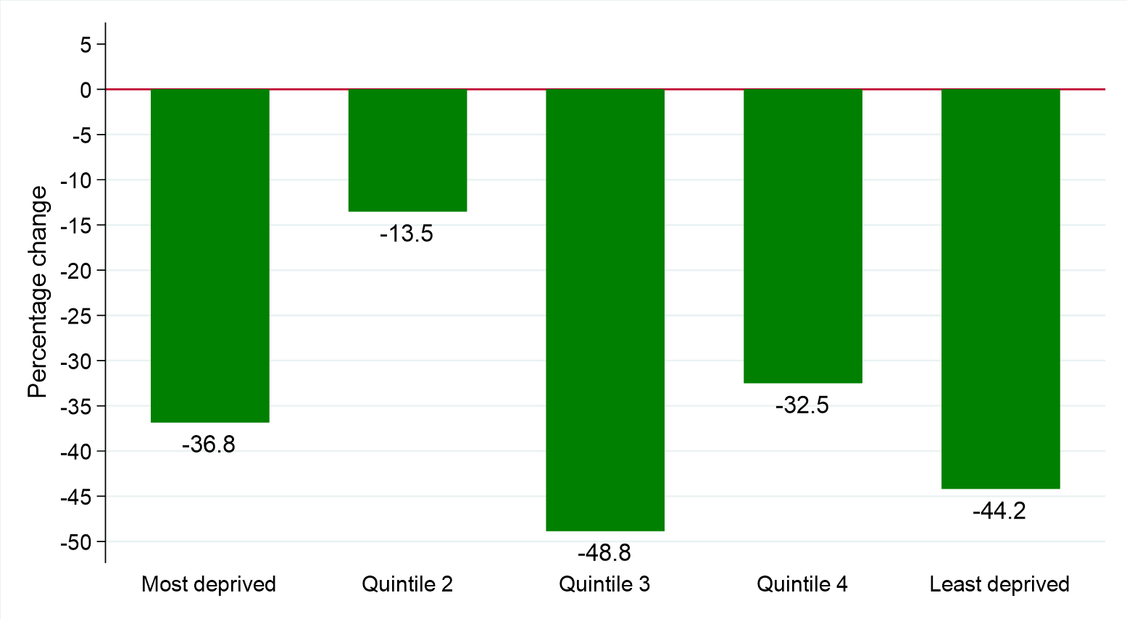

STAGE
Excluding the first quarter of each year the number of oral cancer cases diagnosed at Stage I decreased by 36.0% from 50 per year in 2018 - 2019 to 32 in 2020. Between the same two time periods the number of cases diagnosed at Stage IV decreased by 43.9% from 98 per year to 55. The change in case distribution by stage at diagnosis between 2018 - 2019 and 2020 was not statistically significant.
Table 6: Number and proportion of oral cancer cases diagnosed in April-December of 2018-2020 by stage at diagnosis and period of diagnosis
Stage at diagnosis | Period of diagnosis (Apr-Dec) |  | Percentage
 | 2018-2019* | 2020 | change
Stage I | 50 (22.8%) | 32 (22.7%) | -36.0% (18 patients)
Stage II | 25 (11.4%) | 21 (14.9%) | -16.0% (4 patients)
Stage III | 32 (14.6%) | 28 (19.9%) | -12.5% (4 patients)
Stage IV | 98 (44.7%) | 55 (39.0%) | -43.9% (43 patients)
Unknown | 15 (6.8%) | 5 (3.5%) | -66.7% (10 patients)
All stages | 219 | 141 | -35.6% (78 patients)
* Average cases per year rounded to the nearest integer. Column sums may thus differ slightly from the total.

Figure 6: Oral cancer cases diagnosed in April-December of 2018-2020 by stage and period of diagnosis
(a) Proportion of cases diagnosed
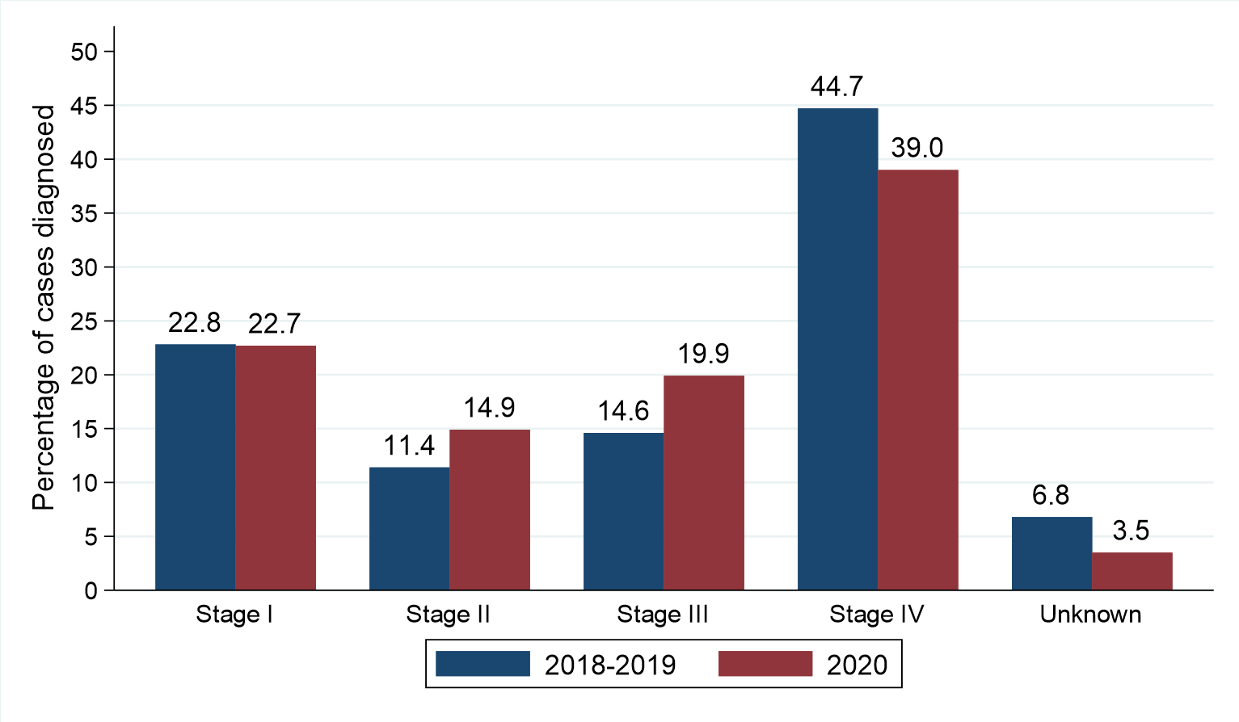
(b) Percentage change from 2018-2019 to 2020 in number of oral cancer cases by stage at diagnosis
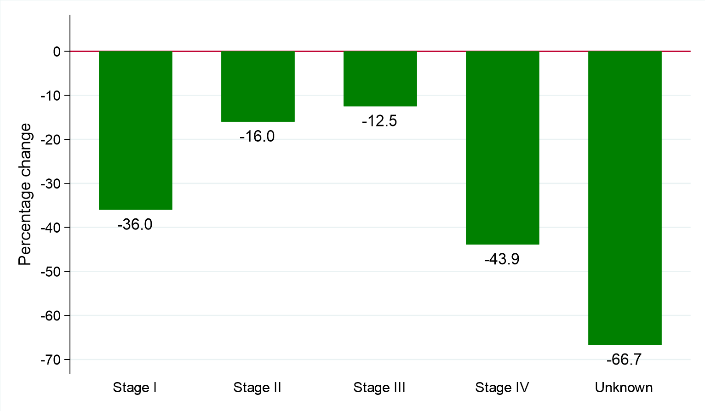

METHOD OF HOSPITAL ADMISSION
Excluding the first quarter of each year there was no change between 2018 - 2019 and 2020 in the number of cases where the patient had an emergency admission recorded as the most recent hospital admission type up to 30 days prior to diagnosis, with an average of 8 cases each year. The change in case distribution by hospital admission type between 2018 - 2019 and 2020 was statistically significant (p = 0.022).
Table 7: Number and proportion of oral cancer cases diagnosed in April-December of 2018-2020 by method of admission to hospital and period of diagnosis
Method of admission to hospital | Period of diagnosis (Apr-Dec) |  | Percentage
 | 2018-2019* | 2020 | change
Emergency admission | 8 (3.7%) | 8 (5.7%) | 0.0% (0 patients)
Elective admission | 87 (39.7%) | 38 (27.0%) | -56.3% (49 patients)
No emergency/elective admission recorded | 125 (57.1%) | 95 (67.4%) | -24.0% (30 patients)
All persons | 219 | 141 | -35.6% (78 patients)
* Average cases per year rounded to the nearest integer. Column sums may thus differ slightly from the total.

Figure 7: Oral cancer cases diagnosed in April-December of 2018-2020 by method of admission to hospital and period of diagnosis
(a) Proportion of cases diagnosed
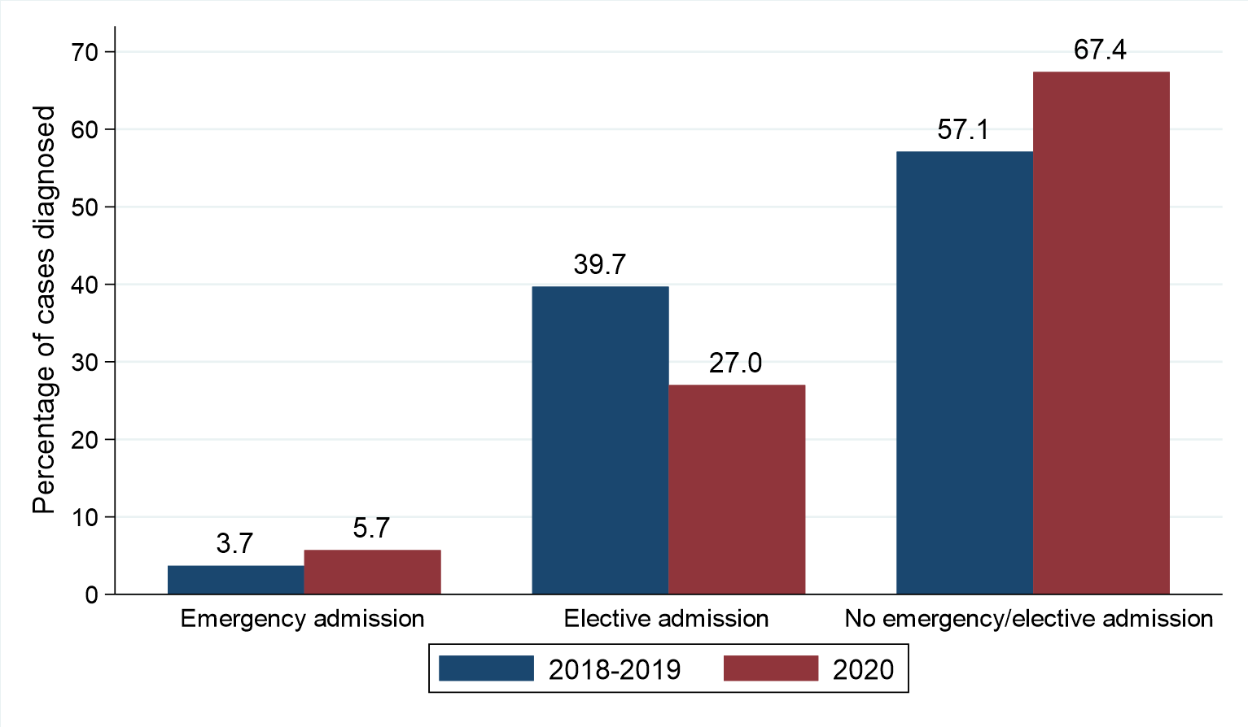
(b) Percentage change from 2018-2019 to 2020 in number of oral cancer cases by method of admission to hospital
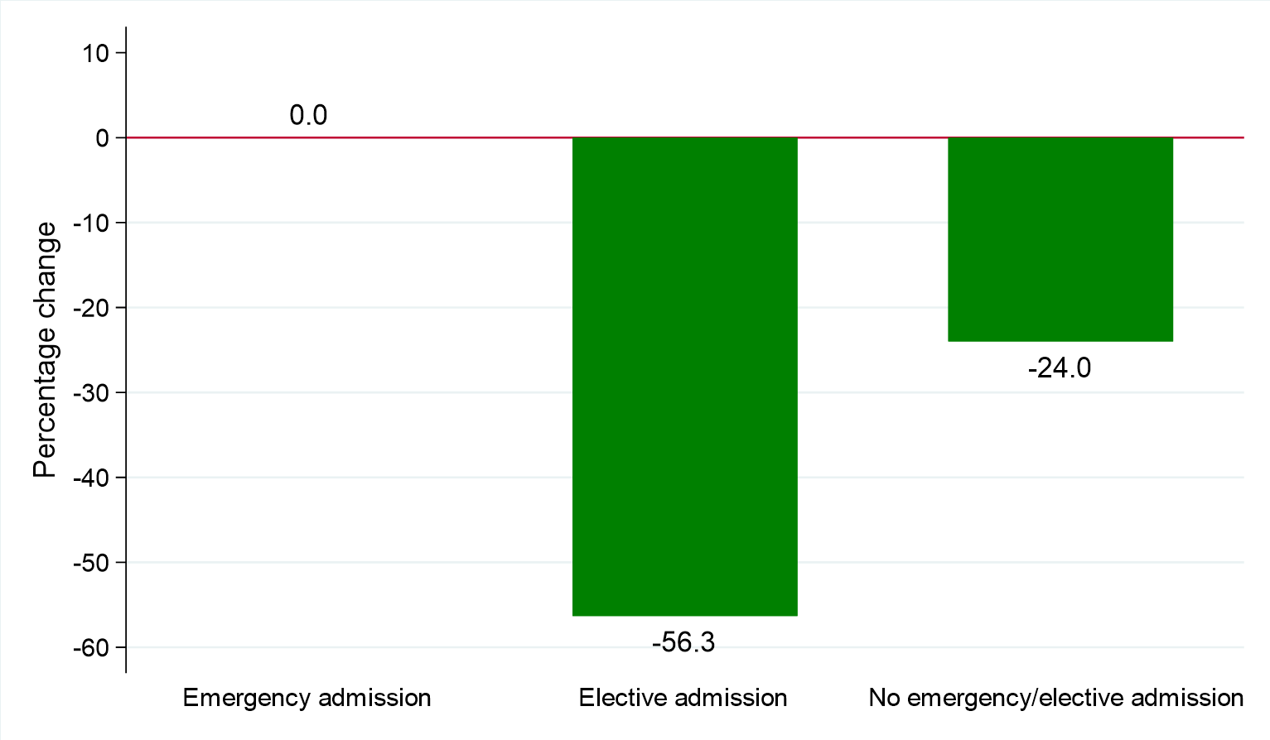

Treatment
Excluding the first quarter of each year the number of oral cancer cases where the patient was treated with surgery (within six months of diagnosis) decreased by 44.3% from 106 per year for those diagnosed in 2018 - 2019 to 59 for those diagnosed in 2020. The resulting change in the proportion receiving surgery from 48.4% in 2018 - 2019 to 41.8% in 2020 was not statistically significant.
Between the same two time periods the number of cases where the patient was treated with chemotherapy (within six months) decreased by 33.3% from 51 per year to 34. The resulting change in the proportion receiving chemotherapy from 23.3% in 2018 - 2019 to 24.1% in 2020 was not statistically significant.
The number of oral cancer cases where the patient was treated with radiotherapy (within six months of diagnosis) decreased by 39.7% from 131 per year for those diagnosed in April-December of 2018 - 2019 to 79 for those diagnosed in April-December of 2020. The resulting change in the proportion receiving radiotherapy from 59.8% in 2018 - 2019 to 56.0% in 2020 was not statistically significant.
The proportion of patients receiving none of surgery, chemotherapy or radiotherapy (within six months of diagnosis) who were diagnosed in April-December 2020 was 19.9%. This compared to 12.8% of those diagnosed in 2018 - 2019. This change was statistically significant (p = 0.038).
Table 8: Number and proportion of oral cancer cases diagnosed in April-December of 2018-2020 by treatment type and period of diagnosis
Treatment type | Period of diagnosis (Apr-Dec) |  | Percentage
 | 2018-2019 average | 2020 | change
Surgery | 106 (48.4%) | 59 (41.8%) | -44.3% (47 patients)
Chemotherapy | 51 (23.3%) | 34 (24.1%) | -33.3% (17 patients)
Radiotherapy | 131 (59.8%) | 79 (56.0%) | -39.7% (52 patients)
None of these treatments | 28 (12.8%) | 28 (19.9%)* | 0.0% (0 patients)
* Statistically significant change

Figure 8: Oral cancer cases diagnosed in April-December of 2018-2020 by treatment received and period of diagnosis
(a) Proportion of cases diagnosed
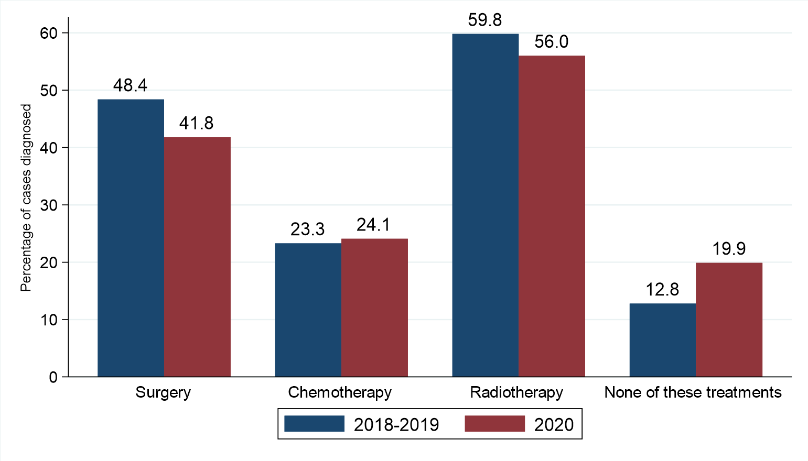

(b) Percentage change from 2018-2019 to 2020 in number of oral cancer cases by treatment received
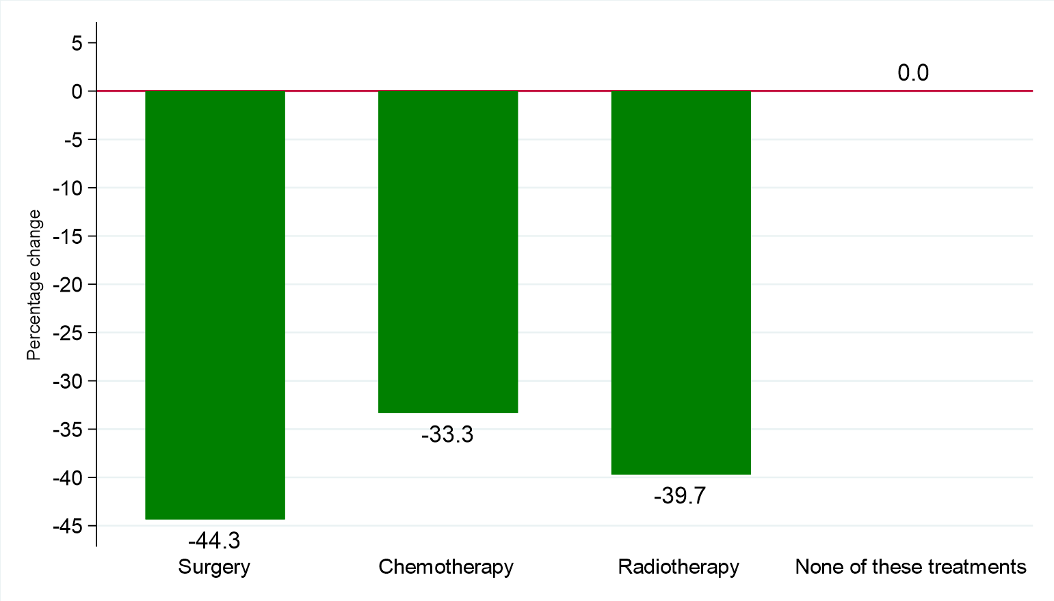

Survival
Changes in survival are evaluated using two measures. Observed survival examines the time between diagnosis and death from any cause. It thus represents what cancer patients experience, however, due to the inclusion of non-cancer deaths (e.g. heart disease), it may not reflect how changes in cancer care impact survival from cancer. Thus changes in age-standardised net survival are also examined. This measure provides an estimate of patient survival which has been adjusted to take account of deaths unrelated to cancer. It also assumes a standard age distribution thereby removing the impact of changes in the age distribution of cancer patients on changes in survival over time. While this measure is hypothetical, as it assumes patients can only die from cancer related factors, it is a better indicator of the impact of changes in cancer care on patient survival.
OBSERVED SURVIVAL
Survival among oral cancer patients one month after diagnosis decreased from 99.1% among those diagnosed in April-December of 2018 - 2019 to 97.6% among those diagnosed in April-December of 2020. This change was not statistically significant. Between the same two diagnosis periods, three-month survival decreased from 94.8% to 92.1%. This change was not statistically significant.
Table 9: Observed survival for patients with oral cancer diagnosed in April-December of 2018-2020 by period of diagnosis
Survival time | Period of diagnosis (Apr-Dec)
 | 2018-2019 | 2020
1 month | 99.1% (97.5% - 99.6%) | 97.6% (92.9% - 99.2%)
2 months | 96.4% (94.2% - 97.8%) | 94.5% (88.8% - 97.3%)
3 months | 94.8% (92.2% - 96.5%) | 92.1% (85.9% - 95.7%)
No statistically significant reductions

Figure 9: Observed survival for patients with oral cancer diagnosed in April-December of 2018-2020 by period of diagnosis
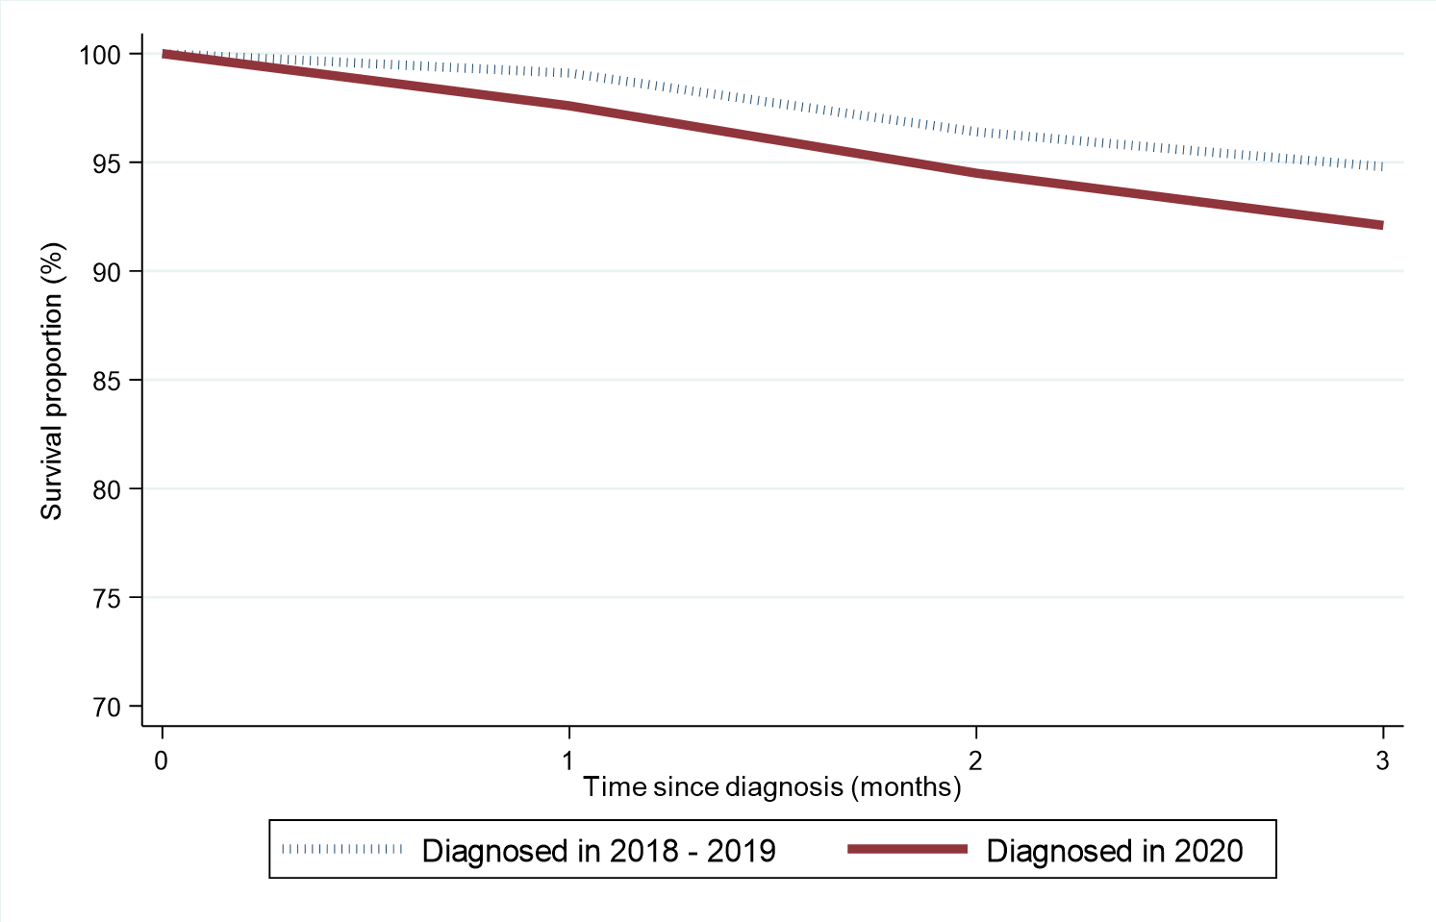

NET SURVIVAL
Age-standardised net survival (which takes account of deaths from other causes such as Covid-19) among oral cancer patients one month after diagnosis decreased from 98.8% among those diagnosed in April-December of 2018 - 2019 to 97.1% among those diagnosed in April-December of 2020. This change was not statistically significant. Between the same two time periods, three-month age-standardised net survival decreased from 93.7% to 90.6%. This change was not statistically significant.
Table 10: Age-standardised net survival for patients with oral cancer diagnosed in April-December of 2018-2020 by period of diagnosis
Survival time | Period of diagnosis (Apr-Dec)
 | 2018-2019 | 2020
1 month | 98.8% (97.5% - 100.0%) | 97.1% (93.9% - 100.0%)
2 months | 95.9% (93.7% - 98.2%) | 93.5% (88.7% - 98.6%)
3 months | 93.7% (90.8% - 96.7%) | 90.6% (84.9% - 96.7%)
No statistically significant reductions

Figure 10: Age-standardised net survival for patients with oral cancer diagnosed in April-December of 2018-2020 by period of diagnosis
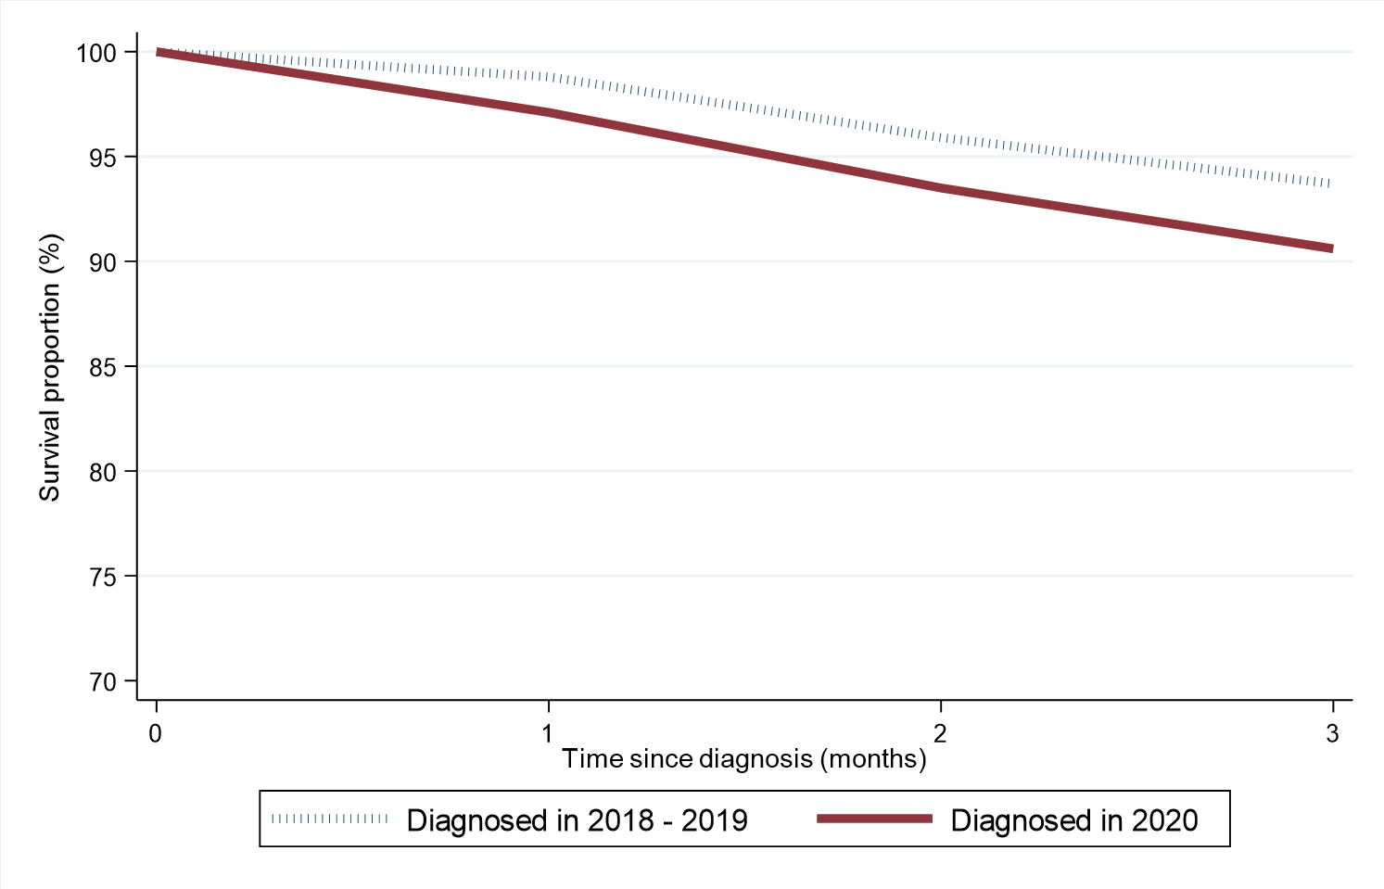

Cancer Mortality
During the April-December period when Covid-19 was present the number of deaths from oral cancer decreased by 2.5% from 79 per year in 2018 - 2019 to 77 in 2020.
Table 11: Number of oral cancer deaths in 2018-2020 by quarter and year of death
Period of death | Annual total | Quarter of year death occurred
 |  | Jan-Mar | Apr-Jun | Jul-Sept | Oct-Dec
2018-2019* | 105 | 26 | 29 | 25 | 25
2020 | 106 | 29 | 27 | 22 | 28
* Average deaths per year rounded to the nearest integer. Row sums may thus differ slightly from the total.

Figure 11: Number of oral cancer deaths in 2018-2020 by quarter and year of death
(a) Number of deaths
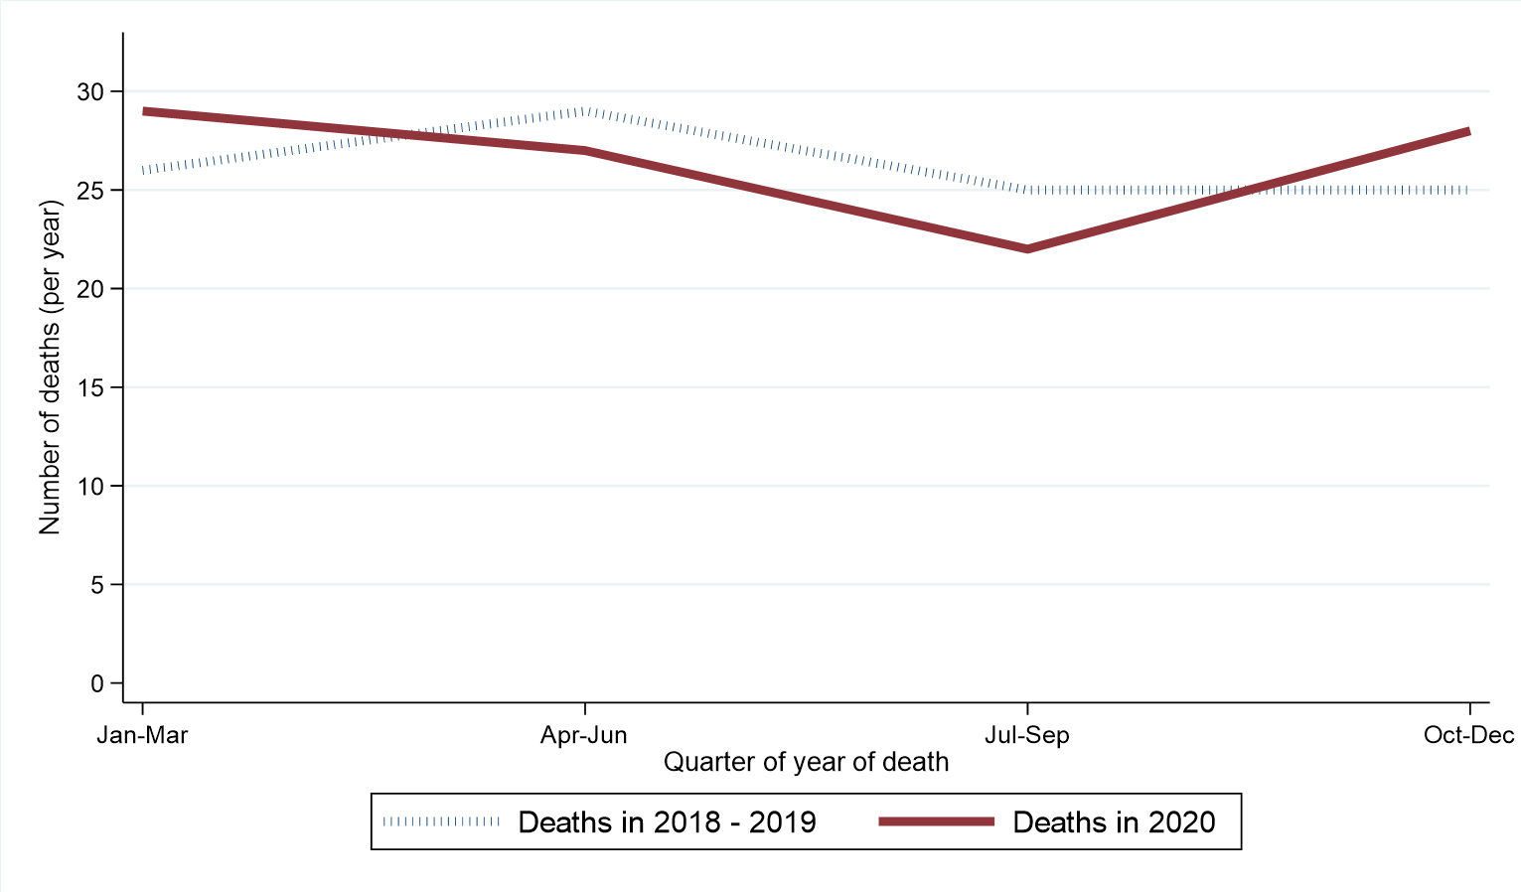
(b) Percentage change from 2018-2019 to 2020 in number of oral cancer deaths by quarter of year of death
