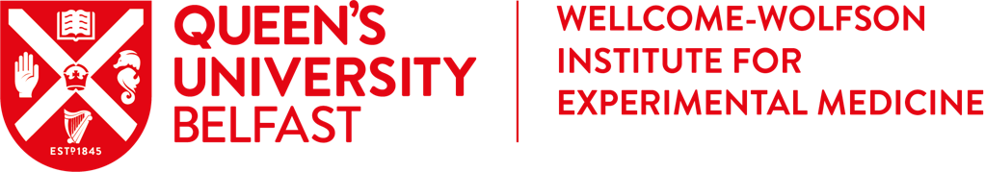

2019 Summer Studentship Application Form

Instructions:
- Complete this form and save in Word format as yoursurname_af.doc OR yoursurname_af.docx
- Save your CV in PDF format named as yoursurname_cv.pdf
- Save your complete exam transcript* in PDF format named as yoursurname_exams.pdf
*If you are a first year student yet to sit exams, please include details of your in-course assessment results to date in lieu of an exam transcript.
- Email these 3 files to cemsummerstudents@qub.ac.uk no later than 5 pm on Thursday March 7th.
e.g. if your name is Joe Bloggs your email should have 3 attachments called:
  - bloggs_af.doc
  - bloggs_cv.pdf
  - bloggs_exams.pdf

- You will receive a confirmation email when your application has been successfully received.
- Incorrect applications will receive an error message with the instructions and common mistakes reiterated.
- The number of incorrect application attempts from each applicant will be considered during the shortlisting process (ability to follow clear instructions is often crucial in research!).
- Late applications will be rejected.
Common mistakes to avoid when submitting your application:
- Files not in correct format
- Files not named correctly or names not in lowercase
- Files missing or combined (every emailed application should have 3 files)
- Parts of application form not completed

Section A
First name: Last name:
Gender:
Postal address:
Phone number:
Email address (for correspondence purposes):

Section B
University:
Student number:
Course title:
Course duration:
Current year of enrolment in your course (e.g. Year 2):

Please note, final year students are not eligible for this scheme.

Section C
Please adhere to all specified word limits, insert your word count in each box and answer all questions to ensure your application is accepted
- Why do you wish to undertake research this summer? (50 word limit)

(Please insert your word count here)

- Why do you wish to undertake research in the Wellcome-Wolfson Institute for Experimental Medicine in particular? (50 word limit)

(Please insert your word count here)

- How do you think a summer studentship will benefit your future career? (50 word limit)

(Please insert your word count here)

- What research study announced anywhere in the world in the past 12 months has impressed you and why? (50 word limit)

(Please insert your word count here)

- Have you applied to any other 2019 summer studentship research programmes? If yes, please tick as appropriate (this will not affect the ranking of your application to WWIEM):
SMDB Research Centres: ☐ CPH ☐ CCRCB Education Centres: ☐ CME ☐ CDE ☐ CBE
Outside QUB (please detail):__________________________________________________

- Have you undertaken a summer research studentship in QUB School of Medicine, Dentistry and Biomedical Science or elsewhere before? If yes, please tick as appropriate and include the year:
Research Centres: ☐ CPH ☐ Cii ☐ CEM/WWIEM ☐ CCRCB Education Centres: ☐ CME ☐ CDE ☐ CBE
Year(s): ____________________________________________________________________
Outside QUB (please detail):____________________________________________________

- Please list your WWIEM project preference from 1 to 5 where 1 is your first preference.
Project details are available @ http://www.qub.ac.uk/research-centres/CEM/Education/SummerStudentProgramme/

Rank | Code | Host Lab (PI) | Title of Project
1
2
3
4
5

- If successful, are you available to undertake your studentship between Monday June 24th and Friday August 16th 2019?
☐ Yes ☐ No (If no, please detail why) __________________________________

- Please tick to confirm that you have attached the following documents to your application email:
☐ WWIEM Application Form (Word format saved as yoursurname_af.doc OR yoursurname_af.docx)
☐ Up to date CV (PDF format saved as yoursurname_cv.pdf)
☐ Complete exam transcript* (PDF format saved as yoursurname_exams.pdf)

Please email the above documents to cemsummerstudents@qub.ac.uk no later than 5 pm on Thursday March 7th.
Late applications will not be accepted.

Results of the selection process will be emailed to all applicants as soon as possible and no later than the end of April. Please note that graduates of UK universities are eligible for Degree Plus upon full completion of this programme.

