GENETIC MODIFICATION POLICY
SAFETY SERVICE

Policy Number | SS/GU/022/2
Version Number | SS-PO-039
Approval Date | 22 March 2017
Approved By | BIAAC
Review Date | 03/2020
Author | Dr D Norwood

Contents Page

1. Legislation …………………………………………………………………………………... 3

2. Definition ……………………………………………………………………………………. 3

3. The Principal Investigator………………………………………………………………….. 3

4. School/Centre Biological Safety Officers………………………………………………… 4

5. GMO Risk Assessment……………………………………………………………………. 4

6. GMO Classification………………………………………………………………………... 5

7. The Biological and Infectious Agents Advisory Committee (BIAAC)………………… 5

8. GMO Risk Assessment Approval Procedures…………………………………………. 6

9. HSENI further notification……………………………………………………………….. 6

10. GMO Risk Assessment Review………………………………………………………. 7

11. Scientific Advisory Committee on Genetic Modification (SACGM) Compendium of Guidance …………………………………………………………………………………… 7

Appendix 1a………………………………………………………………………………….. 8

Appendix 1b…………………………………………………………………………………. 8

Appendix 2……………………………………………………………………………………. 9
Genetic Modification Policy

1. Legislation
The Genetically Modified Organisms (Contained Use) Regulations (Northern Ireland) 2015, regulates the safe use of genetically modified organisms (GMOs) in containment. The regulations cover both the human health and environmental risks from work involving genetically modified micro-organisms which includes modified cell cultures.
Before any GM work is started in an institution the law requires the following:
1. The premises are notified to HSENI
2. The institution is registered as a GM Centre
3. A Genetic Modification Safety Committee is established
4. A Biological Safety Officer is appointed
All of the above have taken place in QUB with the Biological and Infectious Agents Advisory Committee (BIAAC) serving as the GM Safety Committee and Dr David Norwood serving as the appointed University Biological Safety Officer.
2. Definition
“Genetic Modification” in relation to an organism means the altering of the genetic material in that organism in a way that does not occur naturally by mating or natural recombination (or both) and within the terms of this definition—
(a) Genetic modification occurs at least through the use of the techniques listed in Appendix 1a.
(b) The techniques set out in Appendix 1b are not considered to result in genetic modification.
3. The Principal Investigator [PI]
The role of Principal Investigator is extremely important in ensuring GM safety. They will normally be head of a research group or in charge of a specific GM research project. Their responsibilities are to:
- Ensure that all GM work is covered by a risk assessment that has been reviewed and approved by the BIAAC.
- Ensure that contents of the risk assessment and control measures are brought to the attention of individuals working on the project.
- Ensure that work is undertaken in accordance with the findings of the risk assessment.
- Ensure that all individuals involved in GM work receive training and are competent to carry out the work and that this is recorded in a robust manner.
- Ensure an appropriate level of supervision is maintained.
- Ensure that risk assessments are regularly reviewed and any changes notified to the BIAAC for approval.
4. School/Centre Biological Safety Officers
Schools and Centres within the University should appoint local Biological Safety Officers to co-ordinate GM risk assessments, attend BIAAC, and assist in the annual review of GM risk assessments that are initiated by the Safety Office.
5. GMO Risk Assessment
GMO risk assessments are required to be done before any work commences for any work involving the possession or use of genetically modified organisms involved in the work. There are specific requirements in relation to factors that must be considered in GMO risk assessments, and the steps that have to be included. In summary, the required steps are:
- hazard identification
- estimation of the severity of the consequence
- determination of a provisional containment class
- environment and activity considerations
- estimation of likelihood of harm occurring
- review of the risk assessment to check that all hazards are properly controlled
- assignment of the final containment and activity classification
A GM risk assessment is used to assess the potential risks to humans, animals, plants or other aspects of the environment arising from the work and determine what controls are required to protect humans and the environment.
Principal investigators are responsible for ensuring that risk assessment are carried out and the controls are fully implemented, regularly monitored and that the assessment and controls are regularly reviewed and revised where required. GM risk assessments must be carried out by competent persons and approved by the appropriate manager or principal investigator. The work must be categorised on the basis of risks taking into account the hosts, vectors, genetic materials, genetically modified organisms, the type of activity, class, containment level and all the necessary controls required to ensure that the work can be done safely while protecting people and the environment.
GM risk assessments must address all aspects of the work including routine and non-routine work and what to do in emergencies if something goes wrong. The risk assessment and control measures must be suitable and sufficient and proportionate to the risks. All workers including staff, students and visitors must be provided with adequate information, instructions, training and supervision to enable them to safely and competently perform their work.
Queen’s University uses three different risk assessment templates for work with microorganisms, animals and plants. These templates can all be downloaded from the Occupational Health and safety website.
6. GMO Classification
Genetically modified organisms are classified on the basis of the risks to human health or the environment into four activity classes (Class 1-4) according to the following:
- Ability to cause infection.
- Severity of the disease that may result.
- Risk that infection will spread to the population.
- Risk of damage to the environment or economic loss.
- Availability of vaccines and effective treatment.
The four activity classes of genetically modified organisms and the basis of their classification are as follows.
• Activity class 1 (Class 1): Unlikely to cause human disease or have any untoward environmental effects.
• Activity class 2 (Class 2): May cause human disease or be a hazard to employees but it is unlikely to spread to the community and there is usually effective prophylaxis or effective treatment available. Unlikely to cause significant environmental damage.
• Activity class 3 (Class 3): May cause severe human disease and presents a serious hazard to employees and it may present a risk of spreading to the community but there is usually effective prophylaxis or treatment available. Possibility of significant environmental damage, or economic loss if accidentally released.
• Activity class 4 (Class 4): May cause severe human disease and presents a serious hazard to employees and it is likely to spread to the community and there is usually no effective prophylaxis or treatment available. Likely to cause severe environmental damage or economic loss if accidentally released.
The final stage in the risk assessment process for GMMs is assignment of final containment level and activity classification. Class 2 and 3 activities are subject to notification to HSE for which a fee is payable by the School.
Class 1 activities: work may commence once assessment had been reviewed and approved by BIAAC.
Class 2 activities may commence on receipt of acknowledgment by HSENI.
Class 3 activities require the consent of HSENI and work may not commence until this has been received. This may take up to 45 days.

7. The Biological and Infectious Agents Advisory Committee (BIAAC)
The BIAAC meets three times a year to discuss and advise on all aspects of biological and infectious agents’ safety work throughout the university. The committee oversees the work involving genetic manipulation and ensures all such work complies with guidance from the Health and Safety Executive Advisory Committee on Genetic Manipulation. A specialist sub-group of BIAAC review systematically and in detail, every risk assessment involving genetic modification. GMO risk assessments for review by the BIAAC GMO Sub-Group are submitted through the University Biological Safety Officer.

8. GMO Risk Assessment Approval Procedures
GMO Class I
- Start the authorisation process by informing your PI, Centre Director or HoS as appropriate.
- Inform your local Biological Safety Officer and H&S Committee.
- Complete your GMO Risk Assessment and send to the University Biological Safety Officer (Dr D. Norwood).
- The University Biological Safety Officer sends your GMO Risk Assessment to each member of the BIAAC GM Sub–Group who comment on your risk assessment.
- The University Biological Safety Officer contacts you regarding any improvements or not which may be necessary – and finally giving approval for the project to proceed.
GMO Class II
Points 1 to 5 above plus:
- When BIAAC approval has been obtained then then the following must be submitted to the HSENI:
a) Activity Notification (Form CU2)
b) Approved Risk Assessment
c) Fee (£981 on Jan’17)
- If this is the first Class 2/3 Activity Notification, activity may start when consent received (within 45 days for CLII and 90 days for CLIII). Subsequent activity may begin immediately after notification is acknowledged from HSENI for CLII and when consent is received for CLIII (within 45 days).
9. GMO Risk Assessment Review
GMO risk assessments must be reviewed at appropriate intervals or if there is material change to the work. At the very minimum GMO risk assessments should be reviewed annually. However if the work changes e.g. it expands to cover different nucleic acid inserts, uses different host vector systems or the location of the work changes, then the PI must submit an amendment to the BIAAC committee through the BSO for approval as above.
Where the only change is staff joining or leaving a project this should be notified to the BSO but approval is not required. Similarly if the PI changes but all other aspects remain the same the BSO should just be notified of the name of the new PI so records can be amended.

10. HSENI further notification
Further notification to HSENI may be required if:
- if there is any significant change to the work
- new information becomes available that effects the risk assessment
- any changes are made to the containment and control measures
- must first be approved by BIACC GM Sub–Group
- fee may be payable
11. Scientific Advisory Committee on Genetic Modification (SACGM) Compendium of Guidance
The SACGM Compendium of Guidance is the most important source of advice on genetic modification, genetically modified organisms and GM risk assessment. These guidance documents can be obtained from the HSE website. It is divided into the following parts:
• Part 1: Introduction to the legislation and general health and safety issues
• Part 2: Risk assessment of genetically modified microorganisms (other than those associated with plants)
• Part 3: Containment and control of activities involving genetically modified microorganisms
• Part 4: Genetic modification work that involves plants (including plant-associated genetically modified microorganisms)
• Part 5: Genetic modification of animals
• Part 6: Guidance on the use of genetically modified microorganisms in a clinical setting
• List of abbreviations

Appendix 1a
Examples of the techniques which constitute genetic modification as per the definition in the regulations are:
- Recombinant nucleic acid techniques involving the formation of new combinations of genetic material by the insertion of nucleic acid molecules, produced by whatever means outside an organism, into any virus, bacterial plasmid or other vector system and their incorporation into a host organism in which they do not naturally occur but in which they are capable of continued propagation;
- Techniques involving the direct introduction into an organism of heritable genetic material prepared outside the organism, including micro-injection, macro-injection and micro-encapsulation;
- Cell fusion or hybridization techniques where live cells with new combinations of heritable genetic material are formed through the fusion of two or more cells by means of methods that do not occur naturally.

Appendix 1b
The following techniques are not considered to result in genetic modification provided that they do not involve the use of genetically modified organisms made by techniques other than those listed in Part III below, or the use of recombinant nucleic acid molecules, namely -
- In vitro fertilisation
- Natural processes including conjugation, transduction or transformation:
- Polyploidy induction
The regulations do not apply to the following techniques providing they do not involve the use of recombinant nucleic acid molecules or GMOs other than those produced by one of the following techniques of genetic modification:
- Mutagenesis;
- Cell fusion of prokaryotic species which can exchange genetic material through homologous recombination;
- Cell fusion of cells of any eukaryotic species including production of hybridomas and plant cell fusions;
- Self-cloning where the resulting organism is unlikely to cause disease or harm to humans, animals or plants.

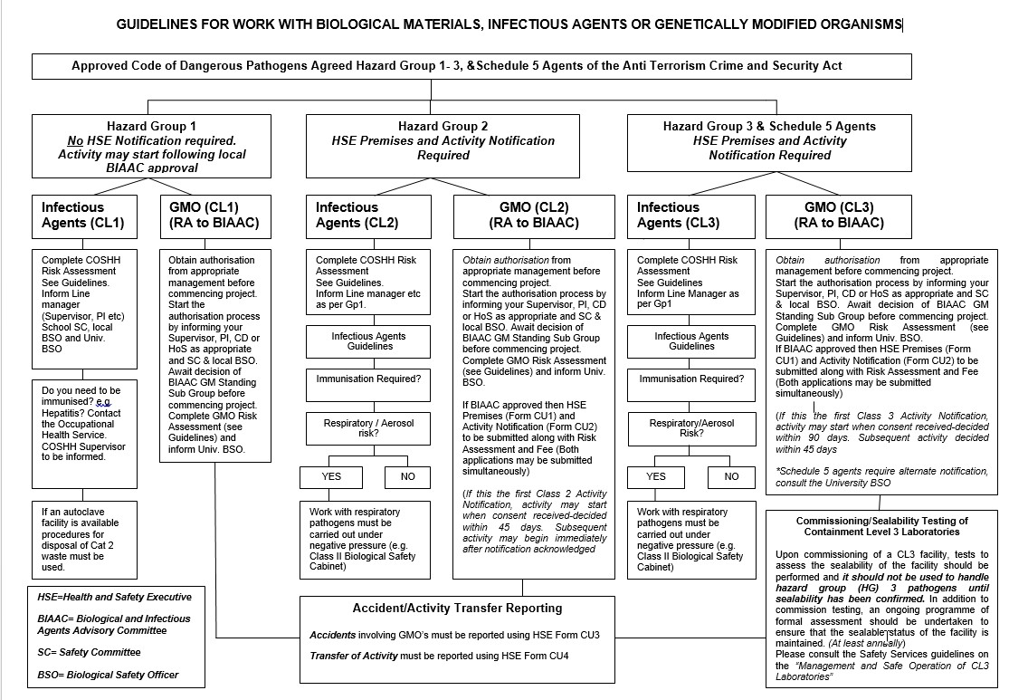
Appendix 2

