Disposal of Clinical Waste

Clinical Waste is either heat treated or incinerated dependent on the type of waste generated. The different types of materials and the required treatment are defined below and in the attached table:

Clinical waste is waste which has the potential to cause sharps injury, infection or offence. When packaged and disposed of appropriately there is virtually no public health significance. Clinical waste contains the following types of waste:
sharps; human tissue (excluding hair, teeth and nails); bulk body fluids and blood; visibly blood stained body fluids and visibly blood stained disposable material and equipment; laboratory specimens and cultures; animal tissues, carcasses or other waste arising from laboratory investigation or for medical or veterinary research.

The operative term is “offence” - this should not be infectious material, which must be sterilised before disposal. Microbial and cell cultures should generally be disposed of through other waste streams after sterilisation by either autoclaving or disinfectant as appropriate. In addition to animal carcasses and body parts it may also include sharps boxes /burn bins which may contain gels contaminated with significant quantities of acrylamide or ethidium bromide (EtBr) – “Cytotoxic waste”.

Note that micropipette tips and paper towels that may have been in contact with such gels are unlikely to be carry significant quantities of acrylamide or EtBr and should be disposed of by other waste streams as follows; Gloves, tips, eppendorfs etc. which are not infectious, cytotoxic or harmful, should be autoclaved and then placed in a bag with a ‘MADE SAFE FOR DISPOSAL’ label attached: The bag can then be disposed of in the general waste bins.

Bags for autoclaving should be left in the bin provided in LG.054; autoclaving and disposal will be carried out by technical staff.

Plasticware contaminated with phenol, chloroform or formamide should also be disposed of as cytotoxic waste (purple-lidded sharps boxes or burn bins labeled HY). Waste from other harmful and corrosive but not toxic chemicals eg. Guanidine thiocyanate, should be disposed of in the yellow-lidded clinical waste bins for incineration (labeled HI).

Please follow the instructions below and in the table for dealing with clinical waste.

The Clinical Waste Store for SoBS is Room LG.066: the key can be obtained from John Dickson in the School Stores

The SoBS store will keep the burn bins, sharps bins and green waste bags as stock items.
Burn bins must not be used for sharps – they are thin gauge plastic and are not designed to contain sharps.

Clinical Waste Colour Coding

Container Type | Type of Waste | Suitable for | Treatment | Code
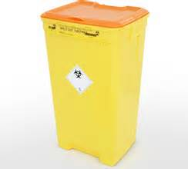  Burn Bin | Infectious Clinical Waste | Infectious or potentially infectious hard clinical waste contaminated with blood / bodily fluids. NO free liquids. Free liquids should be sealed in a screw cap container and then placed in burn bin.  Laboratory and histology waste | Steam Sterilisation Process (alternative treatment) | HT
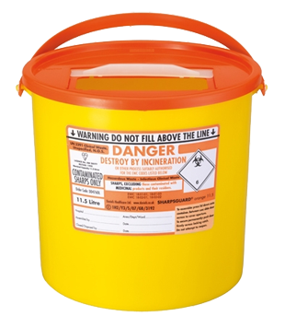  Sharps Container | Infectious Clinical Waste | Sharps (hypodermic needles, attached syringe bodies, etc.) which may be contaminated with potentially infectious body fluids and discharges medicinal syringes. Non-contaminated sharps.  Contaminated slides, stitch cutters, guide wires, trocars and razors  Blood stained or contaminated glass or any other contaminated item likely to puncture a bag | Steam Sterilisation Process (alternative treatment) | HT
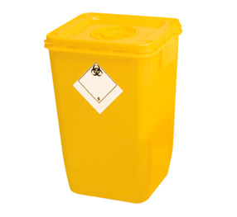  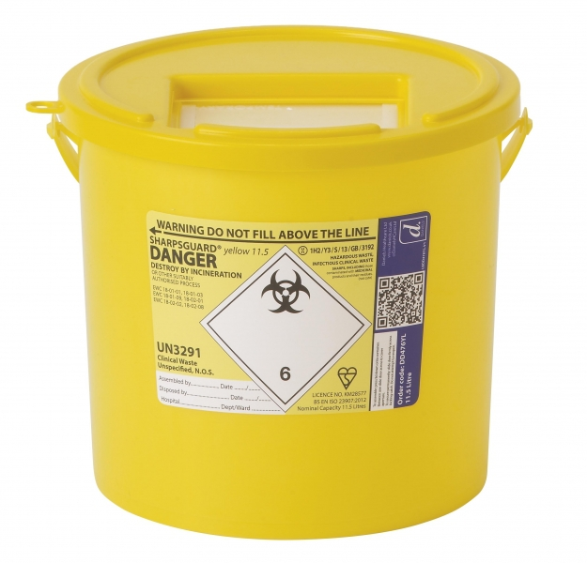 | Infectious Clinical Waste | Laboratory waste or anything else not suitable for heat treatment  Including waste from harmful & corrosive but NOT TOXIC chemicals eg. GUANIDINE THIOCYANATE  NO SHARPS IN BURN BINS  Waste containing Hazard group 4 pathogens or CJD  Non-autoclaved Risk group 2 and 3 laboratory cultures  Large or bulk metallic objects | Incineration Only | HI
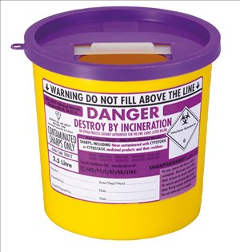 | Cytotoxic / Cytostatic Waste | Needles, syringes, sharp instruments, cartridges and broken glass used in the administration of cytotoxic/cytostatic and vaccine drugs  Cytotoxic sharps & ETHIDIUM BROMIDE GELS; plasticware contaminated with PHENOL, CHLOROFORM, TRIZOL or FORMAMIDE | High Temperature Incineration | HY
Container Type | Type of Waste | Suitable for | Treatment | Code
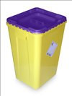 | Cytotoxic / Cytostatic Waste | Containment of non-sharps cytotoxic/cytostatic and vaccine waste, including cover-protected sharps or sharps tips. NO free liquids. Free liquids should be sealed in a screw cap container and then placed in burn bin.  ETHIDIUM BROMIDE GELS  Left-over cytotoxic drug preparations | High Temperature Incineration | HY
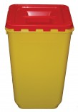 | Anatomical Waste | Infectious healthcare anatomical waste  Containment of recognisable anatomical waste or body parts | Incineration Only | HA
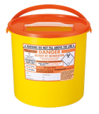 | Anatomical Waste | Human Tissue Act (HTA) related human tissue  Human Tissue Act (HTA) related blood  Human Tissue Act (HTA) contaminated sharps (must be in a sealed orange lidded sharps bin and then placed inside red lidded burn bin and sealed) | Incineration Only | HTA relevant material
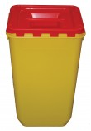 | Animal  Anatomical Waste | Infectious veterinary anatomical waste – non recognisable animal waste or body parts | Incineration Only | VA
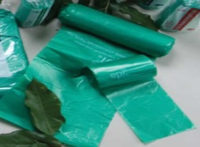  Green Freezer Bag | Animal Anatomical Waste | Animal anatomical waste which is likely to undergo putrefaction  Recognisable animal body parts only – no tissues  Bags should be placed in the bins (WITHOUT LID) in the clinical waste room freezer and the waste log book completed. | Incineration only | VA

ALL CLINICAL WASTE BINS MUST HAVE THE FOLLOWING:

- Correct Lid Colour
- Correct lettering in large letters at side of bin – should be either HT, HI, HY or HA, HTA, VA.ng in large letters at side of bin
- The name of the person filling the bin
- Location of the lab where the waste has come from ie. Building & Lab No. (eg. SoBS 02.031)

Please note that from now on the contractor WILL NOT collect waste which has been incorrectly labelled with the wrong colour lid or bins that have not been securely closed.

The clinical waste log book, kept in the clinical waste storeroom (LG 066), must be completed when leaving waste: an example of the details requiring completion is shown below.

WASTE LOG BOOK:

Please enter ALL the following information including the number of containers at each volume. Each container should also be CLEARLY MARKED with waste type e.g. HT, HY etc and the Centre from which it came.

Date: |  | School/Centre: |  | Name:
 | HT | HY | HTA | HI | Green Bags
60L
30L
22L
11.5L
7L
Other………

