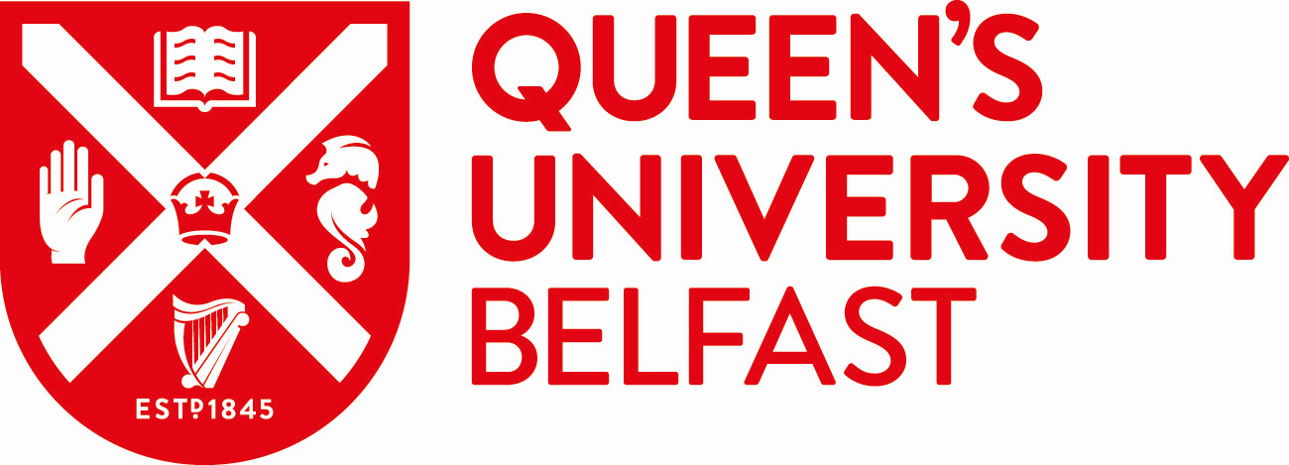 | School of Law

QUB BREXIT PhD RESEARCH STUDENTSHIP

The School of Law is delighted to announce a PhD studentship, funded by the Department for the Economy (DfE). The doctoral research will be focused on the legal implications of Northern Ireland’s hybrid status within both the EU and UK internal markets and external trade policies.
WHAT THE STUDENTSHIP WILL COVER:
- The funded studentship will be £21,000 per year to cover tuition fees and maintenance costs.
To apply, please complete an application form on the Queen’s University Postgraduate Applications Portal including a curriculum vitae (CV) and a research proposal of 1,000 words.
The closing date for applications is Friday 17 January 2020 at 4pm.
Candidates will be notified by 13 March 2020 of the outcome of their application.
Please note you must be in a position to commence your studies on 1 October 2020.
Please insert the code LAW20 into the Funding section within your application form.
ELIGIBILITY
- UK residents: fees plus maintenance.
- Other EU residents: fees only.
- Study can only be undertaken on a full-time basis.
- A first class or 2.1 honours degree in a relevant discipline and have completed or be in the process of completing a Masters, in a relevant discipline, with an average above 60%. Alternatively, a first class honours degree in a relevant discipline and evidence of ability to conduct independent and original research
Please note this studentship is not available to international students.
For further details re eligibility criteria (including academic, citizenship and residency criteria) please click on the DEL Research Eligibility Guidance Notes.

RESEARCH PROJECT
Title: One State, Two Systems: A legal framework for Northern Ireland’s post-Brexit trade regime
Research project:
The aim of the research is to explore the unique place of Northern Ireland (NI) in the context of the United Kingdom’s (UK) and the European Union’s (EU) post-Brexit internal markets and external trade policies.
As part of the Brexit negotiations, the EU and the UK have proposed a Protocol whereby NI will be subject to a specific trading regime with the EU. While the precise legal contours of this agreement have not been defined, this arrangement would de-facto leave NI within the EU customs territory and, in so doing, complicate its place within future UK trade policy.
This gives rise to a series of questions about NI’s trade relations with Great Britain and the rest of the world, seemingly positioning it somewhere between EU and UK trade policy.
The research project would be to explore the legal implications of Northern Ireland’s hybrid status within both the EU and UK internal markets and external trade policies: From an EU-NI trade perspective, research questions include: What cooperative frameworks can be envisaged to ensure that NI is subject to the EU acquis communautaire and able to influence EU decision-making? What is NI’s potential status with respect to EU’s external trade policy? Will NI benefit from preferential treatment negotiated under EU FTAs? From a UK trade policy perspective, research questions include: Are there mechanisms available under international trade law that could be used to ensure frictionless trade between NI and Great Britain? What are the areas of policy overlap between future UK trade agreements and matters falling under the competence of NI? What mechanisms can be envisaged to ensure that NI has a meaningful role in shaping future UK trade agreements?

For more information please contact:
Dr Billy Melo Araujo b.melo-araujo@qub.ac.uk

