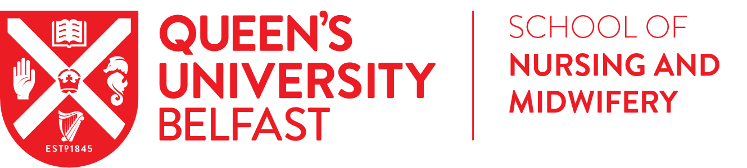

RESEARCH STUDENTSHIP SCHEME
Student Application Form

Overview
A key area of the School’s SWAN Action plan is the promotion of an academic career to students. To address this, we are pleased to announce the launch of the 2021/22 Research Studentship Scheme open to undergraduate students scheduled to graduate this academic year and postgraduate taught (MSc) students to undertake research activities in the School of Nursing and Midwifery. There are five studentship awards available for £1,200 each, providing a stipend of £200 per week for six weeks working on a full-time basis.

An outline of the research projects aligned to each of the studentships, including the title and description of the activity, is available from: http://go.qub.ac.uk/SONMResearchStudentship.

Obtaining the studentship will be a competitive process. The Scheme is open to students:
- Scheduled to graduate from an undergraduate degree programme in December 2021/July 2022 or enrolled on a postgraduate taught programme (MSc) in the School of Nursing and Midwifery, Queen’s University Belfast
- Able to work in the UK i.e. NI/GB/ROI students or EU (non-Irish)/International students with a work permit or settled/pre-settled status
- Available to take up the studentship in accordance with their degree pathway i.e. following completion of all taught elements.

Successful students will work alongside the supervisor(s) to complete the studentship on a full-time basis over six consecutive weeks. We will also consider part time appointments e.g. completion of the studentship on a part-time basis over twelve consecutive weeks. Students will be awarded a stipend of £200 per week (or pro-rata on a part-time basis).

Student Application Process
Interested students are asked to complete the student application form, overleaf, and submit alongside a short one-page CV and a copy of their unofficial academic transcript from their current degree programme.
The short one-page CV must provide details under the following headings:
- Academic achievement
- Work experience
- Research experience/interests

An unofficial copy of a student’s academic transcript can be accessed via Qsis > Self Service > Student Centre.

Student applications will be reviewed at School level by a selection panel nominated by the Head of School comprising of the Head of School, Director of Research and Director of Education, or their nominees. Applicants will be assessed on their:
- Academic profile
- Level of experience
- Fit of research interests to the studentships on offer

The deadline for applications is Tuesday 07 December 2021 at 5pm
Applications must be submitted via email to Dr Fiona Lynn (f.lynn@qub.ac.uk)

Students will be notified of the outcome by 13 December 2021

If you have any queries about the application process or the studentships on offer, please contact Dr Fiona Lynn (f.lynn@qub.ac.uk) or the relevant lead supervisor for the studentship.

STUDENT APPLICATION FORM
Name of student: | Student number:
Programme and year of study:
Registration
- NI/GB/ROI student EU (non-Irish)/International student
If you are registered as an EU (non-Irish)/international student, do you have a work permit or settled/pre-settled status for the UK?
- Yes No
Research studentship*
Please indicate which research studentship(s) is/are of interest to you
- A qualitative evaluation of student nurse perceptions of a digital intervention to improve oral health for older people
- Exploring the place of spirituality in health and social care and its role in improving our teaching approach to equality, diversity and inclusion
- A scoping review of the strengths and limitations of existing faculty development provided to academic and clinical assessors in student assessment
- Equality, diversity and inclusion in bioscience education: how well aligned is the bioscience curriculum for today’s nursing students?
- How is kidney disease and kidney transplantation portrayed on ‘prime-time’ television? A narrative review

*See website for a description of each research studentship: http://go.qub.ac.uk/SONMResearchStudentship

Proposed start date and duration
If successful, when would you be able to commence the studentship?
Date: ____ / ____ / ____
If successful, would you prefer to take up the studentship on a full-time (6 weeks) or part-time (12 weeks) duration?
Full-time Part-time

Please email this completed application form, along with a short one-page CV and academic transcript to Dr Fiona Lynn (f.lynn@qub.ac.uk). The deadline for applications is 07 December 2021 at 5pm.
Checklist
- Student Application Form
- Short one-page CV
- Academic Transcript

