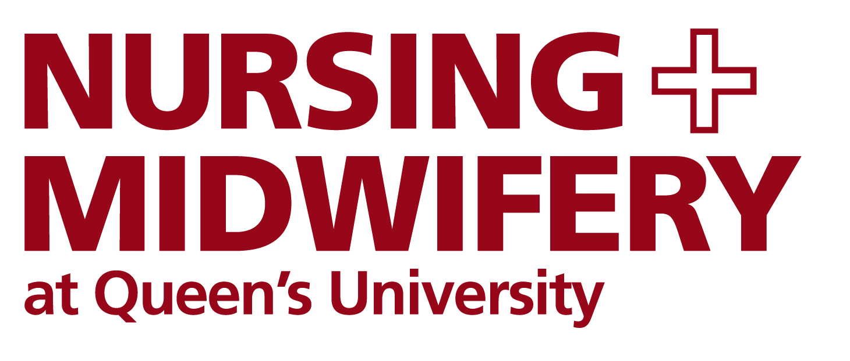

.



The School of Nursing and Midwifery
Application Form

The Patricia Napier Award

The School of Nursing and Midwifery at Queen’s is delighted to be able to offer a full-fees scholarship for Nursing or Midwifery graduates undertaking the following PGT programmes:

- Masters in Advanced Professional Practice
- PG Diploma Cognitive Behavioural Psychotherapy
- Masters in Caring for Children and Young People with Complex Health Care Needs

Background:
This scholarship programme was established by Mr Russell Napier in 2011 in recognition of his mother, Mrs Patricia Napier. The scholarship covers tuition fees and registration fee.

Applicants should provide a written statement of not more than 500 words to explain the contribution of PGT study in improving clinical practice and professional competence. Separately, candidates must also apply and be accepted for the relevant programme to start in September 2018. There is more information on how to apply on our website.

The decision will be based on the record of academic achievement and the supporting written statement. Candidates may be asked to attend an interview to discuss their application as part of the selection process.

Please complete all sections of the application. Once completed, please email this application along with any other additional information to Erin Bryson at e.bryson@qub.ac.uk.

Closing date for receipt of completed applications is Friday 15th June 2018 at 4.00pm.

- PERSONAL DETAILS (please complete in block capitals/black ink)

SURNAME | FIRST NAME(S)
TITLE - MR/MRS/MISS/MS | PREVIOUS SURNAME(S)
DATE OF BIRTH | CORRESPONDENCE ADDRESS
NATIONALITY
EMAIL ADDRESS | POSTAL CODE
CONTACT TELEPHONE NUMBERS  HOME:  WORK:  MOBILE: | YOU MUST BE A NURSING OR MIDWIFERY GRADUATE. PLEASE TELL US:  (1) YOUR FIRST YEAR OF ENTRY & UNIVERSITY ATTENDED  (2) YOUR QUB STUDENT CARD NUMBER  (3) COURSE ATTENDED  (4) DEGREE CLASSIFICATION

- Please submit a written statement, not more than 500 words, to describe why you are interested in pursuing the Masters programme. You should explain the difference you expect it will make to your practice or area of expertise, and tell the panel why you should be considered for this scholarship.

3. DECLARATION AND SIGNATURE OF APPLICANT

I confirm that the information given on this form is true, complete and accurate. I accept that if the relevant information is inaccurate or omitted, the University reserves the right to reject my application for funding.

I authorise the University to approach Government Agencies, Educational Establishments, Former Employers and Referees for verification of application details should they be needed, and I consent to the University processing the information in this form for administrative purposes, including consideration of my application in accordance with the provisions of the Data Protection Legislation.

SIGNATURE: |  | DATE:

PLEASE CHECK YOUR APPLICATION CAREFULLY TO ENSURE THAT ALL SECTIONS HAVE BEEN COMPLETED.

You should return your application to the address below by Friday 15th June 2018 by 4.00pm. The Awards and Scholarships Committee will meet to consider the applications and we will inform candidates of their application status in July 2018.

Please return your completed application to Erin Bryson via email at e.bryson@qub.ac.uk. Alternatively, you can post your application to The Registry Office, School of Nursing & Midwifery, Medical Biology Centre, 97 Lisburn Road, Belfast, BT9 7BL

