**Widening Access to Sexual Healthcare & Relationship and Sexuality Education at Hydebank Wood College**

**A Rights Based Approach & Short Impact Report**

**M. Lohan, C. Kelly & M. Templeton, Queen’s University Belfast**

**The Challenges**

Young men in prison are distinguished by profound socio-economic disadvantage and health problems, including higher rates of sexually transmitted infections and blood borne viruses.

Young men in prison have usually lost out on opportunities for relationship and sexuality education (RSE) in schools or in secure home environments.

One in three young men are already fathers many of whom become estranged from their children before or while imprisoned.

Having a father in prison is recognised as a risk factor for the intergenerational continuity of offending behaviour, mental health problems, substance abuse, and lack of education and employment in the next generation.

Up to 2018, prisons in Northern Ireland (NI) had an *ad hoc* consultant led in reach service for mostly symptomatic patients.

**The Actions**

Hydebank Wood College management, South Eastern Trust Sexual Health, Prison Healthcare and Barnardo’s have introduced two initiatives led by Queen’s University Belfast into the College since 2018.

The first was the upskilling of nursing staff to the highest standards of sexual health care and the introduction of a continuous nurse-led sexual healthcare service, along with the co-production with young men in custody of the health promotion materials ‘Dick loves Doot’ (video and leaflets) to inform peers about the service. This work was supported by the Burdett Trust for Nursing.

The second was the introduction of a Relationships and Future Fatherhood Programme entitled *If I were a Dad*, co-designed with young men and Barnardo’s staff in Hydebank Wood and Polmont. Welcoming the initiative at Polmont, Governor **Brenda Stewart** says*, “Offering relationship and sexuality education to men in prisons is truly novel and it makes perfect sense”*. It’s designed as early intervention reaching out to men before they become fathers, while also enhancing programmes for men who are already fathers in prisons. This work was supported by the Medical Research Council [grant number: MR/RO14450/1].

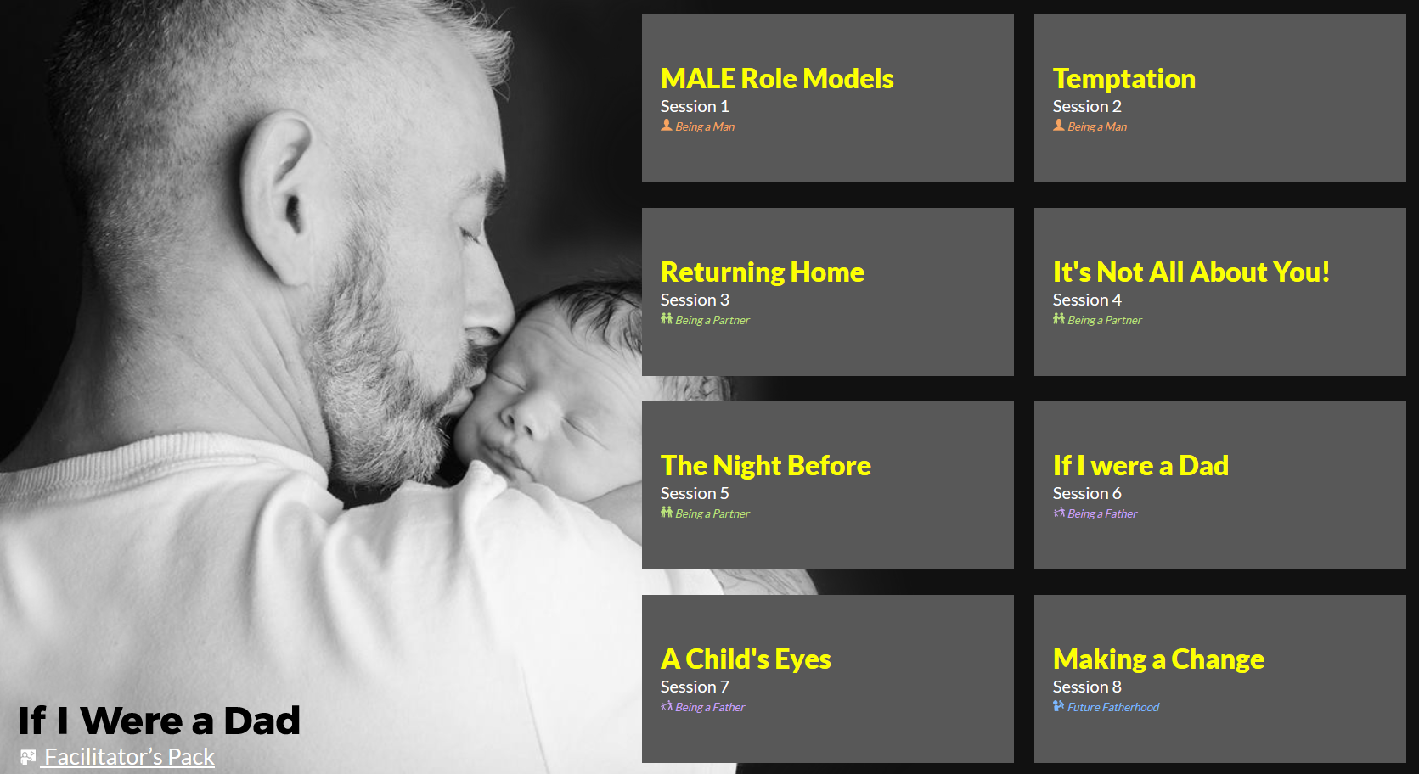

**The Impact**

The Continuous nurse-led sexual health service, one of the first of its kind in the UK, is up and running in all prisons in NI. A case note audit of 171 patients seen in the prison service during the first six-month period, measured care against key performance indicators set by the British Association of Sexual Health & HIV (BASHH), showed 90% of Chlamydia (CT) positive patients received treatment within 14 days, 94% received an HIV test and partner notification was documented as completed in 90% of CT positive patients.[1] Earlier detection results in earlier treatment and better prevention.

The award winning[2] health promotion ‘Dick loves Doot’ is a source of pride for the five men who co-designed it and a source of information for others (see notice boards and video in health clinic).

Co-design students: *“It’s short and its funny as well, that’s the way you need it”.*

“*It was good to hear what the other boys, obviously, thought and all. And obviously get my opinion across. It was good to have a discussion about it”*

*If I were a Dad* was successfully piloted and is currently being delivered by Barnardo’s in Hydebank and Polmont to 5-6 men in an 8-10 week programme on a rolling basis over the year (since October 2019). The programme uses videos, scripted with the young men in Hydebank, to promote identification and points of change – in relation to *being a man*, *being a partner* and *being a father*.

Participants, Hydebank Wood:

“*we had a laugh and did get to talk about things we would never before with each other”*

*“It’s very interesting, come and find out for yourself”*

Participant, Polmont: “*I think this was the first thing I’ve done about being a dad. So, it’s opened my eyes a bit”.*

**Stevie Mann**Head of Student Development Unit at Hydebank Wood College: “*Many of our guys have often dropped out of school so motivation to learn and programmes they can relate to is key to making a difference in their lives. By involving the young men from the start in developing the programme, I’m sure Queen’s, their Scottish partners and Barnardo’s will achieve that”.* **Gary Milling** Governor at Hydebank Wood College, said “*Relationships are key to rehabilitation”.*

1. Kelly et al (under review) Design and piloting of nurse-led sexual health services in prisons and six-month follow-up data. Journal of Clinical Nursing.
2. The 2018 Trust’s Chairman’s Award, for ‘Helping you to stay healthy and well’ and two Chartered Institute for Public Relations (CIPR) NI PRide Awards for best ‘Health Campaign’ and ‘Best Use of Content’