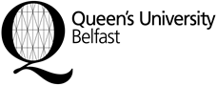
Des and Angela Clarke Summer Studentship
Application Form
Notes:
- Completed applications must be submitted either electronically or hard copy to:
School of Pharmacy
School Manager
MBC, 97 Lisburn Road
Belfast, BT9 7BL
pharmacyinfo@qub.ac.ik

- Closing date for applications is 5pm on Monday 12 June 2017

- Applicants should also attach a Curriculum Vitae

- Applications must be signed by the student

- Eligibility criteria: Level 2 or 3 students currently enrolled on an undergraduate programme in the School of Pharmacy.

Student Name

School and UG degree programme

Student Number

Student email

Date degree course commenced

Student signature

Date

Personal Statement (total word count maximum 500 words)

- Outline why you would like to be considered for the Des Clarke Scholarship

- Outline your career aspirations

- Outline your research experience to date

