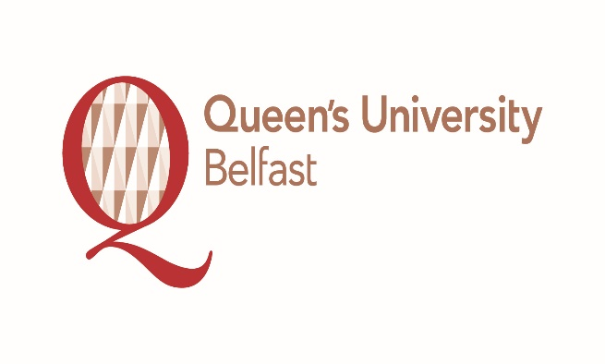
SCHOOL OF PHARMACY
Minutes
A meeting of the
SWAN SAT Team
Monday 22nd May 2017

Present: Dr Deirdre Gilpin (Chair)
Dr Jonathon Coulter (Vice-Chair)
Professor Carmel Hughes (Head of School Pharmacy)
Dr Heather Anderson (School of Pharmacy Manager)
Professor Karl Malcolm
Dr Maurice Hall
Dr Lezley-Anne Hanna
Dr Maeliosa McCrudden
Dr Cian McCrudden
Dr Mei Zhou
Aine McGuckin (Technician Representative)
Lee – Anne Howell (Clerical Officer Representative)
Emma McErlean (PGR and UG Representative)

Apologies: Professor Ryan Donnelly
Professor Michael Tunney

In attendance: Mr Gervase McGivern

- Updates from Faculty and SWAN champion meetings

1.1 After welcoming and thanking everybody for attending Dr D Gilpin informed the team that the School of Mathematics and Physics and School of Nursing and Midwifery were both successful in their recent submissions for the Athena SWAN Silver Award. Dr Gilpin stated that with regards to submissions it is the view of Athena SWAN that less is more with simple headline data.
1.2 There are Athena SWAN representatives on the newly formed Faculty Recruitment and Work Allocation Models WAM working groups informed Dr Gilpin.
The Faculty WAM is currently only applicable to Academic Staff and is due on September 17th confirmed Dr Gilpin.
1.3 As part of the Faculty group a job specification has been drafted for the position of a Data Analysist. Dr Gilpin informed the team that this is currently ongoing with HR and emphasised that it would be useful to have this position filled as it can be difficult to benchmark data across Schools. In the interim a summer student internship is being advertised on the University’s My Future website to fill the position.
Currently the Faculty SWAN group is considering a potential budget for all Schools in the Faculty.
Dr M McCrudden informed the team that Professor Aaron Maule Head of the School of Biological Sciences and a member of their SAT Team advised the Faculty of Medicines and Health Sciences Post – Doctoral Society to contact Athena SWAN for potential funding towards Post - Doctoral events as such events would provide an opportunity to carry out surveys on the male/female split in the Post – Doctoral community.
2 Update on action plan and November submission
2.1 Dr L A Hanna and Dr Gilpin agreed that it would a good idea to announce to the School of Pharmacy Board Meeting on May 31st that the Athena SWAN Staff Survey will be emailed out in the coming weeks and it would be really helpful if staff took time to complete.
2.2 The current status of the previous action plan is that most of the actions are at a more advanced stage and based on the traffic light system a lot of the criteria that was at red is now at the amber and green stage confirmed Dr Gilpin.
Dr Gilpin confirmed that the School of Pharmacy was applying to renew its Silver Athena Swan status.
2.3 With regards to mentoring Dr Gilpin advised that a lot of Schools only have mentoring programmes in place for staff who are on probation. As a result Professor M Tunney is looking at the possibility of having a mentoring programme beyond probation.
Dr Gilpin revealed that there is a concern that TEQs may be biased against female teaching staff. Professor K Malcolm asked is there data to back this up as the School of Pharmacy female teaching staff are very good and where does the bias lie for example in the form of questions being asked or in the cohort of students being asked.
Professor C Hughes agreed with Professor Malcolm with regards to the quality of teaching students received from female teaching staff in the School and this is reflected in the recent University Teaching Awards.
Dr H Anderson informed the team that with regards to bias in TEQs against female teaching staff this is an issue outside the School of Pharmacy.
Dr Gilpin emphasised the importance of being no bias in TEQs and to consider when students are being asked to complete TEQs.
Dr J Coulter believed that with regards to TEQs in the School of Pharmacy good practice was in place and Dr Gilpin agreed with this view.
Dr M Hall stated that he thought the University and College Union (UCU) issued a statement previously regarding this subject. Dr Hall also said that it would be interesting to see the gender breakdown in Schools that have problems and issues.
With regards to finding a suitable breastfeeding/quiet room Dr Gilpin informed that Faculty is having problems finding an appropriately sized room but hopefully this will be resolved.
2.4 There is E&D training on welcome week for Queen’s University Belfast under graduate students confirmed Dr Anderson.
Dr Gilpin stated that it is important to have Athena SWAN mentioned in induction packs for new staff to raise its profile. It is hoped that with the appointment of the new Director of Human Resources Athena SWAN will receive more prominence in recruitment and induction.
Dr Anderson informed the team that staff induction will be part of the new PA for the Head of School remit.
2.5 Professor Hughes informed attendees that the Head of the School of Pharmacy at the University of Manchester Professor K Marshall had expressed the idea of having a SWAN champions event amongst PhSC schools. Dr Anderson suggested that the School of Pharmacy at Queen’s can take the lead on this and organise an event for SWAN champions across other Universities.
3 SWAN Website
3.1 Dr Gilpin congratulated L-A Howell and Dr M McCrudden on the new School of Pharmacy Athena SWAN website and asked the team that if they had any pictures or useful information that could be added to the website this would be very helpful. Dr Coulter supported Dr Gilpin’s request.
Professor Hughes asked L- A Howell to upload the School of Pharmacy Newsletter on to the Athena SWAN website.
4 Data request from Louise
4.1 Dr Gilpin asked the team to please respond to Louise McDonald the Faculty of Medicine, Health and Life Sciences Athena SWAN Co-ordinator email with regards to data collection for the School of Pharmacy’s next Athena SWAN Application later this year. Dr Coulter suggested that this request should also be made at the 31st May meeting of the School Board.

5 AOB
5.1 A McGuckin sought confirmation that she could proceed with asking technicians their views on Athena SWAN which Dr Gilpin confirmed.
5.2 Dr Anderson asked the group if there are plans for a School of Pharmacy social event. Dr Gilpin informed that this will likely be in September with the possibility of a colour run taking place in the Dub playing fields followed by a BBQ with proceeds going to a mental health charity. Dr M McCrudden advised that if families were to be invited then childcare may be an issue for some staff.
5.3 Dr M Zhou asked would it be possible for toilets in the School to be converted to unisex as this would shorten waiting times for students during lectures. Dr Gilpin informed Dr Zhou that the Estates Department were looking into this as well as finding a suitable room for baby changing in the MBC complex.
Dr Zhou suggested that this be included in the Athena SWAN Application and Dr Gilpin agreed.
5.4 Professor Hughes suggested that some of the team meet in June with regards to the application.

