School of Pharmacy Summer Studentships

The School of Pharmacy is offering two funded Summer Studentships which will provide students with an excellent opportunity to undertake a research project in one of our research groups.
Students will be paid a student stipend of £200 per week for a specified 8-week period during the summer and will work Monday to Friday on a full-time basis.
Applications are welcome from Queen's students in the 2nd or 3rd year of their degree in a relevant discipline such as Pharmacy, Medicine, Dentistry, Biomedical/Biological Sciences.
In addition to the two projects funded by the School, externally funded summer studentships may also be available. Students apply, together with a supervisor of their choice, to one of a number of external funding bodies. Success is dependent upon the quality of the proposed project, but also upon University examination results obtained to date.

Academic staff in the School have proposed a number of different projects listed below. If you are interested in any of these projects, can you please e-mail Mrs Sinead McCullough (sinead.mccullough@qub.ac.uk) by 5pm Monday 3rd February 2020, indicating your 1st, 2nd and 3rd choice projects. The top two ranked candidates, based on academic performance to date, will be awarded the School-funded Studentships. Additional candidates will be allocated to remaining projects and will work with academic staff to submit an application to an external funding body.

Peptide hydrogels as sustained release injectable drug delivery implants for HIV prevention

Description:
Patients struggle to adhere to the complex regimens of HIV/AIDs therapies. This project aims to test an innovative technology, composed of peptides which form tissue-like hydrogels, to provide long-acting preventative therapy for HIV/AIDs. We will use these peptides to create a soluble subcutaneous injection that will form a long-acting drug releasing hydrogel implant, in response to enzymes present under the skin. This will allow antiretroviral drugs to be released gradually over 28 days. This project will allow the student to undertake simple chemical synthesis, structural analysis (e.g. microscopy) and drug release studies within the Laverty group.

Supervisors: Dr Garry Laverty
Email: garry.laverty@qub.ac.uk

Microneedle delivery of the anti-psychotic medicine haloperidol decanoate.
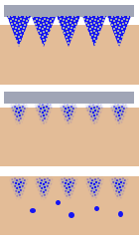

Description:
In this project, the student will use tiny arrays of needles, termed microneedles, to deliver the anti-psychotic medicine, haloperidol decanoate, across the skin. Dissolving microneedle arrays penetrate the stratum corneum and can deposit medicines in the tissues just below the skin surface. Haloperidol decanoate can be given as a depot intramuscular injection which provides slow and sustained release of the active haloperidol, for up to 1 month. However, this is associated with significant pain and discomfort for the patient. Microneedle-mediated transdermal delivery of haloperidol decanoate is an alternative that could provide the opportunity for patients to painlessly self-apply a patch, instead of receiving a painful oily injection. The microneedles penetrate the outer layers of the skin and facilitate delivery of a bolus dose of haloperidol decanoate. Esterases present in the blood can hydrolyse haloperidol decanoate, releasing the active haloperidol into the systemic circulation, where it can have a therapeutic effect. The aim of the project will be to design and optimise a dissolving microneedle array for the delivery of haloperidol decanoate, using laboratory based analytical techniques and approved tests for needle insertion and drug permeation.

Supervisor: Professor Ryan Donnelly
Room M108
Email: r.donnelly@qub.ac.uk
Hydrogel-forming microneedles for periodontal bio-sensing

Description:
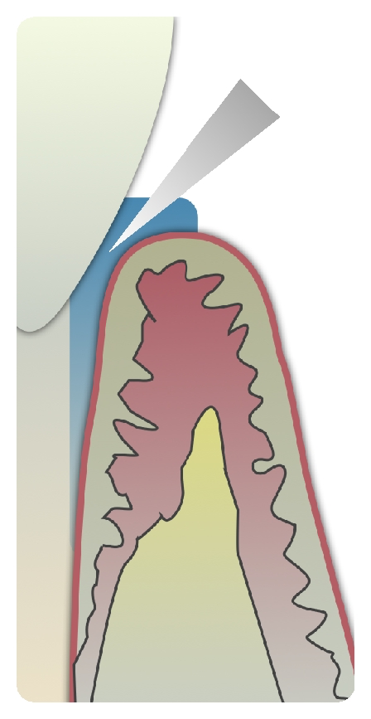
In this project, the student will design a hydrogel-forming microneedle platform to gain access to the small volumes of fluid found between teeth and gums, in order to monitor and screen for periodontal disease related biomarkers. Periodontal disease is a common dental condition affecting the gum structures and ligaments around the teeth that can result in gingivitis, bleeding gums, and tooth loss. The small natural pockets that exist between teeth and gums, termed the gingival sulci, hold tiny volumes of fluid. Hydrogel-forming microneedles could provide an oppourtunity to gain access to this gingival crevicular fluid and allow painless sample acquisition for biomolecular monitoring. Monitoring of disease related biomarkers could allow early detection of periodontal disease and bone degeneration preventing severe morbidity and distress for many patients. The aim of the project will be to select and optimise the most appropriate microneedle design and formulation for fluid sampling from the gingival sulcus.

Supervisor: Professor Ryan Donnelly
Room M108
Email: r.donnelly@qub.ac.uk

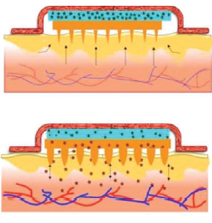
Oxytocin delivery using a microarray patch for postpartum haemorrhage

Description:

In this project, the student will use tiny arrays of polymeric projections, termed microneedles, to deliver the hormone oxytocin across the skin. Oxytocin is recommended as the gold-standard treatment for postpartum haemorrhage (PPH). However, it must currently be given by injection and requires cold storage to prevent degradation, meaning that in low-income countries it is often not available. Because of this PPH is the leading cause of maternal mortality in many low-income countries. Transdermal delivery of oxytocin using hydrogel microneedles would offer a safe, painless method of administration. Once inserted in to the skin hydrogel microneedles take up interstitial fluid and swell, creating a continuous network through which large molecules, such as hormones, can permeate to the systemic circulation. Furthermore, formulation of oxytocin for a microarray patch could increase its heat-stability, meaning it would not need cold storage. The aim of this project will be to design and optimise a microarray patch for the delivery of therapeutic levels of oxytocin across the skin.

Supervisor: Professor Ryan Donnelly
Room M108
Email: r.donnelly@qub.ac.uk

Development of a new high-throughput method for isolation of bacteriophages against human pathogens

Description:

Phage therapy – the targeted application of a mixture of bacterial viruses (bacteriophages) that can infect and kill specific pathogenic bacteria – is currently viewed as one of the most attractive experimental alternatives to antibiotic treatment. The identification of phages demonstrating a broad host range spectrum is highly desirable. The existing methods of bacteriophage host range determination are laborious, wasteful, and time-consuming. This project offers an opportunity to participate in the development and optimisation of a new high-throughput method for identification of phages demonstrating extended host range.

Supervisor: Dr Timofey Skvortsov
Email: t.skvortsov@qub.ac.uk

Isolation of bacteriophages against major UTI-associated bacterial pathogens
Description:

Phage therapy rapidly becoming a viable therapeutic option for treatment of infections caused by multidrug-resistant bacteria. This project will focus on isolation and characterisation of novel bacteriophages from natural sources and investigation of their activity (either alone or in combination with antibiotics) against selected pathogenic bacteria representative of urinary tract infections, such as Proteus mirabilis.

Supervisor: Dr Timofey Skvortsov
Email: t.skvortsov@qub.ac.uk

3D printing of anti-infective implantable devices for cardiovascular applications

Description:

Cardiovascular disease is the leading cause of death worldwide. Common disorders are associated with the stenosis or occlusion of blood vessels. Vascular grafting is a surgical technique used to bridge occluded blood vessels to restore blood flow. Accordingly, there is a growing demand to develop synthetic vascular grafts. 3D printing can be used to prepare vascular grafts adapted to patients needs incorporating drug substances such as antimicrobial agents or antiplatelet drug. This approach can be used to prevent the infection of vascular grafts, devastating complication leading to high patient mortality. This project will explore the use of 3D printing to prepare drug eluting vascular grafts.

Supervisors: Dr. Eneko Larrañeta and Dr. Dimitrios Lamprou
Email: e.larraneta@qub.ac.uk

Laser-surface modification of orthopaedic prostheses for the prevention of implant associated-infection.

Description:

This project will be building on previous work that we have conducted in collaboration with the School of Mechanical and Aerospace engineering, using laser technology to modify the surface of titanium alloys. We have found that these surfaces are antimicrobial, and this is likely to be due to changes in surface topography, specifically “nano-spikes” which can damage the bacterial cell. The summer project will focus on screening materials with optimised and refined surface properties, to identify lead materials for further development as medical devices.

Supervisor: Dr Louise Carson
Email l.carson@qub.ac.uk

Development of nanocomposite materials for medical devices

Description:

This project will involve the development of novel nanocomposites – polymeric biomaterials incorporating titanium oxide and/or titanium nitride nanoparticles, both of which are antimicrobial. The nanocomposite materials will be screened against a library of bacterial species to investigate their ability to resist bacterial adherence and biofilm formation, and potential as antimicrobial materials for wound management applications.

Supervisor: Dr Louise Carson
Email l.carson@qub.ac.uk

Effect of E-cigarettes on bacterial lung pathogens

Description:
E-cigarette use is increasing world-wide, as people become more aware of the dangers of smoking. This project will investigate (i) the effect of e-cigarette vapour on lung bacteria, in order to determine whether bacteria become more resistant to antibiotics and (ii) the role of vape exposure in increasing bacterial induced inflammation in lung epithelial cells, and whether this increases the potential of lung cells to develop cancer-associated markers.

Supervisors: Dr D. Gilpin & Prof. M. Tunney
Email: d.f.gilpin@qub.ac.uk

Robust antibacterial coatings for prevention of medical device-associated infections

Description:

Biomaterials perform a host of life-saving and life-enhancing roles when employed as medical devices within the body. Their susceptibility to bacterial colonisation, however, often leads to infection, complicating the care of patients and causing much morbidity, potential mortality and increased healthcare costs. The proposed project is based on the development of robust antibacterial coating technologies for medical devices to prevent associated issues of pain, tissue trauma and infection. Skills will be developed in a range of techniques including formulation, microbiological assessments and physicochemical characterisation.

Supervisors: Dr. Nicola Irwin
Email: n.irwin@qub.ac.uk

