PGR Studentship Information Template 2021 entry

- Please complete the template with as much information as possible.
- *fields are essential.
- If you have information that does not have a label, please create a new row in the table for it.

*Title of studentship | Electrospun Nanofibers for the Delivery of Biopharmaceuticals
Value / what is covered?
Awarding body
Number of studentships
*Summary descriptive text / Example of research project | Aims and objectives  The aim of this project is to investigate the use of both solution and melt based electrospinning methods for the manufacture of oral films and scaffolds for wound healing by incorporating biologic drugs (e.g. SiRNA).  Rationale  Biopharmaceutical formulations are more stable in the solid state than in liquid form. Currently, the pharmaceutical industry is typically applying freeze-drying and spray-drying processes in order to obtain solid biopharmaceuticals, however, both technologies have disadvantages.  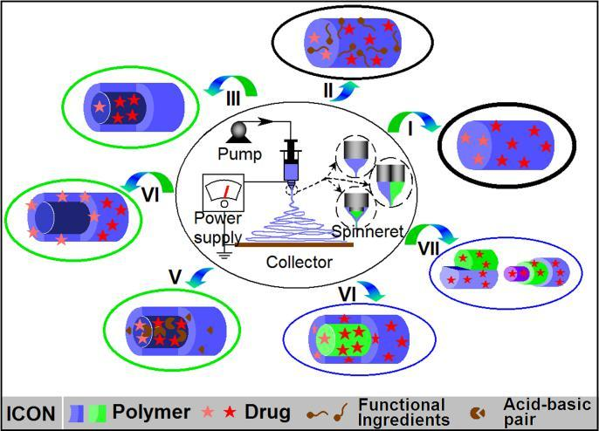  Figure 1. Mechanism of electrospinning and various structures of electrospun products  Electrospinning (as illustrated in Figure 1) is a unique and versatile technique that depends on the electrostatic repulsion between surface charges to constantly draw nanofibers from viscoelastic fluids and has been used to manufacture nanofibers for various applications. Advantages of this novel technique include extremely rapid drying speeds, ease of implementation, compatibility with a wide range of active ingredients (including those which are thermally labile), and the generation of nanofibrous products with large surface areas and high porosity, well controlled spatial distribution of components and concomitantly improved/programmable drug release profiles [1]. The manufacturing of nanofibers for a variety of drug delivery and tissue engineering applications includes oral films, mesh implants, and scaffolds for wound healing [2-5]. As illustrated with the development of amorphous sold dispersions in Figure 2, there are two models of electrospinning, melt and fluid/solution.  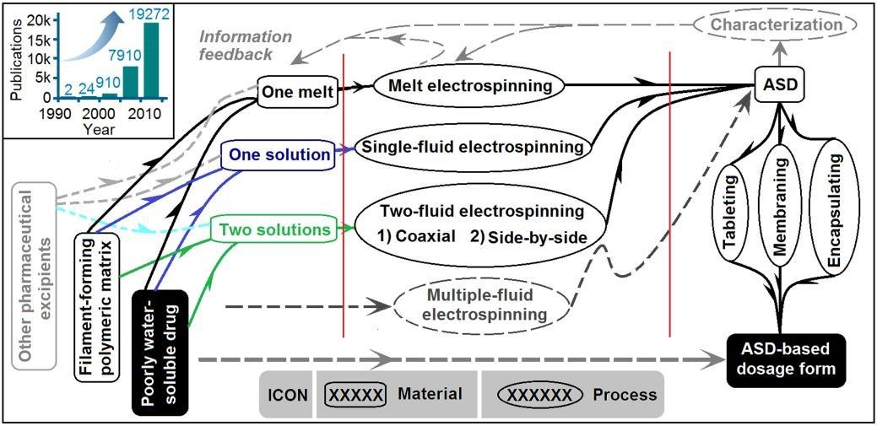  Figure 2. Melting vs Fluid electrospinning methods [1]  To our knowledge, however, comparisons between solution/fluid and melt modes of electrospinning technology as a means of formulating biopharmaceuticals has not been well explored. Our facility in QUB hosts four electrospinning systems, covering both solution and melt approaches. Hence, the proposed project will systemically compare these two methods through investigating a range of electrospun parameters and biodegradable polymers with a model biopharmaceutical system.
*Supervisor(s) | Dr Min Zhao, Dr Dimitrios Lamprou
Project outline | Month 1-3:  Literature searching. Screening of drug and excipient candidates.  More specifically:  - Screening several therapeutic classes to list the most common excipient combinations for licensed biological products  - Screening the required specific tests for biologics in pharmacopeia and regulatory guidance documents (EMA, ICH, MHRA, WHO)  - Defining an excipient mixture appropriate for electrospinning and for the use with biologics.  Introduction to electrospinning and analytical approaches (see main techniques involved below). Training provided.  Month 4-6:  Studies on raw drugs and excipients (biodegradable polymers etc).  Get familiar with all techniques.  Month 7-12:  Focus on the electrospun formulations using the solution electrospinning method for completing QUB upgrade viva. These will be achieved by optimising formulation composition (most importantly polymer screening) and processing parameters with a final view to establishing an effective formulation platform using the solution based electrospinning technology.  Month 13-15:  Preparing suitable final electrospun dosage forms with the most promising formulation and evaluating the in vitro drug release performance.  Month 16-19:  Exploring the melt electrospinning process and performing comparison between the two methods, solution and melt to better understand the mechanisms under which the expected performance of electrospun formulations were obtained respectively.  Month 20-24:  A ‘bridging’ research on establishing the relationship between the formulation composition, the processing variants and the structure and performance of nanofibers using melt or solution electrospinning.  Month 25-30:  6 months stability test on the most promising final product(s);  Cell culture (cytotoxicity) and antimicrobial studies may also be carried out depending on the nature of the most promising product.  Month 31-36:  Wrap-up experiments and thesis writing.
*Eligibility / residence Status | Student eligibility criteria for DfE-funded studentships can be accessed here.  No eligibility limitation for self-funded students.
Country
*Start date and duration | The PhD project is expected to commence in Sep/Oct 2021 for three years.
*Faculty | MHLS
*Research centre / School | School of Pharmacy
Subject area
Candidate requirements / Key skills required for the post | Applicants should have a 1st or 2.1 honours degree (or equivalent) in a relevant subject. Relevant subjects include Pharmacy, Molecular Biology, Pharmaceutical Sciences, Biochemistry, Biological/Biomedical Sciences, Chemistry, Engineering, or a closely related discipline. Students who have a 2.2 honours degree and a Master’s degree may also be considered, but the School reserves the right to shortlist for interview only those applicants who have demonstrated high academic attainment to date
*Deadline for applications | 31/05/2021
*How to apply / contacts | Postgraduate Research applicants for Pharmacy who are interested in applying for a fully funded DFE studentship must have applied to Queen’s, via the Direct Applications Portal, and submitted all required supporting documents by the closing date, which will be announced later in the Academic year.  https://dap.qub.ac.uk/portal/user/u_login.php
Relevant links / more information | http://www.qub.ac.uk/schools/SchoolofPharmacy/Research/PostgraduatePositions/  http://www.qub.ac.uk/schools/SchoolofPharmacy/Research/
Keywords for search filters | Electrospinning; nanofibers; biopharma ceuticals
Training provided through the research project | - Training on main techniques required  - Electrospinning (solution & melt) have been widely researched within the scientific field, and in particular within the creation of drug delivery systems (DDSs). The process fundamentally involves applying electric charges across a metallic needle that contains a polymeric solution or solid for melt-electrospinning. The type of drugs being studied range from levofloxacin to dexamethasone. Both melt and solution electrospinning methods will be investigated in this project.  - Thermal analysis include differential scanning calorimetry (DSC) and thermal gravimetric analysis (TGA) which are among the most common techniques. In addition, localised-thermal analysis which has been applied in our previous studies [6-7] will also be applied for understanding the local physical structure of the electrospun nanofibers especially the spatial distribution of drug within such systems. Specifically, LTA is a technique that allows the measurement of thermal transitions of specific regions on a sample surface by replacing the conventional probe of AFM with a thermal probe hence its feature combines the high resolution of AFM with the capacity of characterizing the surface of samples.  - Imaging techniques such as Scanning Electron Microscope (SEM) and Atomic Force Microscope (AFM) will be used to understand the morphologies.  - Spectroscopic techniques that will be used in this project include near-infrared (NIR) and mid-infrared (ATR-FTIR) and Raman Microscopy.  - Rheometer and dynamic mechanical analysis (DMA) will be used to understand the rheological and mechanical properties of the formulations before and after electrospinning.  - Contact Angle Goniometry (CAG) will be used to investigate the hydrophobicity/hydrophilicity of the electrospun formulations.  - Facilities for assessing in vitro drug release, cytotoxicity, antimicrobial activity as well as stability (Climate Chamber) performance.  - Training on expertise required  - Clinical evaluation of biological formulations.  - Electrospinning technology and physicochemical characterisation  - Pharmaceutical performance evaluation of the final drug delivery systems.
Expected impact activities | Following key findings are expected with the development of project:  - Electrospinning show potential for formulating challenging biological formulations with different properties.  - A preferable approach is identified between solution and melt based electrospinning.  - A most functional excipient/mix is identified among all studied.  - A better understanding is achieved on the relationship between formulation composition, processing method and associated parameters and performance of both the intermediate (e.g. nanofibers) and final products.  - An innovative electrospun system containing biological formulations is recommended for further clinical studies as oral films or for wound healing.

