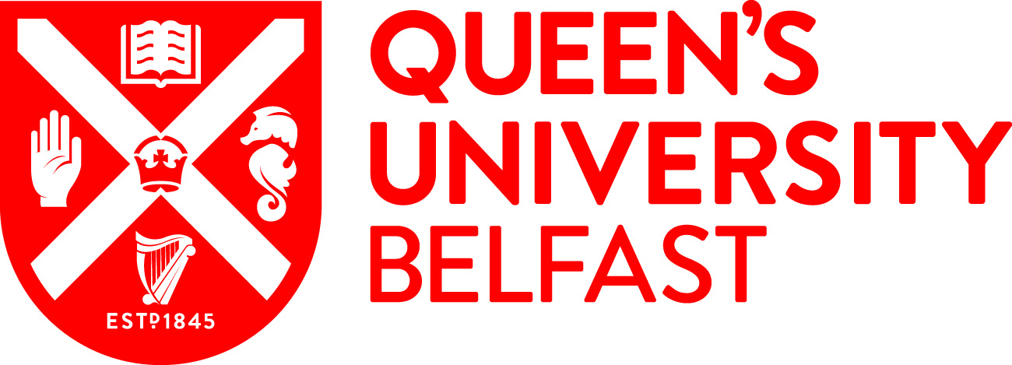

|  |  |
| --- | --- |
| **\*Title of studentship** | Lipid-based implants for sustained protein release |
| **Value / what is covered?** |  |
| **Awarding body** |  |
| **Number of studentships** | 1 |
| **\*Summary descriptive text / Example of research project** | Protein-based therapeutics are an important class of medicine with significant value for the treatment of many relevant disorders such as cancers, inflammation, and exposure to infectious diseases. Despite their advantages, proteins are limited by short biological half-lives and typically require frequent dosing via injection. This can lead to reduced patient compliance and increased potential for side-effects, hampering therapeutic efficacy. Providing sustained protein release is therefore key to efficient and safe therapy. However, developing drug delivery systems which ensure long-term protein release and stability remains a significant challenge.  The proposed PhD project will focus on developing lipid-based implants via melt processing for sustained protein release. Lipid-based systems are biodegradable, biocompatible and have been successfully used to demonstrate controlled protein release. Melt processing is a versatile manufacturing technology and a promising encapsulation method for biomacromolecules. The scientific approach of this project is to develop protein-encapsulated lipid-implants for sustained release while maintaining protein structural stability and bioactivity. To do so, the impact of melt processing on protein release and stability of the protein drug will be investigated. Protein stability will be safeguarded via covalent and non-covalent polymer-based strategies (e.g., PEGylation) and polymorphic changes will be correlated with protein release profiles. The developed lipid-based implants will be characterized and biologically activity evaluated *in vitro* and *in vivo.* The successful candidate will be part of a highly interdisciplinary project and have the opportunity to learn about lipid formulation, protein formulation, bioconjugation, biological testing and continuous manufacturing. |
| **\*Supervisor(s)** | Dr Sheiliza Carmali  Prof. Gavin Andrews |
| **\*Eligibility / residence Status** | UK / EU |
| **Country** | Northern Ireland |
| **\*Start date and duration** | 3 years |
| **\*Faculty** | MHLS |
| **\*Research centre / School** | Pharmacy |
| **Subject area** | pharmaceutics |
| **Candidate requirements / Key skills required for the post** | Applicants should have a 1st or 2.1 honours degree (or equivalent) in a relevant subject. Relevant subjects include Pharmacy, Pharmaceutical Sciences, Biochemistry, Biological/Biomedical Sciences, Chemistry, Engineering, or a closely related discipline. Students who have a 2.2 honours degree and a Master’s degree may also be considered, but the School reserves the right to shortlist for interview only those applicants who have demonstrated high academic attainment to date. |
| **\*Deadline for applications** |  |
| **\*How to apply / contacts** | Postgraduate Research applicants must have applied to Queen’s, via the Direct Applications Portal.  <https://dap.qub.ac.uk/portal/user/u_login.php> |
| **Relevant links / more information** | <http://www.qub.ac.uk/schools/SchoolofPharmacy/Research/PostgraduatePositions/>  <http://www.qub.ac.uk/schools/SchoolofPharmacy/Research/> |
| **Keywords for search filters** | Proteins, biotherapeutics, lipid-based implants, hot-melt extrusion, continuous manufacturing, bioconjugation |
| **Training provided through the research project** | Training will be provided in a range of techniques including protein characterization, lipid-based formulation, hot-melt extrusion technology and performance characterization including *in vitro* bioactivity, drug release and stability assays. The student will also develop generic research skills in scientific writing, literature reviewing, time management and delivery of presentations, nationally and internationally. |
| **Expected impact activities** | The PhD student will be encouraged to engage in a variety of impact activities, disseminate the research project findings through public talks, and participate in QUB showcase events. |