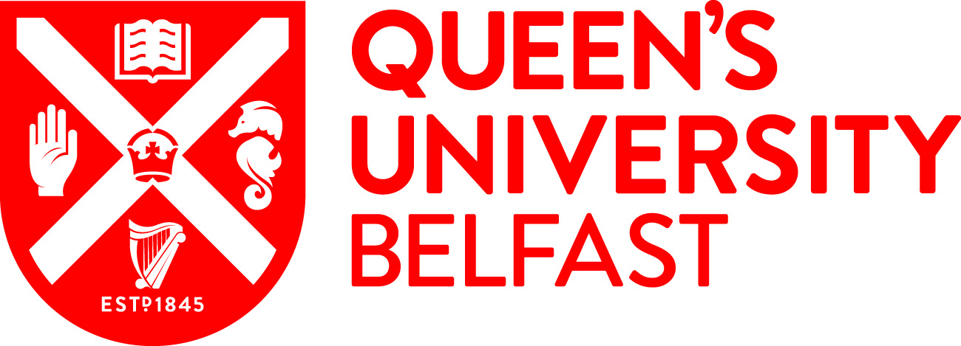
*Title of studentship | Exploration of Amorphous solid dispersion systems with multiple APIs
Value / what is covered? | The successful candidate will receive a fully funded scholarship, which covers home tuition fees and an annual stipend for 3 years, and budget to attend conferences, mini courses & workshops for further development.
Awarding body | Janssen Ph.D. Studentship
Number of studentships | 1
*Summary descriptive text / Example of research project | A number of formulation strategies have been developed to improve the delivery of Biopharmaceutical Classification System (BCS) II and IV class drugs. These, are based on techniques that increase the dissolution rate or to achieve sustained solubilization of the drug. One of the strategies involves the formation of solid dispersions. The term solid dispersions describe a family of dosage forms whereby one or more active ingredients are finely dispersed in a biologically inert solid-state carrier or matrix. Solid dispersions are mostly prepared by melting or the addition of a solvent. The fusion method consists of melting the carrier and drug, whereby the solid dispersion is formed upon cooling of the melt. With the solvent method, the drug and carrier are dissolved in a common organic solvent, followed by removal of the solvent via evaporation. Evidently, there is great interest to produce these (amorphous) solid dispersions via 3D Printing (3DP) techniques. In addition, 3DP could have potential to manufacture different concepts to study long-term stability, or to optimize dosing during clinical studies, or tablet shape during the development phase as it is a fast and flexible method. Our aim is to develop concepts employing multiple active pharmaceutical ingredients (APIs) in the same drug product resulting in novel treatments with controlled release patterns, e.g., combining slow and long-acting drugs.
*Supervisor(s) | Prof Dimitrios Lamprou (https://pure.qub.ac.uk/en/persons/dimitrios-lamprou)  Dr Sune Andersen (Janssen)
*Eligibility / residence Status | UK and Ireland
Country | Northern Ireland
*Start date and duration | 1st October 2022 (36 months)
*Faculty | MHLS
*Research centre / School | Pharmacy
Subject area | 3D Printing, Drug Delivery, Pharmaceutical Technology.
Candidate requirements / Key skills required for the post | Applicants should have a 1st or 2.1 honours degree (or equivalent) in a relevant subject. Relevant subjects include Pharmacy, Pharmaceutical Sciences, Biochemistry, Biological/Biomedical Sciences, Chemistry, Engineering, or a closely related discipline. Students who have a 2.2 honours degree and a Master’s degree may also be considered, but the School reserves the right to shortlist for interview only those applicants who have demonstrated high academic attainment to date. Technical experience and knowledge in some of the following would be desirable: pharmaceutical formulation,
*Deadline for applications | 17th June 2022
*How to apply / contacts | Postgraduate Research applicants must have applied to Queen’s, via the Direct Applications Portal.  https://dap.qub.ac.uk/portal/user/u_login.php
Relevant links / more information | http://www.qub.ac.uk/schools/SchoolofPharmacy/Research/PostgraduatePositions/  http://www.qub.ac.uk/schools/SchoolofPharmacy/Research/
Keywords for search filters | 3D Printing, Drug Delivery, Pharmaceutics
Training provided through the research project | The student will be working in a multi-disciplinary environment in the laboratories of both Prof Lamprou and Janssen.  The experimental programme will include: Preparation and characterisation of various 3D printed systems, physicochemical characterisation, In Vitro Testing, and computational modelling. The techniques that will be used during the project covers a wide-range and include DSC/TGA, FTIR, Raman, SEM, Rheology, UV-Vis, HPLC, release studies, and 3D printing technologies.  Transferrable skill training will also include research management, personal effectiveness, communication skills, networking, team working and career management.  The successful candidate will also spend time to Janssen being exposed to industrial view on drug development, attend conferences, mini courses & workshops for further development.
Expected impact activities | The PhD student would be encouraged to engage in a variety of impact activities, disseminate the research project findings through public talks, and participate in QUB showcase events. Examples of impact activities includes: Blogs or web articles, Magazine articles, Public lectures, School visits, oral & poster Presentations (at local, national and international conferences), and Publication of scientific papers in peer reviewed journals.

