WEBSITE TEMPLATE

1. RESEARCH THEME/s; PRP; GI:
Materials and Advanced Technologies for Healthcare
Pharmaceutical Materials Science and Formulation
Drug Delivery and Biomaterials

2. PI DETAILS (Name, Pure Link, Twitter Handle & Photo)

Prof Dimitrios Lamprou
Pure Link: https://pure.qub.ac.uk/en/persons/dimitrios-lamprou
Lamprou Lab web site: https://www.lamproulab.com/
3D Printing & Bioprinting Lab: https://www.3dprintingbioprintinglab.com/
Lamprou Lab FB: http://www.facebook.com/LamprouLab/
Lamprou Lab Twitter: https://twitter.com/LamprouLab
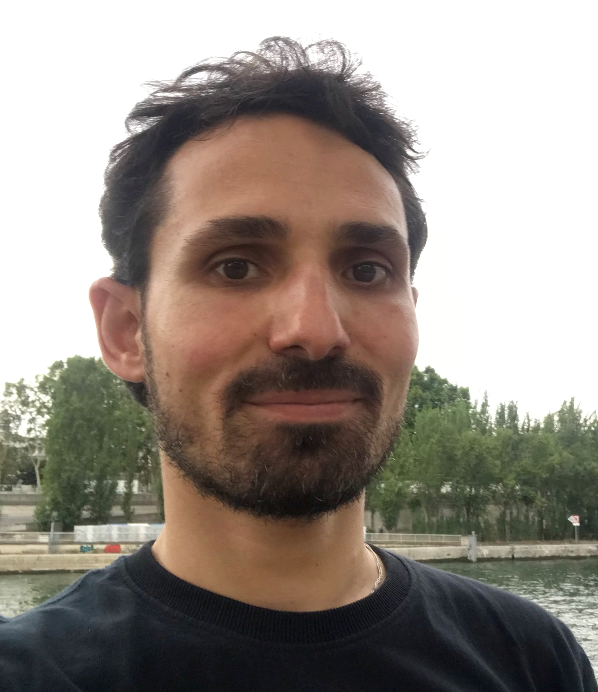
3. Research focus (80 words max)
The Lamprou Research Lab, is focusing in Emerging Technologies (e.g., 3D Printing & Bioprinting, Electrospinning, Microfluidics & Lab-on-a-chip, and BioMEMS) for Drug Delivery Systems and Medical Devices & Implants. Our research lab offers an excellent environment for research with several laboratories that are fitted with state-of-the-art equipment. Our recent research focuses on three major areas using Emerging Technologies: nanoparticles for imaging & therapeutic applications, lab-on-a-chip & microfluidic devices, and implants for therapeutic delivery & tissue engineering.

4. Research opportunities 40 words max
- 3D Printed drug delivery systems & medical devices.
- Bioprinting applications in drug delivery systems and tissue engineering.
- 4D printing in cancer management.
- Manufacturing of nanofibers for drug delivery and tissue engineering applications.
- Nanomedicine development using microfluidics.

5. Research students

Name: Miss Aikaterini Dedeloudi
PhD title: 3D Printed Implants for Long-Acting Drug Delivery for Bone Cancer
Years of Study: 2021-2025
Country: Greece

Name: Miss Eman Jaradat
Ph.D. Title: Microfluidic Platforms for the Production of Nanomedicines for Cancer Therapy
Years of Study: 2021-2024
Country: Jordan

Name: Mr Edward Weaver
Ph.D. Title: Microfluidic Synthesis of Nanomedicines for the Delivery of Biologics Years of Study: 2020-2023
Country: UK

Name: Miss Francesca Corduas
PhD title: Next Generation Drug-Eluting Meshes for Tissue Engineering Applications
Years of Study: 2019-2022
Country: Italy

Name: Miss Essyrose Mathew
PhD title: Novel Delivery Systems for Transdermal and Intradermal Drug Delivery
Years of Study: 2019-2022
Country: UK

6. Alumni - where are they now? (3 Max)

Name: Dr Carlota Mendez Torrecillas
PhD Title: Process and Product Understanding of Rapid and Continuous Wet Granulation
Years of Study: 2014-2018
Country: Spain
Current Position: Project Scientist, CMAC Future Manufacturing Research Hub

Name: Dr Laura Martinez Marcos
PhD title: Development and control of pharmaceutical solids using extrusion and granulation
Years of Study: 2012-2016
Country: Spain
Current position: Janssen

7. Public Outreach/ other achievements (media links; DNA innovation links etc; other press)
Researchers develop 3D treatment that could revolutionise diabetes treatment
3D Printing Sees COVID-19-Induced Boost for Formulations
Microfluidics offers easier and faster manufacturing of nanomedicines
Amphibian foam used for drug delivery for first time
Queen’s University Belfast provides NHS with protective facemasks
Research could signal safer generation of mesh implants
Nanomedicines' impact on patients under the microscope

8. Key words
3D Printing, 4D Printing, Bioprinting, Drug Delivery, Electrospinning, Lipid Nanoparticles, Medical Devices, Microfluidics, Nanomedicines, Vaccines

