WEBSITE TEMPLATE

Changes highlighted in red

1. RESEARCH THEME/s; PRP; GI:

Nanomedicine & Biotherapeutics: Proteases in Disease.
Centre for Advanced Technologies for Healthcare

2. PI DETAILS (Name, Pure Link, Twitter Handle & Photo)

Name: Professor S. Lorraine Martin
Webpage: https://pure.qub.ac.uk/en/persons/lorraine-martin
Email: l.martin@qub.ac.uk
Twitter: @Prof_SLMartin
linkedin: www.linkedin.com/in/prof-slorrainemartin

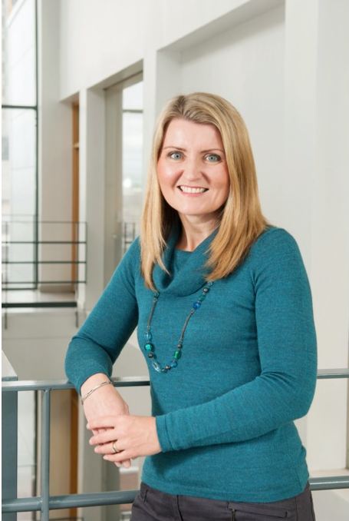

3. Research focus (80 words max)
The focus of the Martin group is to understand the diverse roles that active proteases play in the progression of chronic airways diseases, such as cystic fibrosis (CF) and chronic obstructive pulmonary disease (COPD), to include the characterisation of novel cellular proteins and pathways. A central theme is the development of therapeutic strategies to combat airways dehydration, a key factor contributing to disease progression, as well as the characterisation of novel biomarkers to aid earlier diagnosis and disease management.
4. Research opportunities (40 words max) (NO CHANGES)
Open to PhD applications in the field of:
Chronic airways diseases, to include cystic fibrosis, COPD, bronchiectasis & asthma, with a particular emphasis on:

- Proteases as potential biomarkers and therapeutics targets;
- Ion channel modulation, airways hydration & mucociliary clearance;
- Infection and inflammation.

5. Research students (updated)

Name: Xuan Ouyang
PhD title: Targeting allergen-associated proteases and airways remodeling in allergic asthma.
Years of Study: 2019-2023
Country: China

Name: Bethany Montgomery
PhD title: The inhibition of furin as a strategy for the treatment of cystic fibrosis airways disease.
Years of Study: 2021-2024
Country: Northern Ireland

Name: Amy Hendren
PhD title: Targeting deubiquitinases for the treatment of airway diseases.
Years of Study: 2021-2024
Country: Northern Ireland

6. Alumni - where are they now? (3 Max) (Updated)

Name: Suhad Bani Melhim
PhD title: An investigation of the cellular effect of multi-drug combinations in cystic fibrosis
Years of Study: 2018-2022
Country: Jordan
Current position: Assistant Professor, Biochemistry/Biological Chemistry, Department of Clinical Pharmacy and Pharmacy Practice, Faculty of Pharmaceutical Sciences, Hashemite University, Jordan.

Name: Dr Lisa Douglas
PhD title: Putting a CAP on ENaC: A mechanism to rehydrate the airways and restore mucociliary function in cystic fibrosis
Years of Study: 2015-2018
Country: Northern Ireland
Current position: Post-doctoral Research Fellow, School of Pharmacy, QUB
Name: Dr Timothy Ferguson
PhD title: The design, synthesis and evaluation of novel inhibitors and activity-based probes targeting serine proteases in cystic fibrosis
Years of Study: 2012-2015
Country: Northern Ireland

7. Public Outreach/ other achievements (media links; DNA innovation links etc; other press) (NO CHANGES)

- Vice-Chancellor’s Research Culture Prize (2020)
  - Vice-Chancellor’s announcement
  - BREATH Research Culture video (below)

- Asthma/COPD Project of the Year, NI Healthcare Award, 2019
- Vice-Chancellor’s Research Impact Prize (2016)
- Award of €7.7M EU funding for fight against lung disease (BREATH)
- New Discovery in Combatting Cystic Fibrosis
- Founding CEO of ProAxsis Ltd
- Winner of NISP Connect 25K Award

8. Key words (NO CHANGES)

Cystic fibrosis, COPD, proteases, ENaC, ion channels, infection, inflammation.

