WEBSITE TEMPLATE

1. RESEARCH THEME/s; PRP; GI:

Infection and Antimicrobial Resistance (Novel antimicrobials and anti-infective biomaterials); Drug Delivery and Biomaterials (Polymeric Medical Devices and Photoactive Biomaterials)

2. PI DETAILS (Name, Pure Link, Twitter Handle & Photo)

Name: Dr. Matthew Wylie
Pure Link: https://pure.qub.ac.uk/en/persons/matthew-wylie
Twitter Handle: @mwylie89
Photo: 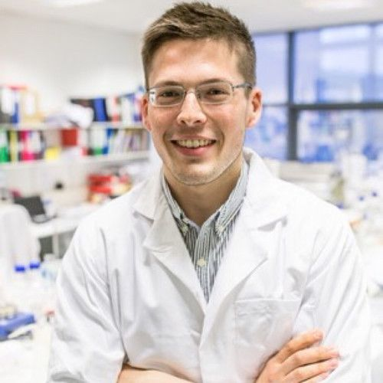

3. Research focus (80 words max)
Dr Wylie’s research is focused on the development of infection-resistant materials and surface modification strategies, and sensor technologies for the prevention of medical device-related infections and improved healthcare infection control. In addition we develop stimuli-responsive drug delivery systems, for delivery of antimicrobials, using hydrogels and ionomers. The group is also involved in the design of enhanced medical device coatings for improved comfort and quality of life for ostomates and intermittent catheter users.

4. Research opportunities 40 words max
Open to PhD applications in the field of:

- Design, synthesis and characterisation of biomaterials and device coatings
- Bacterial-polymer surface interactions
- Polymer/metallic surface modification strategies for anti-fouling applications
- Next-generation surface disinfectants

5. Research students

Currently I am part of the supervisory team for 13 PhD students from the UK, Ireland, Jordan, Saudi Arabia, and China. Examples of these projects include:

Name: Jasmine Ross
PhD title: Biomaterial coatings with lubricious, slippery coatings for improved urinary catheter performance
Years of Study: 2022-2025
Country: Northern Ireland

Name: Jingyi Xu
PhD title: Self-triggered ionogels for biomedical applications
Years of Study: 2021-2024
Country: China
Name: Mohammad Rabee
PhD title: Triggered drug delivery systems for targeted therapy
Years of Study: 2020-2023
Country: Jordan

Name: Tiancheng Luo
PhD title: Development of anti-infective polymer coatings for medical device applications
Years of Study: 2020-2023
Country: China

Name: Jia Li
PhD title: Multi-Mode Responsive Biomaterials Resistant to Infection
Years of Study: 2019-2022
Country: China

6. Alumni - where are they now? (3 Max)

Name: Sijin Li
PhD title: Infection-Responsive Biomaterials Capable of Triggered Self-Cleaning
Years of Study: 2018-2021
Country: China
Current position: Lecturer (Education), China Queen’s College

7. Public Outreach/ other achievements (media links; DNA innovation links etc; other press)

The research is strongly linked to industrial collaborations built upon Dr. Wylie’s participation in Innovate UK’s ICURe commercialization programme which has led to several prototype materials for infection control: https://doi.org/10.1016/j.jphotobiol.2020.112098

Our work has recently received funding from the HEA’s Shared Island Initiative: https://www.sfi.ie/research-news/news/protection-medical-device/ and https://www.healthestatejournal.com/story/39237/taking-preventative-science-to-a-new-level

8. Key words

Biomaterials; stimuli-responsive drug delivery; surface modification; infection control

