WEBSITE TEMPLATE

1. RESEARCH THEME/s; PRP; GI:

Biofilm resistant liquid-like surfaces for medical devices to combat infections and associated complications

2. PI DETAILS (Name, Pure Link, Twitter Handle & Photo)

Dr Shuai Zhang
https://pure.qub.ac.uk/en/persons/brad-cheung
https://mobile.twitter.com/spzhang01
https://www.researchgate.net/profile/Shuai-Zhang-212
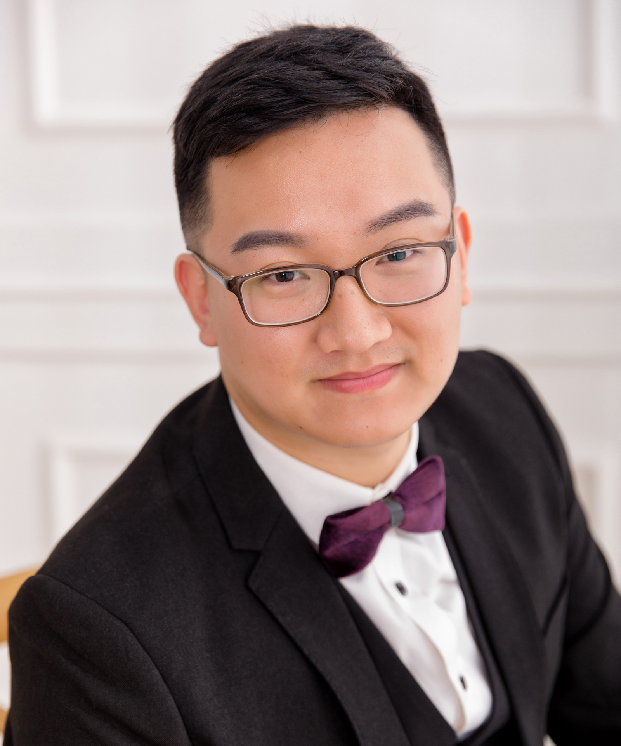

3. Research focus (80 words max)
Dr Shuai Zhang’s research mainly involves functional biomaterials and surface engineering. His current research is centered on developing bio-inspired self-cleaning coating technologies for medical devices and fabricating smart nanohybrid materials for early diagnosis of infections. His work also involves the application of novel electron-beam technologies in bone repair materials for enhancement of fracture-healing.

4. Research opportunities 40 words max
Bio-inspired liquid-like coatings for medical devices to combat biofilms and associated infections

5. Research students

Name:
PhD title:
Years of Study:
Country:

Name:
PhD title:
Years of Study:
Country:
Name:
PhD title:
Years of Study:
Country:

Name:
PhD title:
Years of Study:
Country:

6. Alumni - where are they now? (3 Max)

Name:
PhD title:
Years of Study:
Country:
Current position:
Name:
PhD title:
Years of Study:
Country:
Current position:
Name:
PhD Title:
Years of Study:
Country:
Current Position:

7. Public Outreach/ other achievements (media links; DNA innovation links etc; other press)

https://vimeo.com/user133138122/review/664096109/341df0c623

8. Key words

Surface; Biomaterials; Coating; Medical device

