WEBSITE TEMPLATE

1. RESEARCH THEME/s; PRP; GI:

Infection and antimicrobial resistance

2. PI DETAILS (Name, Pure Link, Twitter Handle & Photo)

Dr Timofey Skvortsov
Pure: https://pure.qub.ac.uk/portal/en/persons/timofey-skvortsov(deaeaaae-e6f9-47d6-a762-8511cb685dbd).html
Twitter: (@timskvortsov)
https://twitter.com/timskvortsov
LinkedIn: https://www.linkedin.com/in/timofey-skvortsov-5826b443/
E-mail: t.skvortsov@qub.ac.uk

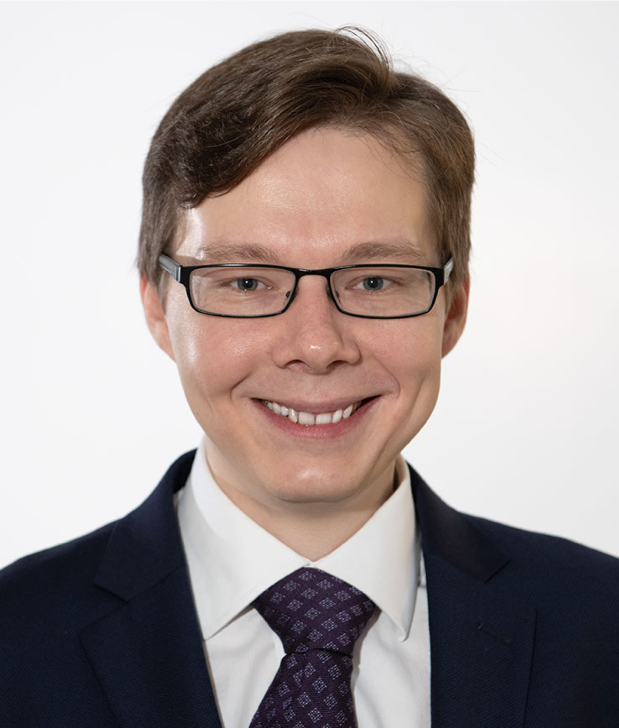

3. Research focus (80 words max)
Dr Skvortsov’s team studies bacterial viruses and bacteriophage-derived antimicrobial agents for the detection, control and elimination of pathogenic bacteria and their biofilms.

Other areas of interest include:
- Environmental viromics;
- Metagenomics and metatranscriptomics of complex microbial communities;
- Horizontal gene transfer of antimicrobial resistance and virulence determinants;
- Synthetic microbiology.

4. Research opportunities 40 words max
Open to PhD applications in the following areas:
- Synthetic biology and genetic engineering of bacteriophages and their proteins
- Structural biology of phage enzymes with antibacterial and antibiofilm properties, including endolysins and depolymerases
- Phage therapy
- Viromics and mobilomics
- Microbiome analysis and manipulation
- Microbial bioinformatics

5. Research students

Name: Akash Shambharkar
PhD title: Investigation of phage therapy approaches as an attractive alternative to antibiotics for bio-control of genitourinary infections
Years of Study: 2021 – 2024
Country: India

Name: Xinyao He
PhD title: Liposome loaded phage cocktail to enhance the potential of phage therapy against intracellular bacteria
Years of Study: 2021 – 2024
Country: China

6. Alumni - where are they now? (3 Max)

Name: Cormac Rice
PhD title: Investigation of novel biocontrol agents against biofilms formed by human pathogens
Years of Study: 2018 – 2021
Country: Northern Ireland
Current position: Senior NGS Bioinformatician & Microbial Genomics Team Lead, Randox, NI

7. Public Outreach/ other achievements (media links; DNA innovation links etc; other press)

Member of:
- Royal Society of Biology (RSB NI branch committee member)
- Microbiology Society
- Society for Applied Microbiology
- International Society for Viruses of Microorganisms
- COVID-19 Genomics UK Consortium
Visiting Scientist:
- San Diego State University, CA, USA (2019)
- Quadram Institute Bioscience, England (2018)
Interviews and blog contributions:
- NI Healthcare (http://nihealthcare.com/a-world-of-opportunity/) (2019)
- How to manage and influence the skin microbiome (National Biofilms Innovation Centre) (https://www.biofilms.ac.uk/manage-and-influence-skin-microbiome/)
- Bacteriophage and biofilms (National Biofilms Innovation Centre) (https://www.biofilms.ac.uk/bacteriophage-and-biofilms/ )

8. Key words

Bacteriophages, antimicrobial resistance, genomics, bioinformatics, protein modelling, microbiomes, genetic engineering, biofilms, protein evolution, synthetic biology, endolysins, depolymerases

