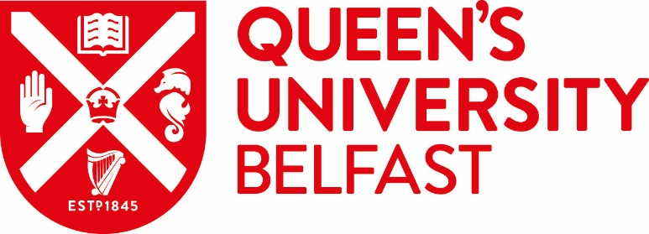

School of Arts, English and Languages – Postgraduate Open Day

Thursday 22 March 2018, 11 University Square

11 University Square, G01
(ground floor, first on right)

12.05–12.15 MRes in Arts and Humanities
12.15–12.25 MA Film
12.25–12.35 MA Arts Management
12.35–12.45 MA Translation

12.45–13.15 Q&A over light lunch
(10 University Square, ground floor)

13.15–13.25 MA English – Literary Studies
13.25–13.35 MA English – Poetry
13.35–13.45 MA English – Creative Writing
13.45–13.55 MA Media and Broadcast Production

11 University Square, 01/008
(1st floor, along corridor at the back)

12.05–12.15 MA English – Literary Studies
12.15–12.25 MA English – Poetry
12.25–12.35 MA English – Creative Writing
12.35–12.45 MA Media and Broadcast Production

12.45–13.15 Q&A over light lunch
(10 University Square, ground floor)

13.15–13.25 MRes in Arts and Humanities
13.25–13.35 MA Film
13.35–13.45 MA Arts Management
13.45–13.55 MA Translation

TO REGISTER PLEASE CLICK HERE
Any queries to Deirdre McCrory (d.mccrory@qub.ac.uk)

