

‘Edward Bunting Competition’

The Music Department and Sonic Arts Research Centre (SARC) at Queen’s University, Belfast is excited to announce a call for new compositions / performances as part of its international outreach work.

The winner will be awarded a prize of £300 and will be invited to Queen’s University, with all costs covered (up to £1k), to perform their music and to air on SARC Radio. A podcast/video will also be made as part of the visit.

The competition is open to student performers, composers, songwriters or improvisers in secondary or tertiary level education based anywhere outside of the United Kingdom and Ireland.

Competition Brief

The Edward Bunting Collection, held by Queen’s University’s Special Collections, remains one of the most important collections of European folk music ever compiled. Between the Belfast Harpers’ Assembly of 1792 and his final publication in 1840, Bunting gathered more than 3300 individual transcriptions of tunes and song lyrics, on the one hand helping to save the musical heritage of Gaelic Ireland from extinction, and on the other documenting the rapidly growing interest in dance music and English language song that were emerging during this time.

This year marks 230 years since the Belfast Harpers’ Assembly and our call for new work centres around one of the tunes collected at that time. ‘The Rejected Lover’ (An Graidheoir Duilteach) was transcribed by Bunting from a Dr Stokes in Belfast in 1792, and the melody of is presented in Bunting’s final publication of 1840 for piano.

We invite submissions of new songs, instrumental compositions, electro-acoustic compositions, or improvised performances based on this melody. You might write a new song to the original melody (or a part of it), or you may use any element of the piece as the basis for your composition or improvised performance. Whatever form your submission takes, it should have a duration of no more than three minutes.

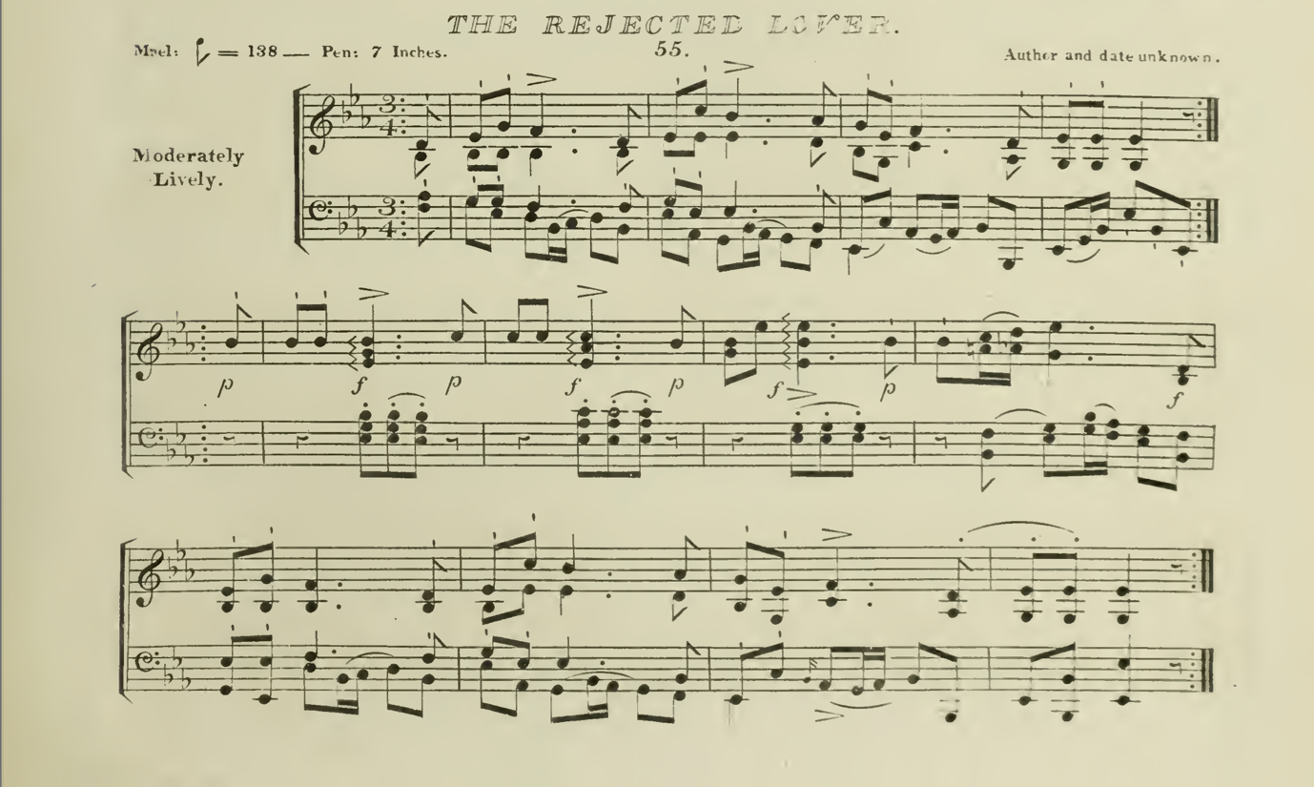

Submissions

Completed pieces should be submitted as either an MP3 audio file or a PDF score and should be accompanied by a short (max 200 word) programme note.

The following submission site can be used for entry:
https://docs.google.com/forms/d/e/1FAIpQLSfL2_fYRLJTUaDNSfhTRZKWXuYrTib9tHxvjpwfolc8WMhwwg/viewform

The deadline for submission has been extended to 10am, Monday 6th June 2022

The winning entry will be announced by Friday 17th June 2022.

Informal queries regarding the competition may be sent to Franziska Schroeder (f.schroeder@qub.ac.uk).

