Justice in the Middle Ages
Before this trip, I was very excited to get to know the city of Bruges. I had seen pictures of its beautiful architecture and canals. However, I must admit that I ended up finding Ghent much more beautiful. Although smaller than Bruges, a two-block walk through the historic city centre leaves one impressed. Watching the sun set over the buildings on the banks of the river Lys, one feels the energy of those European cities where the hustle and bustle of modern life unfolds over the serenity of thousands of years of history.
When it comes to history, Ghent is an inexhaustible source of iconic places. However, there is one that particularly caught my attention: the Castle of Gravensteen.
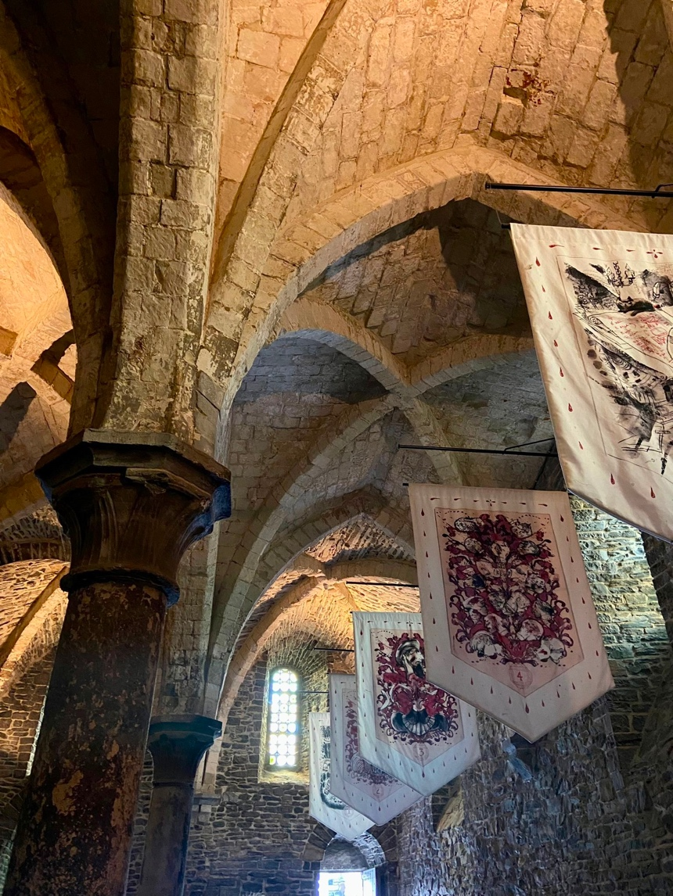
Also known as the Castle of the Counts, this castle is a medieval fortress located in the heart of Ghent. It was built at the end of the 12th century by Philip of Alsace, Count of Flanders. It served as the residence of the Counts of Flanders until the 14th century. Over the centuries, the castle was used for various purposes, such as a courthouse, a prison and even a factory. Today, this place is a museum which you can visit and take a very interesting audio-guided tour.
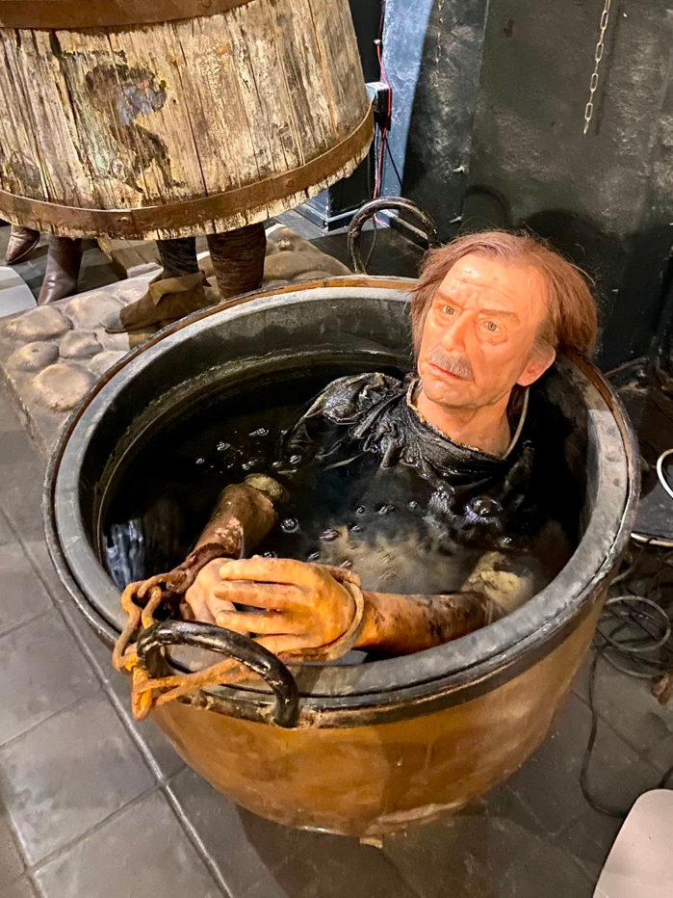
As we had already visited the museum of medieval torture in Bruges, I had an idea of the methods used as punishment in the Middle Ages. However, one of the things that impressed me the most during this visit was to learn about the five worst executions that took place in Gravensteen. They even have a wall with drawings of each of them!
In my opinion, the most horrifying story was that of the man who was boiled alive in the 16th century. This was a fairly common form of execution, and we were also able to see a representation of it in the torture museum.
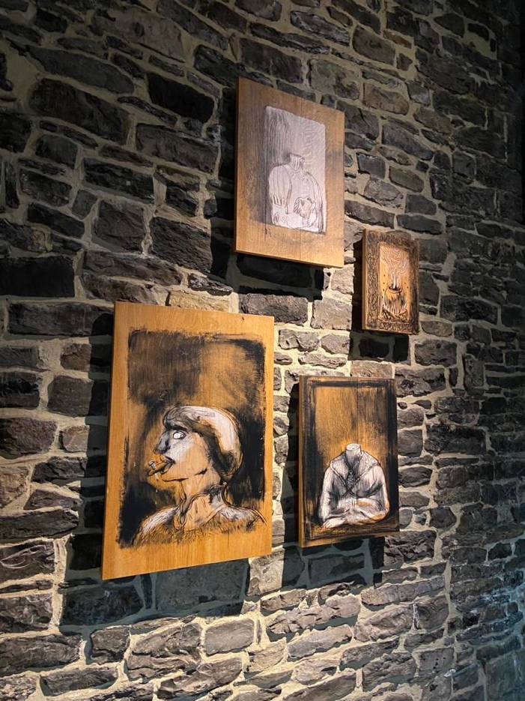
Also, the punishments varied depending on the crime committed by each person. For example, a person who stole would have his hand cut off, while a person who spoke ill of the king would have his tongue pierced. This gave the rest of the society an idea of the offence for which they had been condemned.
Having seen all this, I think that the most interesting thing about studying how people lived in medieval times is to be able to understand that the motivations and desires of these people were not so different from those of today. To do this, it is important to set aside prejudices. An example of this is that in order to put an end to all these forms of punishment, the guillotine was invented in France, as it was considered a more just and painless way of condemning people to death. So, while these practices may seem creepy, the reality is that they evolved over time in line with humankind itself.
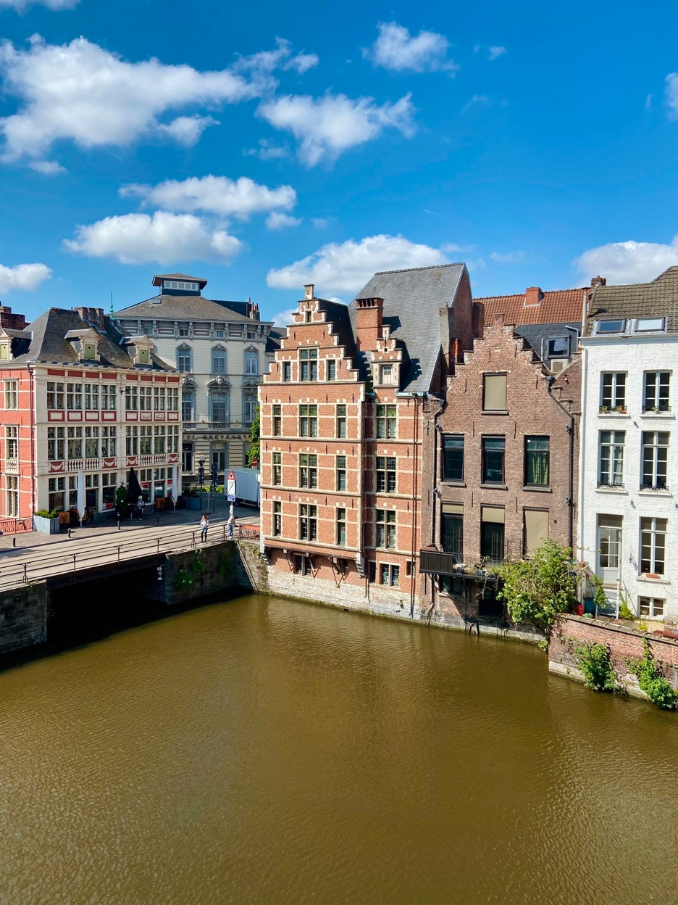
I am very grateful to have had the possibility to learn all this, because I believe that one of the great advantages of studying the past is to appreciate this evolution, to understand that the present in which we live would not have been possible without it and that we can continue to improve as humans.

