How do I locate the Computer Science Building at QUB?
Computer Science
Building
The Computer Science Building (CSB) is located at 18 Malone Road, Belfast. Highlighted on the Map.

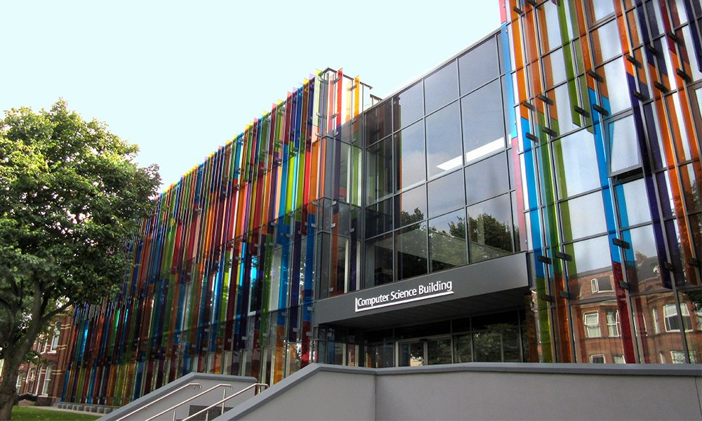

The Computer Science Building is quite distinctive with the multi-coloured glass on the front of the building.

How do I get to the Computer Science Building?

By Train: Nearest Train Station is Botanic Avenue. Highlighted on the Map
By Bus: Belfast Metro Buses from the City Centre – Buses 8C, 8D & 93 stop just past the Computer Science Building. Highlighted on the Map.
By Belfast Bike: Nearest Bike Docking Station is in front of the former Students Union Building or McClay Library Building. Highlighted on the Map.
By Car: There are no parking facilities available at the Computer Science Building as we currently have construction work taking place. However there is on-street parking available around the building. Also parking is available at the top of Botanic Avenue in the QUB Car Park at the McClay Library. This Car Park is open for free from 16:30. Highlighted on the Map.

Map of University Quarter:
