Postgraduate Studentships
School of Electronics, Electrical Engineering and Computer Science
PhD Studentship 2019/20

Proposed Project Title: The Unknown Unknowns: Quantifying Uncertainty in Deep Machine Learning

Principal Supervisor: Professor Neil Robertson

Project Description:

Deep learning has seen incredible success in a huge range of applications ranging from audio visual data to natural language. For all its success, to become truly viable for safety critical or auditable applications, there is a requirement for understanding when it doesn’t work and why. Deep neural networks trained with Stochastic Gradient Descent are point prediction machines by design. That is, when presented with data, it produces an output without any estimate of the confidence of the classification. This may still be useful when the data is within the knowledge domain of the deep network, i.e., the domain shift during test is minimal. When the test domain is radically different from training domain, it may over-confidently predict wrong answers leading to potentially disastrous consequences if left unchecked. This PhD project aims to develop methods to quantify uncertainty in deep learned networks and use this to improve the range of their safe application.

Uncertainties in this type of machine learning can be broadly classified into two major classes [1] and are illustrated below.
- Epistemic Uncertainty: fundamental limitation in knowledge due to limited data not capturing all kinds of variations.
- Aleatoric Uncertainty: uncertainty due missing information like occlusion or bad imaging
conditions.

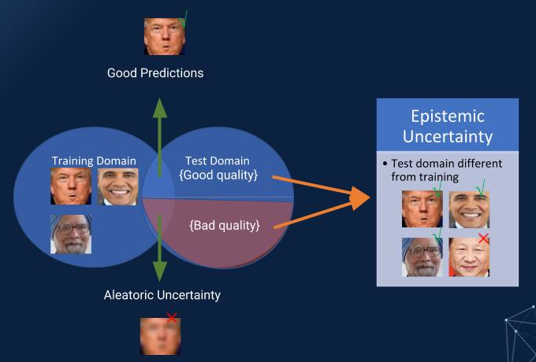

In this figure, we can see that not having adequate data for some ethnicities in the training data can manifest as epistemic uncertainty in the test data. Whereas badly captured image can be attributed to aleatoric uncertainty.

Capturing the knowledge bounds and uncertainties also lends us insight into the failure of the black-box inference methods such as deep neural networks. Certain methods [1,2] have shown promise in modelling the two kinds of uncertainties. However, challenges remain in terms of applicability in real-world real-time systems. Methods like Monte-Carlo dropout is able to estimate certain types of uncertainty but requires sampling from the inference model multiple times. It has been also shown to not capture certain multi-modal uncertainties.

Objectives: The aim of this project is to find a theoretical bound of knowledge given a neural network and a training dataset. During test time the neural network needs to provide a measure of confidence in its predictions based on how much the test data is within its knowledge bounds. Improvements over current methods will require better or more efficient sampling methods and better theoretical understanding of the problem. The project is directly aligned to the EPSRC major programme UDRC, in which Queen’s University leads the Machine Learning Track.

Academic Requirements:

A minimum 2.1 honours degree or equivalent in Computing Science, Electrical and Electronic Engineering or relevant degree is required. International English Language Testing System (IELTS) 6.0 with a minimum of 5.5 in all four elements of the test or equivalent. A strong knowledge of mathematics and/or computer vision is desirable.

GENERAL INFORMATION
This 3 year PhD studentship is available immediately (latest start date October 2019 ), covers tuition fees and a maintenance grant (approximately £15,038 per annum). An industrial enhancement to the stipend may be available through the UDRC partners (under negotiation currently).

Applicants should apply electronically through the Queen’s online application portal at: https://dap.qub.ac.uk/portal/

Further information available at: http://www.qub.ac.uk/schools/eeecs/Research/PhDStudy/

Supervisor Name: Tel: 028 9097 1979

QUB Address: ECIT, Queen’s Rd, BT3 9DT Email: n.robertson@qub.ac.uk

Web: https://pure.qub.ac.uk/portal/en/persons/neil-robertson(41defca3-1fb7-41ed-b427-583d1baf7602).html

Deadline for submission of applications is August 31^{st,} 2019

For further information on Research Area click on links below:

EPSRC UDRC
Machine Learning at Queen’s:

