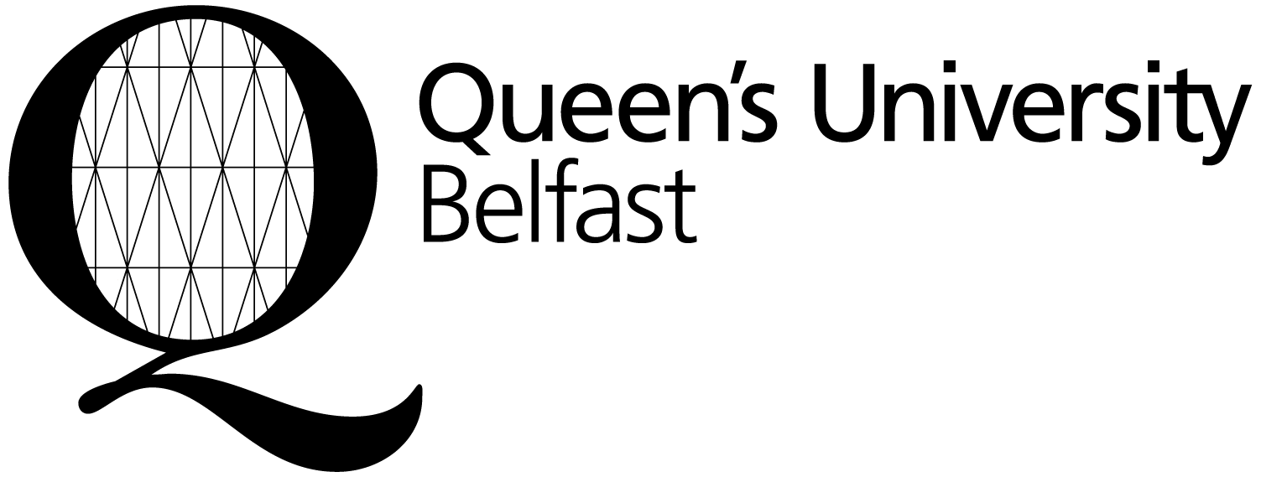EQUAL OPPORTUNITIES MONITORING INFORMATION
APPLICANT CODE:

This form is not used as part of the selection process and the recruitment panel will not have access to the monitoring information.

Queen’s University Belfast through its Charter of 1908 is committed to equality of opportunity for all. Section 75 of the Northern Ireland Act 1998 requires the University in carrying out all its functions to have due regard to the need to promote equality of opportunity and to have regard to the desirability of promoting good relations.

The University considers that monitoring is the essential first step in the effective implementation of its equal opportunities policy and its equality scheme. To fulfil its legal objectives under fair employment legislation, the University is required by law to monitor the community background and gender of applicants. The University would appreciate your cooperation in completing this monitoring form in order that it may effectively monitor, evaluate and review its policies and procedures. The monitoring data will be strictly controlled and managed by the Equality and Diversity Unit in a manner compliant with data protection legislation.
----------------------------------------------------------------------------------------------------------------------------

Please tick the appropriate box

GENDER Please indicate your gender: □ Male □ Female

NORTHERN IRELAND COMMUNITY BACKGROUND

Regardless of whether they actually practice a religion, most people in Northern Ireland are perceived to be members of either the Protestant or Roman Catholic communities. It is not related to your personal religious or philosophical belief. In order to ensure than unintentional discrimination is not taking place, if you are from Northern Ireland you are requested to indicate your Community Background below

Please note that it is an offence under fair employment legislation to give false information to an employer who is seeking that information in order to make a monitoring return. If you do not complete this section we will write to you asking you to indicate your Community Background.

Please indicate your NI community background:

□ I am from Northern Ireland and am a member of the Protestant community
□ I am from Northern Ireland and am a member of the Roman Catholic community
□ I am from Northern Ireland and a member of neither the Protestant nor the Roman Catholic community
□ I am not from Northern Ireland

RELIGION/RELIGIOUS BELIEFS

What religion, religious denomination or body do you belong to? Please select from the list below:

□ No Religion □ Christian – Other Denomination
□ Buddhist □ Hindu
□ Christian □ Jewish
□ Christian- Church of Scotland □ Muslim
□ Christian – Roman Catholic □ Sikh
□ Christian - Presbyterian □ Spiritual
□ Christian – Church of Ireland □ Any other religion or belief
□ Christian – Methodist Church □ Information refused

NATIONALITY (as shown on your passport)

NB: If you hold dual Nationality, please state the one under which you are applying

RACE/ETHNIC ORIGIN

Please indicate which category best describes the ethnic group to which you belong:

□ White British □ Black or Black British-Caribbean
□ White Irish □ Black or Black British-African
□ White Other European □ Other Black Background
□ Other Asian Background □ Asian or Asian British-Indian
□ Chinese □ Asian or Asian British-Pakistani
□ Irish Traveller □ Asian or Asian British-Bangladeshi
□ Mixed ethnic group □ Any Other ethnic group
□ Not Known □ Prefer not to say
□ Information Refused

The University has adopted the categorisation scheme suggested by the Higher Education Statistics Agency (HESA), which is compatible with the 2011 Census Data.

DISABILITY

The Disability Discrimination Act considers a person disabled if:

- He/she has a longstanding physical or mental condition or disability that has lasted or is likely to last at least 12 months; and

- This condition or disability has a substantial adverse effect on his/her ability to carry out normal day-to-day activities.

Do you consider yourself to have a disability? □ Yes □ No

If Yes, please indicate the nature of your disability by ticking the appropriate box(es).

□ Physical Impairment, such as difficulty using your arms, or mobility issues, which perhaps means using a wheelchair or crutches
□ Sensory Impairment, such as being blind/having a serious visual impairment or being deaf/having a serious hearing impairment
□ Mental Health Condition, such as depression
□ Learning Disability/Difficulty, such as Down’s syndrome or dyslexia or cognitive impairment, such as autistic spectrum disorder
□ Long-Standing Illness or Health Condition such as cancer, HIV, diabetes, chronic heart disease, or epilepsy
□ Multiple Disabilities
□ Declined to Specify
□ Other (please specify)

MARITAL STATUS Please indicate your current marital status:

□ Married □ Single □ Widowed
□ Divorced □ Civil Partnership □ Separated

DEPENDANTS Please indicate if you have any dependants: □ Yes □ No

If ‘Yes’, are you responsible for the (tick as many as apply):

□ Care of a child/children □ Care of a person/persons with a disability/disabilities
□ Care of an elderly person(s) □ Care of all three dependant groups
□ Care of both children and disabled person(s)
□ Care of both elderly and disabled person(s)

SEXUAL ORIENTATION

My sexual orientation (sexual preference) is towards someone:

□ Of the same sex □ Of either sex
□ Of a different sex □ I do not wish to answer

Thank you for completing this form

Please return the completed form to the address below.

ACF/ACL Recruitment
Education Management Team
NIMDTA
Beechill House
42 Beechill Road
Belfast
BT8 7RL
Valuedtrainees@hscni.net

