POLITICAL THEORY AND PHILOSOPHY SEMINAR SERIES
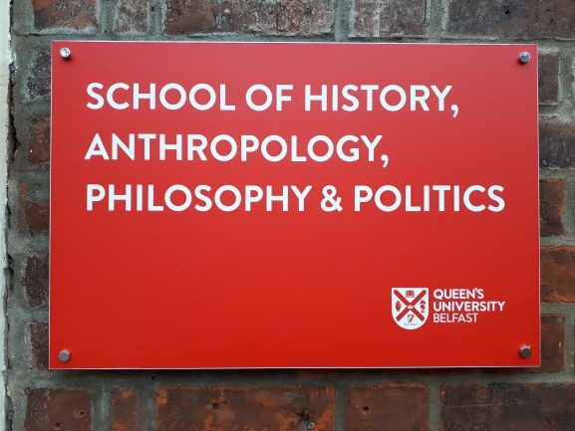
Semester 1, 2018/19
All seminars at 2 pm in The Meredith Room, School of History, Anthropology, Philosophy, & Politics, 23 University Square, Queen’s University, Belfast.

Friday 12 October Kyle Shuttleworth, ‘Virtues and ethics within Watsuji Tetsuro’
Friday 19 October Meghan Van Portfliet, ‘The stigmatization of whistleblowers’
Friday 26 October Cillian McBride, ‘Authenticity’
Friday 2 November Charlene McKibben, 'Populism on the periphery of democracy: moralism and the politics of recognition'
Friday 9 November Craig Henderson, 'A defence of resentment'
Friday 16 November Suzanne Whitten, 'Critical civility as a response to harmful speech'.
Friday 23 November Noírin MacNamara, ‘Challenging abortion stigma through a concept of political subjectivity as embodied and interdependent’
Friday 30 November Fabian Schuppert, ‘Climate adaptation between collective self-determination and global duties’
Tuesday 4 December Margaret Moore (Queen’s, Canada): Title and Room tbc
Friday 7 December Jon Kuyper, 'Complementing and correcting representative institutions: When and how to use mini-publics' (co-authored with Fabio Wolkenstein).
Friday 14 December Keith Breen, ‘Neo-republicanism and workplace democracy: beyond the non-domination ideal’

To receive the pre-circulated papers please email Fabian Schuppert at f.schuppert@qub.ac.uk

Also, please earmark already the following dates for semester 2:
February 1st: Beth Kahn (Durham)
March 8th: Guy Aitchison (King’s College London)
May 10th: Lisa Herzog (Munich)
May 17th: Miriam Ronzoni (Manchester)

