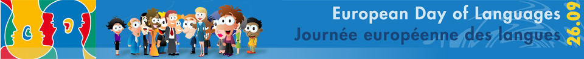
Name…………………………………………
Breakfast around Europe
Can you guess which European country these breakfast items come from? Use the options below to help you and write your answers in the boxes under each picture.
We’ve given you a description of the harder items to help.
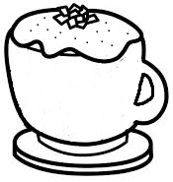 | 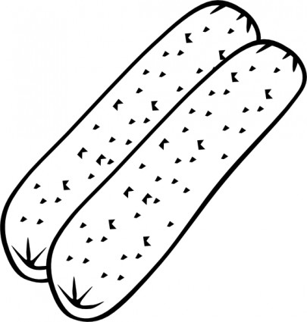 | 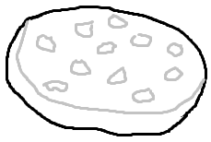 | 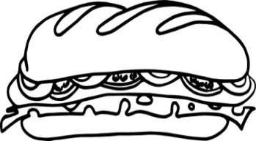
Cappuccino | Wurst | Draniki  (Potato Pancake) | Kanapka  (Meat or cheese filled sandwich)
1. | 2. | 3. | 4.
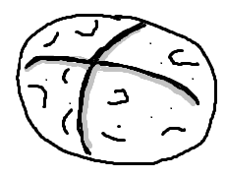 | 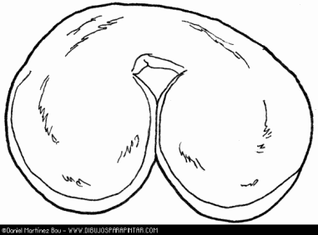 | 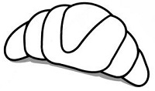 | 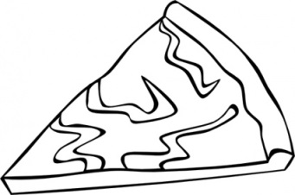
Wheaten farl | Palmera Dulce  (Flaky pastry rolled bun) | Croissant | Burek  (Pastry stuffed with meat or cheese)
5. | 6. | 7. | 8.
France Italy Germany Poland
Croatia Ireland Belarus Spain

