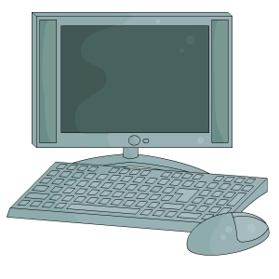



**HOW TO CREATE A KAHOOT**

1. Search kahoot! in your search engine
2. Choose: Kahoot!: Making Learning Awesome!

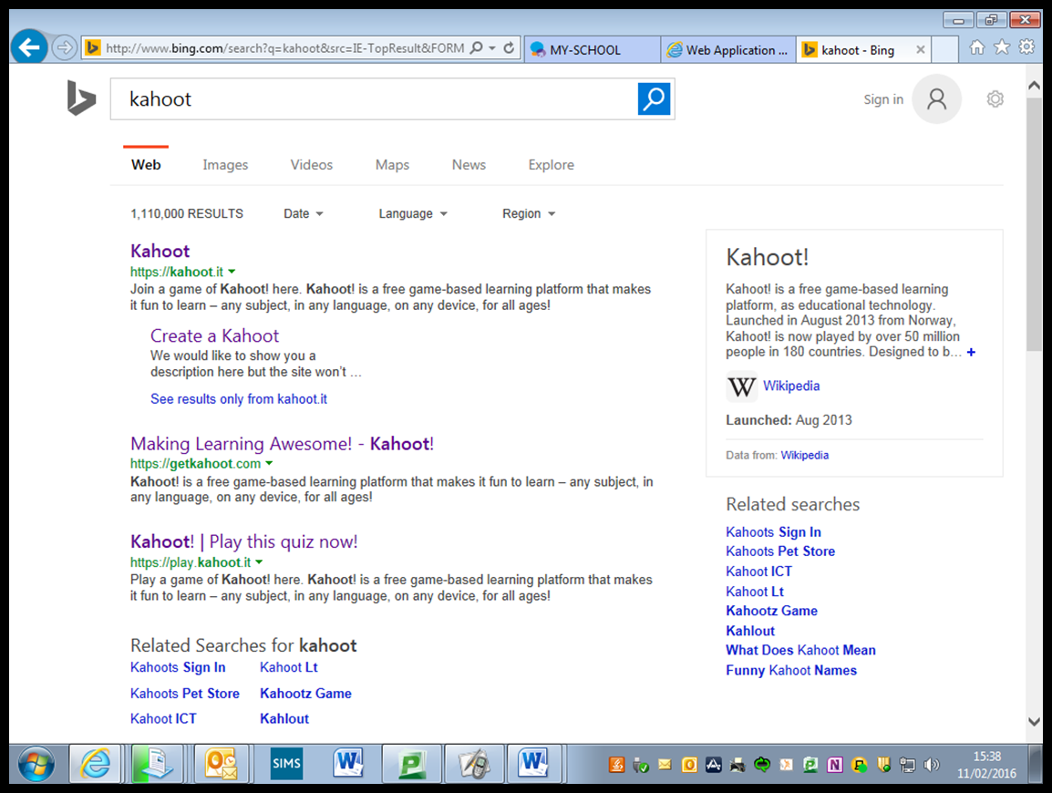

1. Click on “SIGN UP FOR FREE”

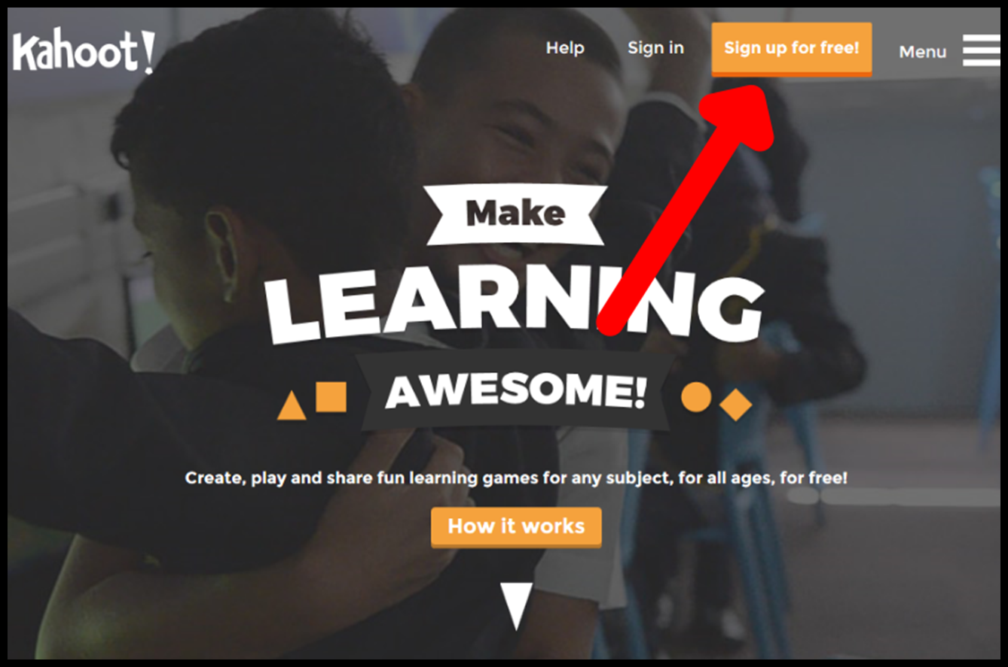

1. Choose your role from the drop down box, “I AM A TEACHER”



1. When creating your account, it easier to use your C2K account

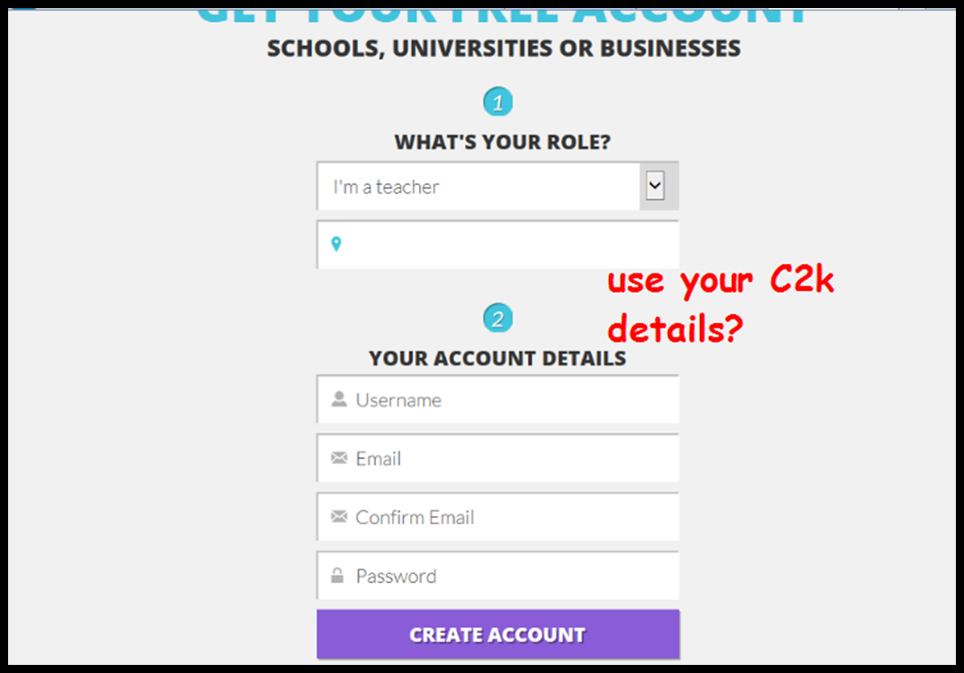

1. Now you are signed up, you can begin to create your Kahoot!
2. To create your Kahoot!, click on “NEW K!” and “QUIZ”

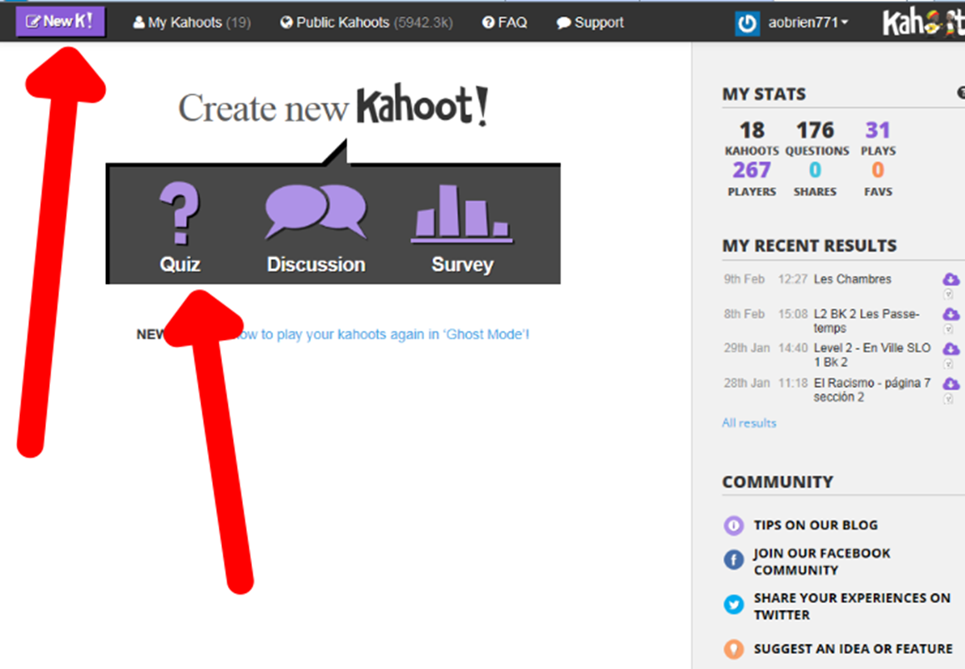

1. When you begin to create your Kahoot! Remember that you will want to make your title clear, Topic, Level, style etc. Select your audience as school

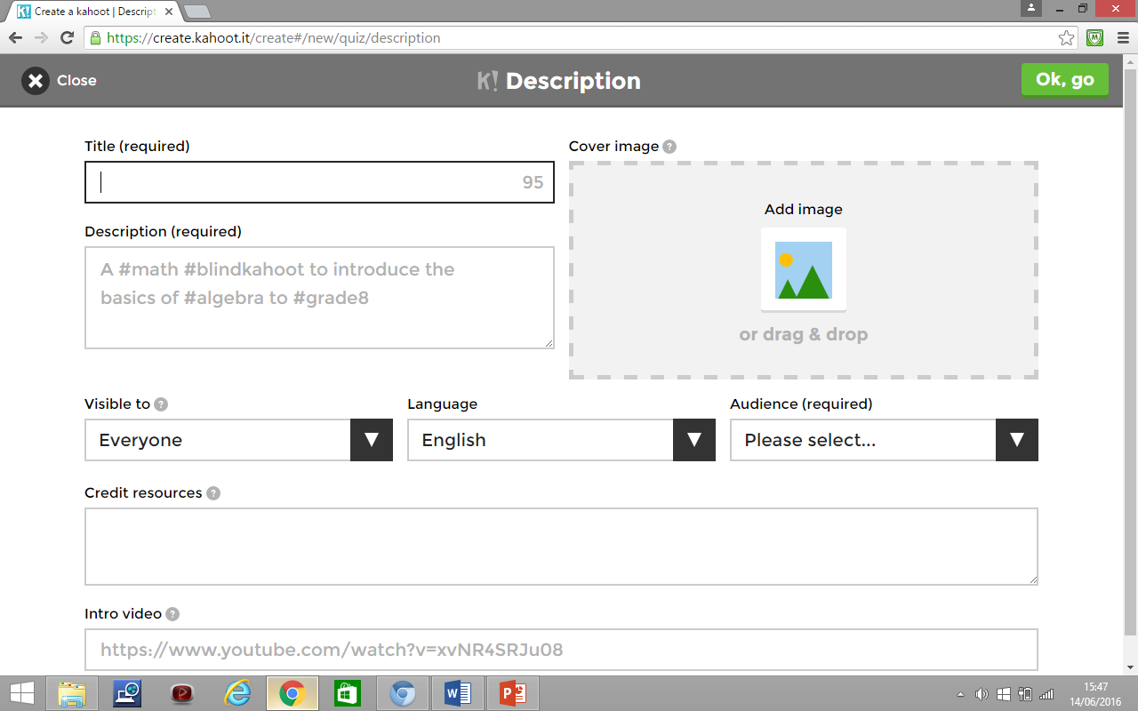



1. To add a cover picture Add an image from your “My Pictures” folder. You can simply drag and drop. It should be PNG or JPeg**.**



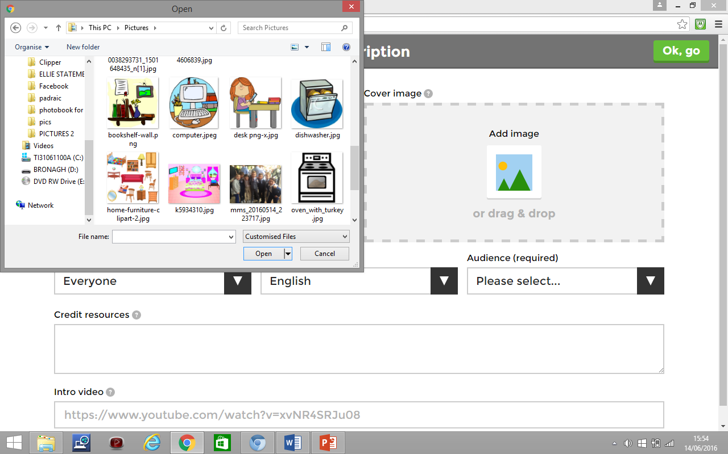

10) You can add interesting music or a visual from YouTube. Simply copy and paste the YouTube address from the clip you have sourced

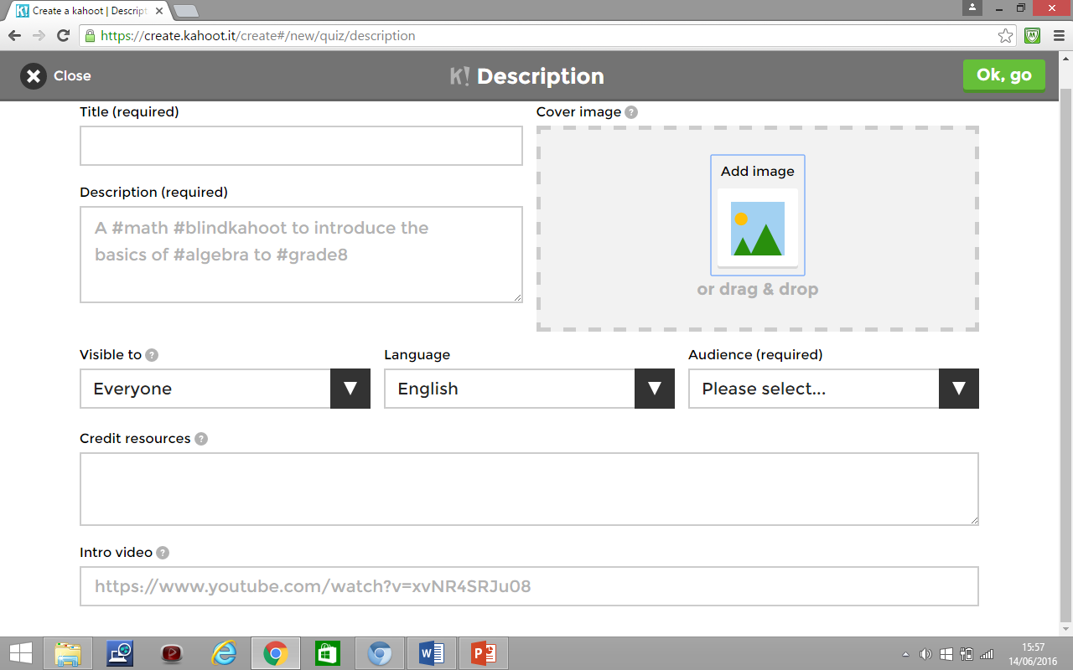



11) To start creating your questions click the EDIT ICON

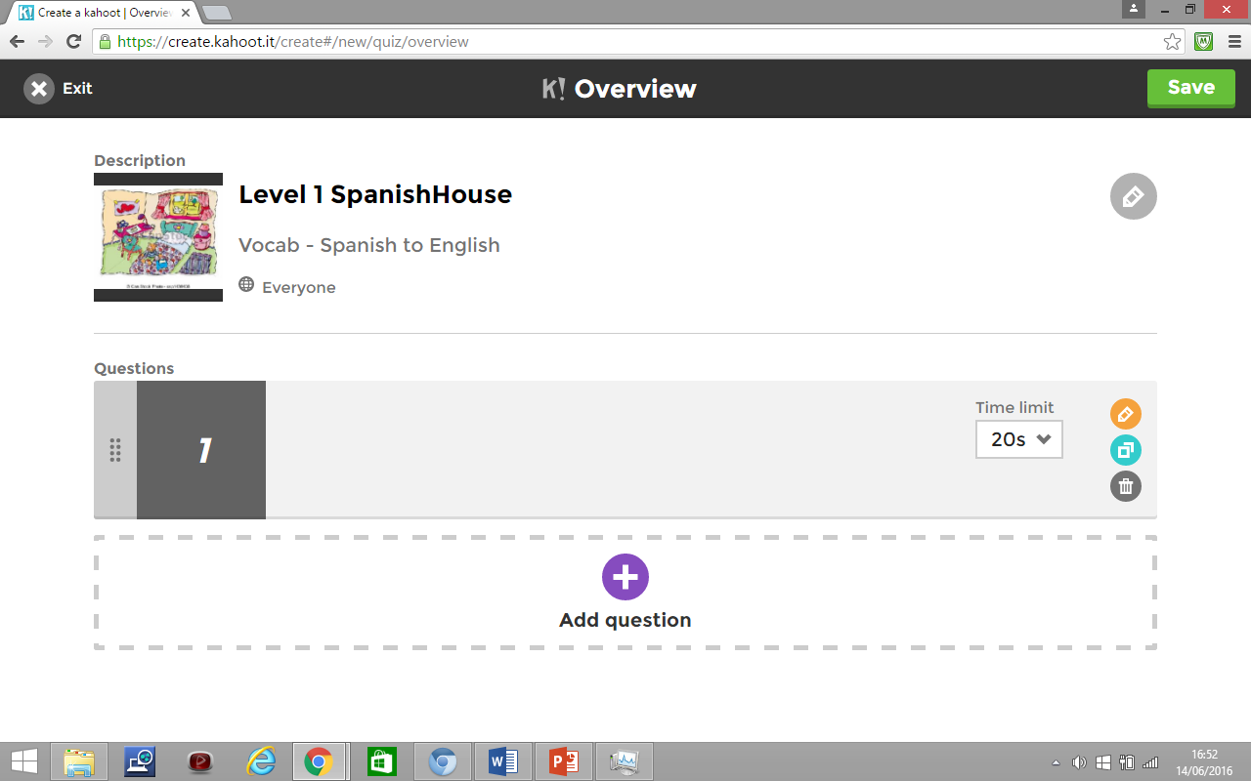



12) Type in your question. Do you want it in English? When you are adding the answers in the TL remember to add mistakes.

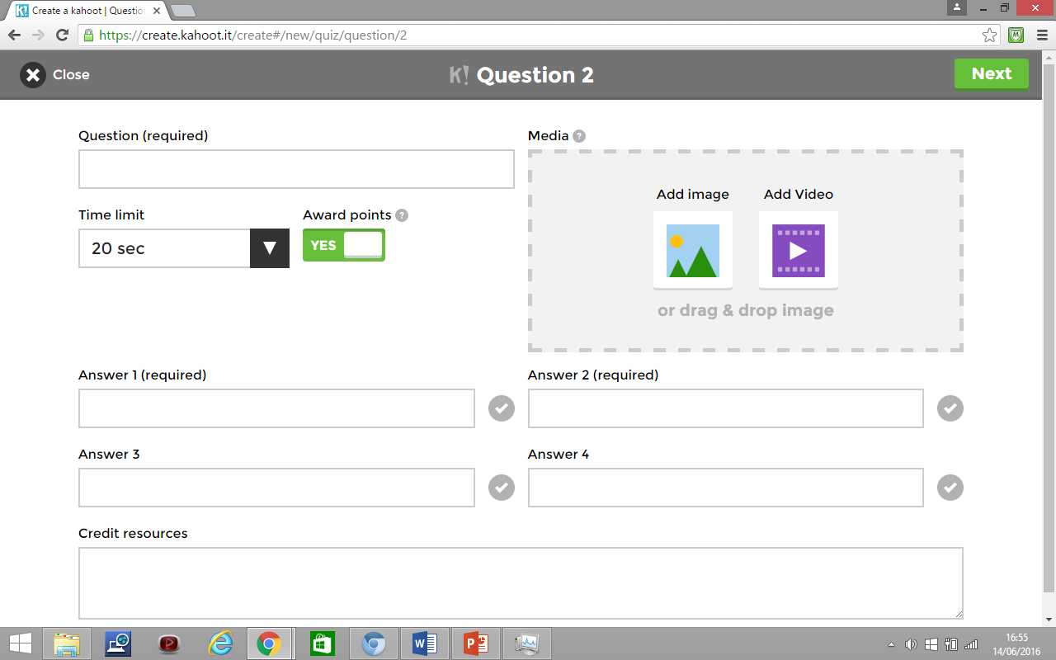





13) You can add an image by dragging and dropping once more from your “My Pictures”. Don’t forget to highlight the correct answer!!

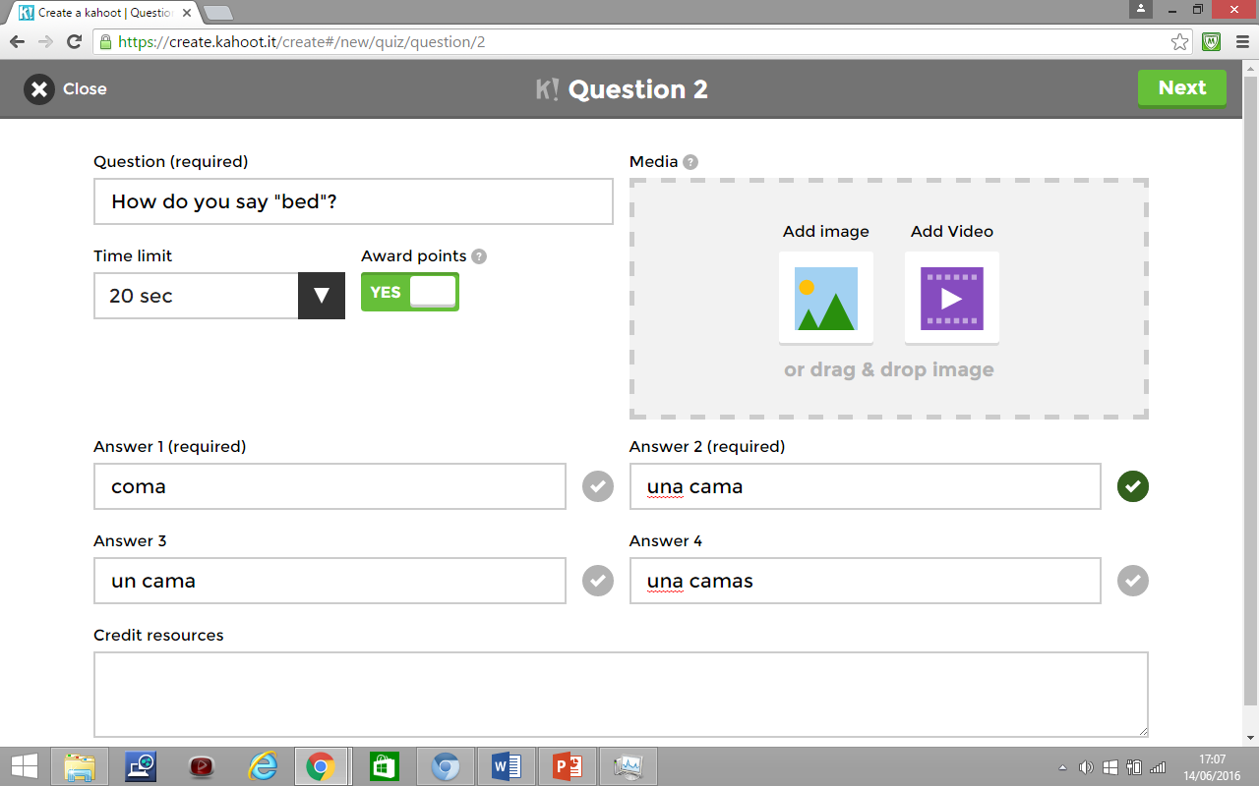





**14)** It’s **important to note** that there is a character limit when you are inputting your question and answers. The programme will let you know if you have gone over the limit.

15) You can change the time limit to allow the desired “thinking time” required. When the students are playing the game, once all the answers have been entered the clock will automatically STOP.

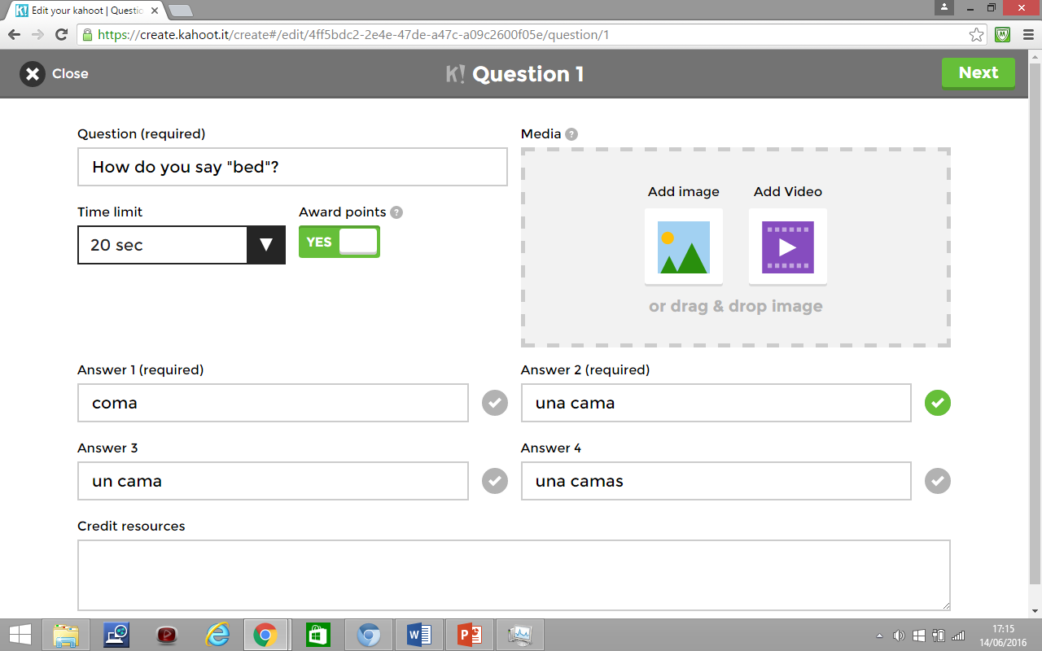



16) When you are happy click on NEXT to continue to the next

question. Then click ADD QUESTION.

17) Repeat the process and complete as many questions as you desire

for the game and level of the class. When you are happy with your

questions and answers, click SAVE



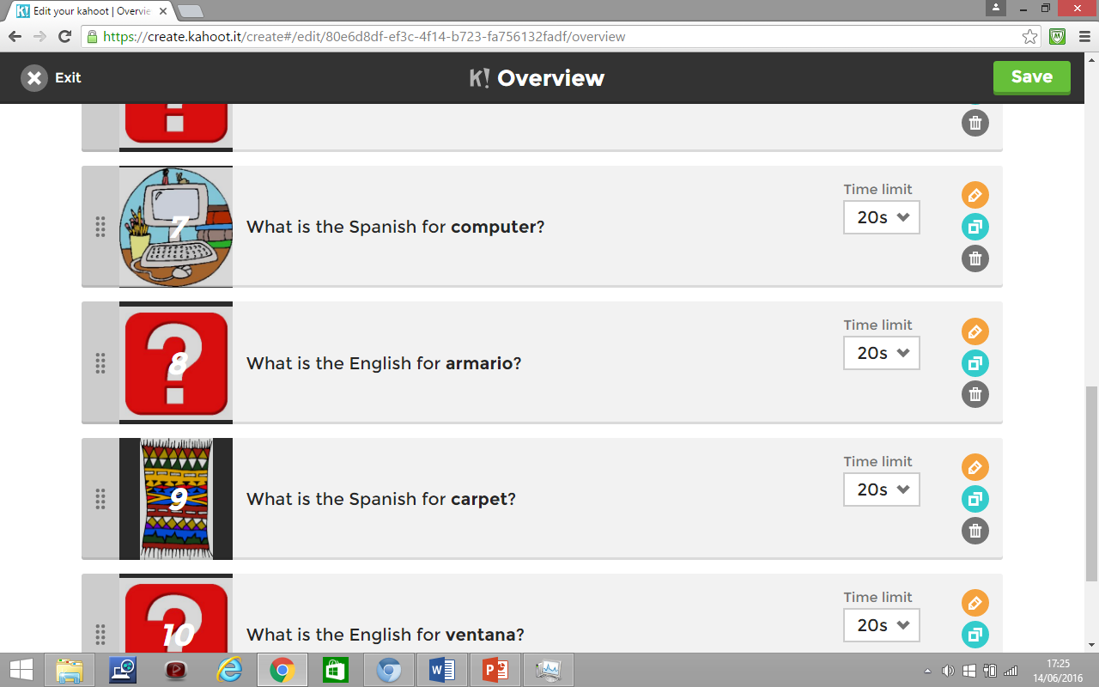

18) Before clicking “I’M DONE”. You can EDIT, PREVIEW, PLAY OR

SHARE your Kahoot!

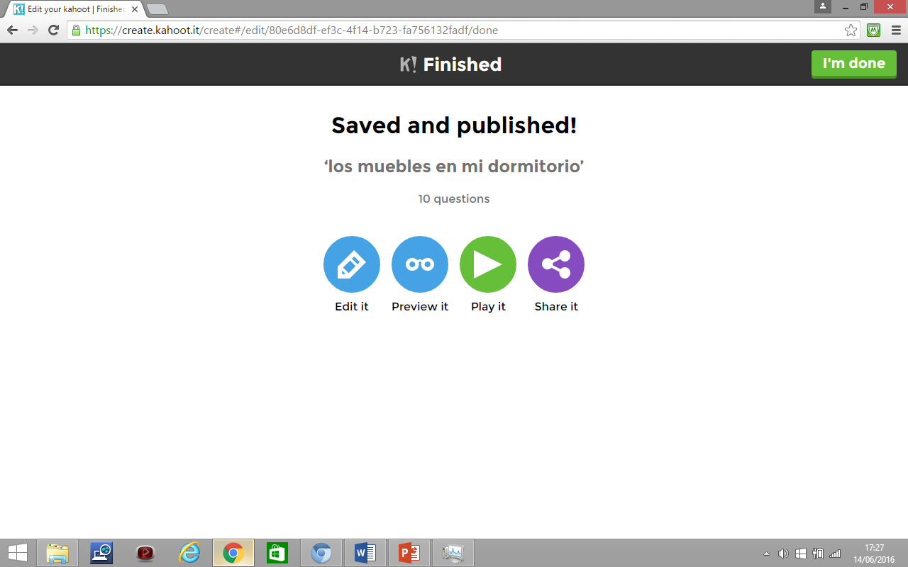

19) It’s good to SHARE with your colleagues, as you can DUPLICATE,

EDIT and translate for another class or language.

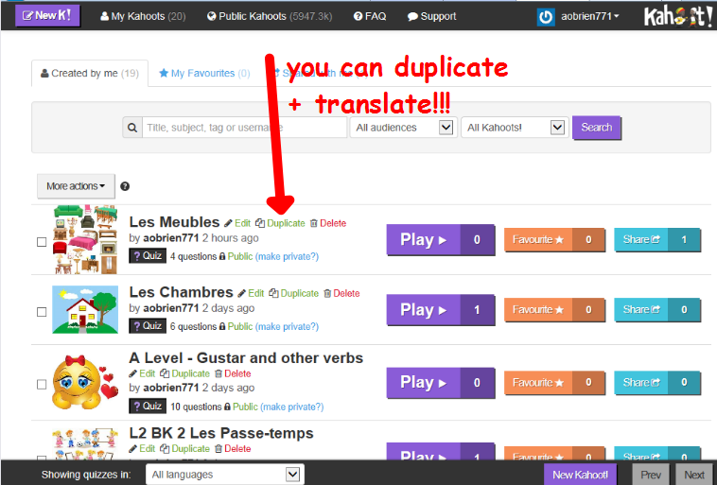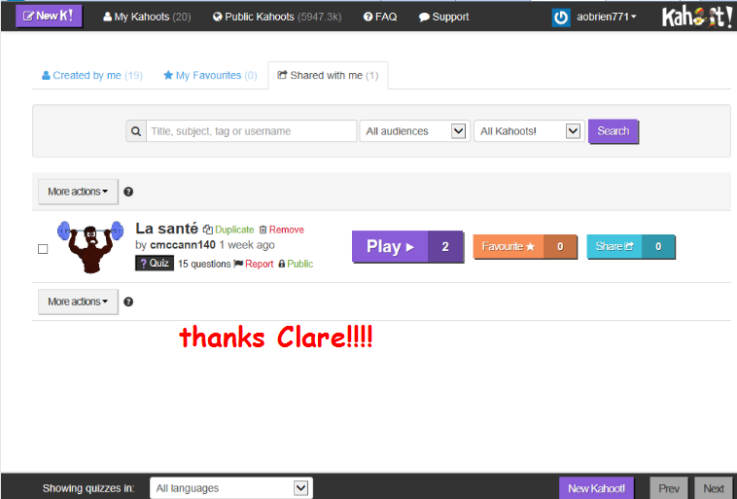

### 20) When you are ready to play it in the classroom ask the students to search for Kahoot! and enter the website entitled: [Kahoot!](https://www.google.co.uk/url?sa=t&rct=j&q=&esrc=s&source=web&cd=1&cad=rja&uact=8&sqi=2&ved=0ahUKEwjJ5_--pqjNAhWDLMAKHZJ6CN0QFggcMAA&url=https%3A%2F%2Fkahoot.it%2F&usg=AFQjCNH6tc_PFESmNjT1oPa4bWopCyh7qw&bvm=bv.124272578,d.ZGg)

[https://**kahoot**.it/](https://kahoot.it/) to join a game.



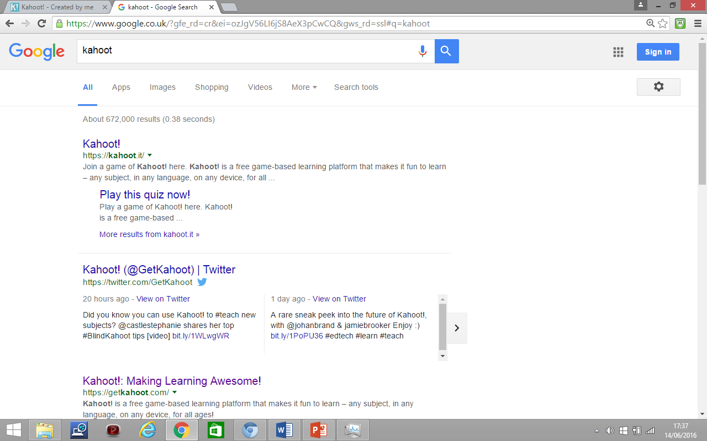

21) When they click on this, they will find this page and will be waiting

on a PIN to enter the game

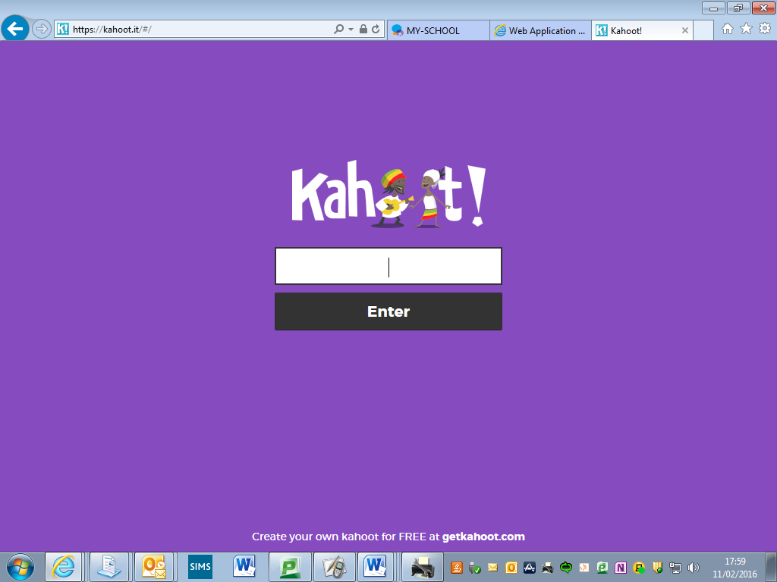

21) To enable the students to play you need to launch your game. To do this select the game you want and press PLAY



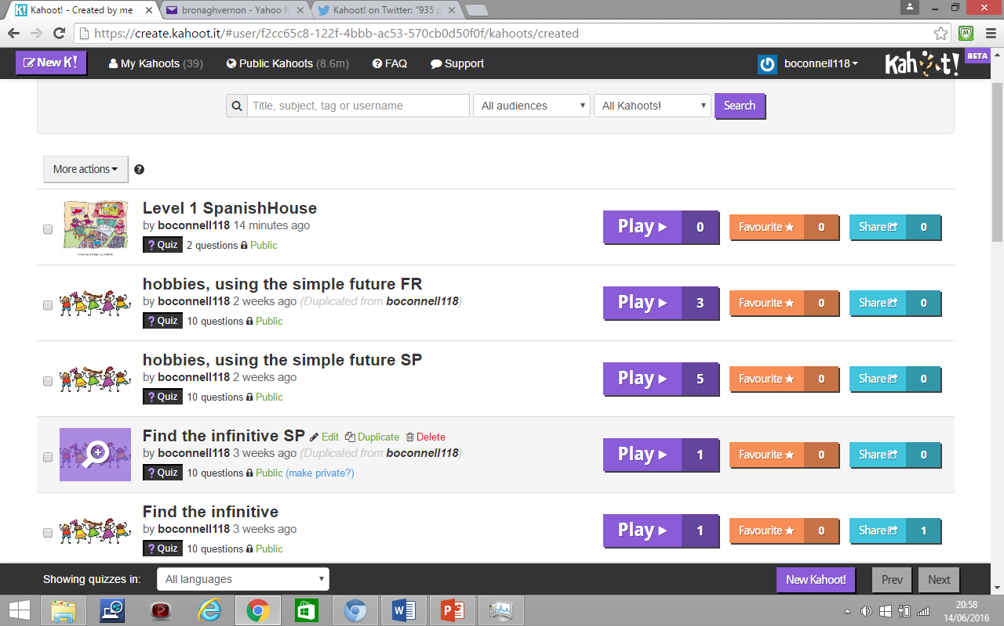

22) Now select which type of game you want to play: CLASSIC or TEAM MODE

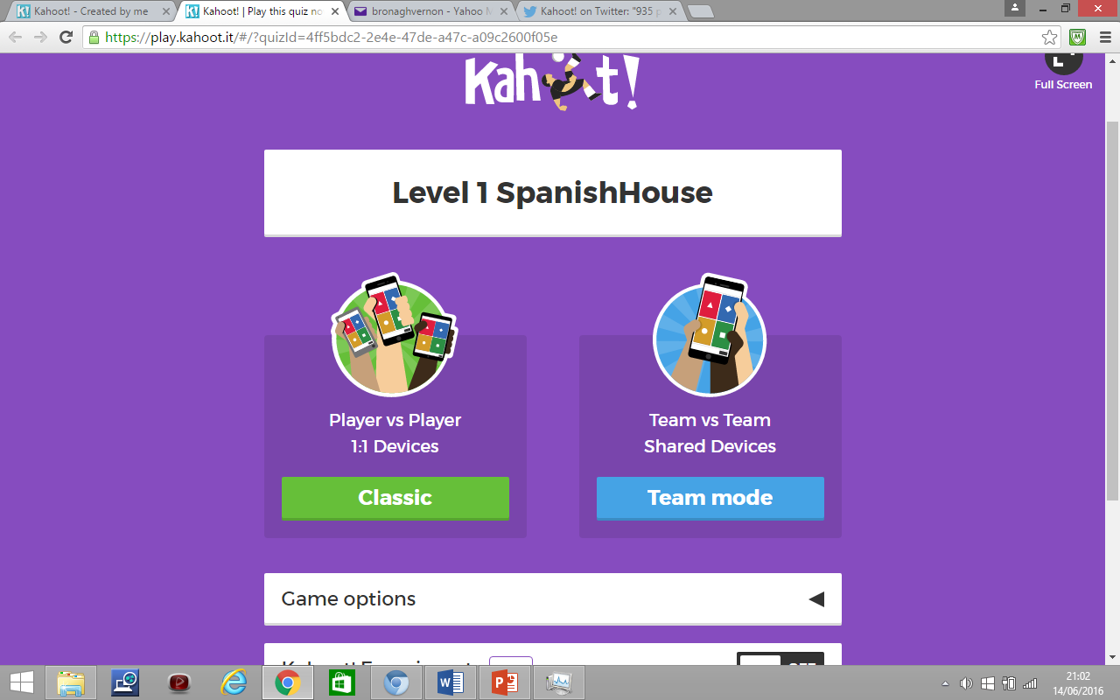

23) Once you have selected your preferred type of game, the PIN number will be displayed on the board and the students enter the number on their consoles.

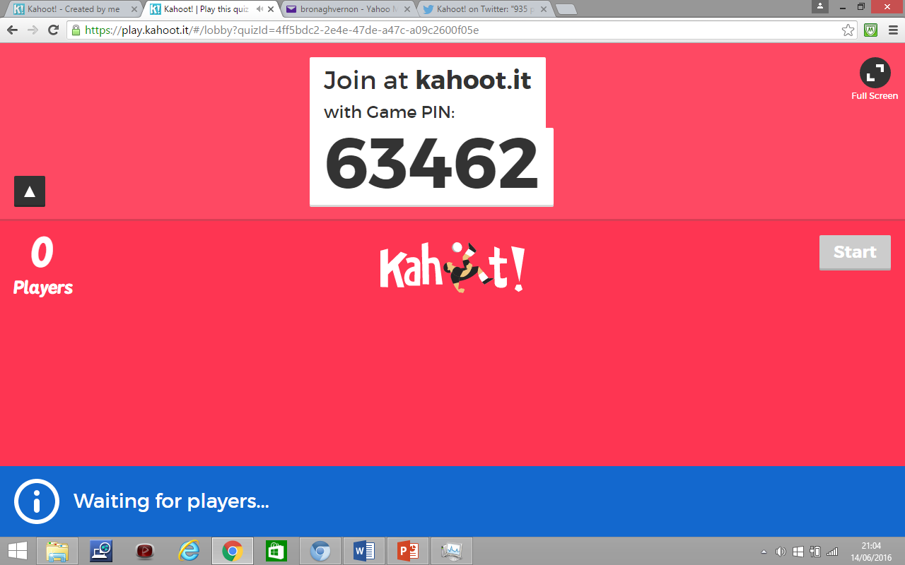

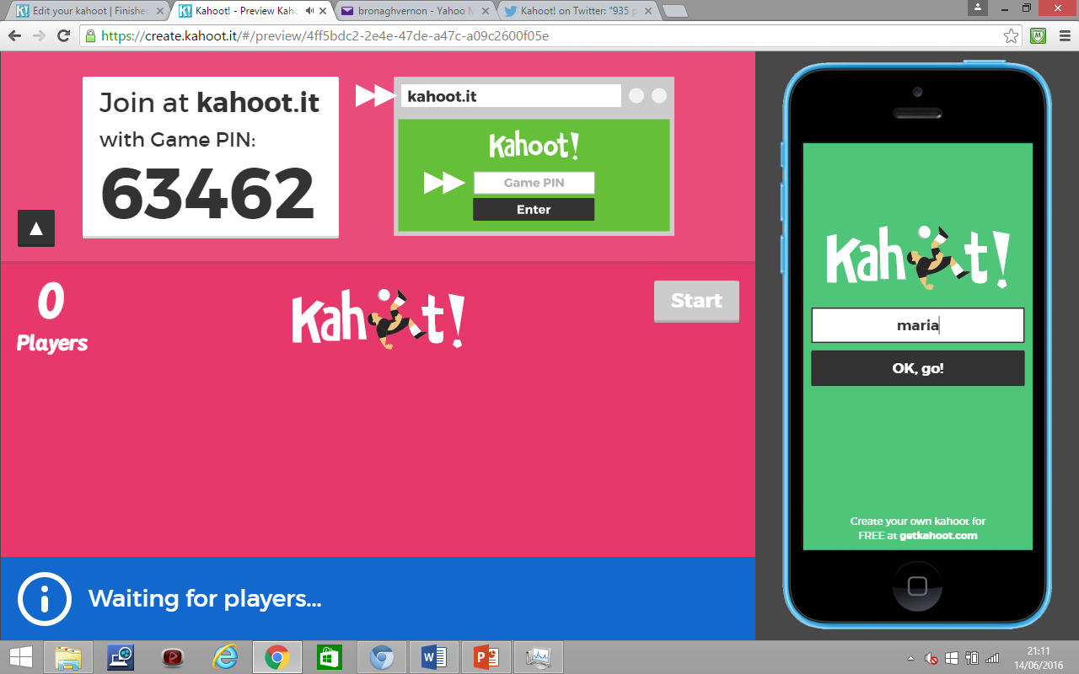**24) Students will be prompted to enter their name, which will be displayed on the board. If they do not enter an appropriate name the teacher can X them out of the game.**

**25) Now, enjoy the game!!**

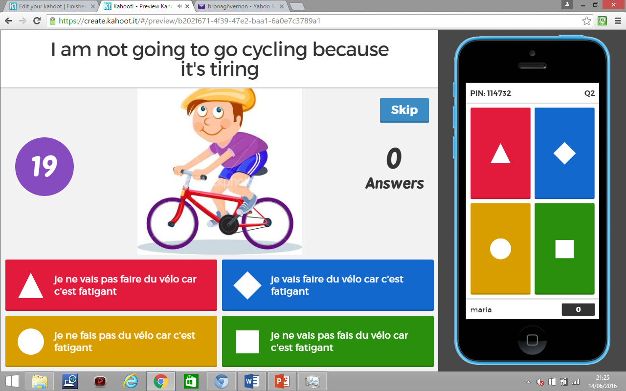

**26) At the end of the game, the students can RATE the game, and register opinions on the LEARNING, whether they would RECOMMEND it and their FEELINGS**

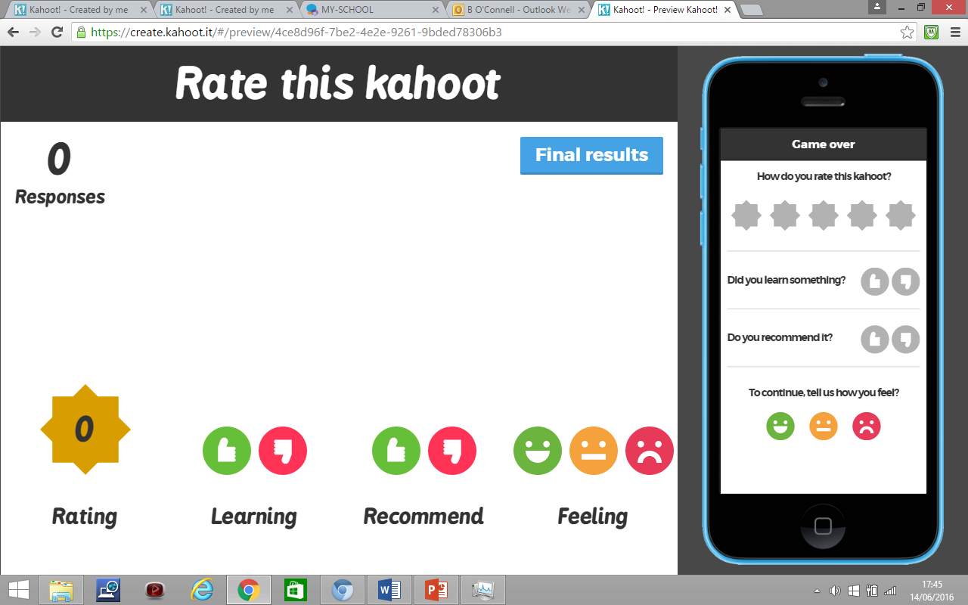

**27) Don’t forget to DOWNLOAD the final results and you can analyse the learning, and where to go to next.**

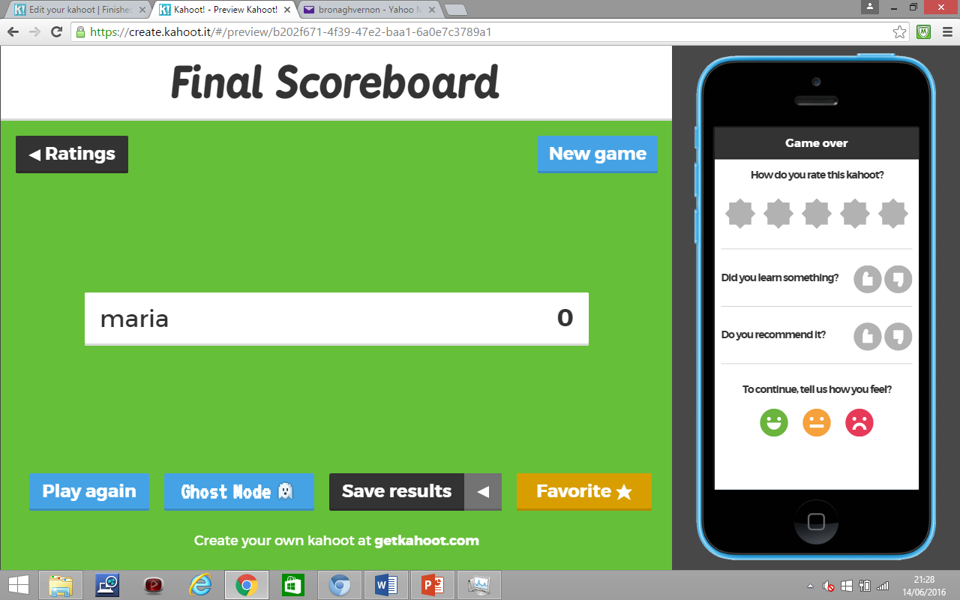

**Enjoy Kahooting!!**