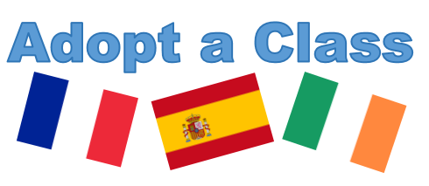
Application Form
Please complete and return to nicilt@qub.ac.uk by 5pm on Friday 26th January.
Please note that if you are studying two languages, please choose the language of the country of your year abroad. (Students studying Irish who are going to a French/Spanish speaking country cannot choose Irish as their project language). For further information, please visit: http://go.qub.ac.uk/adoptaclass
Full Name
Subject | Please select
QUB Email Address

In 150 words, please tell us why you would like to be take part in this project:

Please provide details of a member of staff who can act as a referee:
Name
Position
Email Address

