Hello & welcome to our Autumn newsletter!

We have a lot of good news to share with you for our first Alumni 2019/20 edition. We have recruited some fantastic new staff to our School Community and have been celebrating our Investors in People Silver accreditation. We have also refurbished parts of the School building in order to make it a better place to study and work.

Our placement scheme that allows undergraduate and MSc students to gain valuable workplace experience goes from strength to strength, and next year, we are introducing two new MSc Programmes that we hope will help enhance the employability of our students.

We hope that you enjoy this newsletter, and please let us know if you have news that you would like to share with your School and Alumni friends.

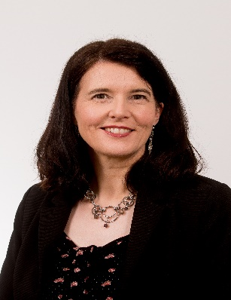 | Professor Teresa McCormack  Head of School  School of Psychology, Queen’s University Belfast  t.mccormack@qub.ac.uk

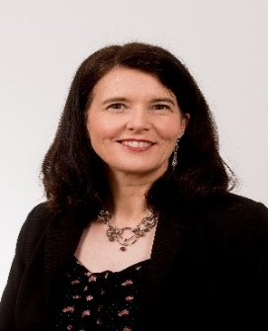 | 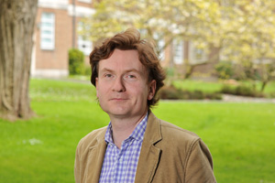 |  | 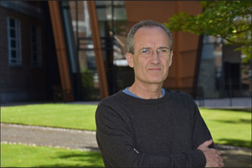

Our Leadership Team

Professor Teresa McCormack took over as Head of School in Summer 2018. Teresa is a developmental psychologist who focuses on aspects of children’s thinking. Teresa is currently working on an ESRC funded project examining how children think and make decision about the future. More information about Teresa’s research can be found here.

Teresa is supported by Prof Aidan Feeney as Deputy Head of School, Dr Will Curran as Director of Education and Prof Rhiannon Turner as Director of Research.

Full details about our staff are available here.

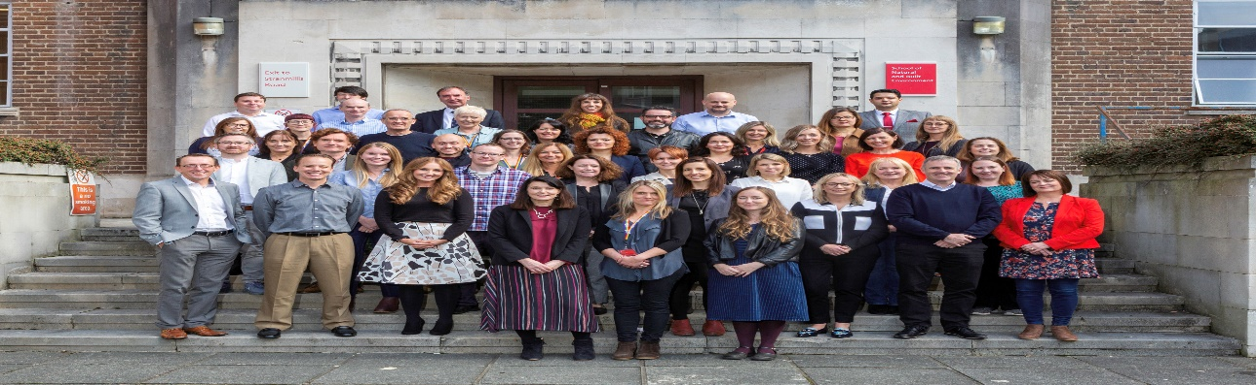

Hello & Goodbye

In the Spring semester, we were delighted to welcome a number of new faces to our School Community.

Prof Cherie Armour has joined us from the University of Ulster and Prof Kevin Vowles from the University of New Mexico. Together these new Chairs will lead our Health & Clinical Psychology Group.

Chris Brown is our new IT Manager and will be supporting us with various IT upgrades and the computer lab refurbishment.

Dr Elida Cena joins as Lecturer (Education). Elida’s research interests are interdisciplinary, crossing the fields of migration studies and psychology. She is interested in studying migrant children and adults, their adjustment processes, practices of inclusion and exclusion, identity and wellbeing.

Dr Agnieszka Jaroslawska is our newly appointed Lecturer in Applied Developmental Psychology and joins us following her post-doctoral research at the University of Edinburgh. Agnieszka is particularly interested in understanding what limits memory for the immediate past, and how those limits change as people grow older.

Dr Aideen McParland is our latest Lecturer (Education). Aideen's research interests are predominantly in the fields of behavioural, experimental and developmental psychology.

Dr Magdalena Rychlowska’s research focuses on expressions of emotions, their effects, and the mechanisms underlying their perception and interpretation. She joins as Lecturer in Experimental Social Psychology.

Finally we wish Dr Lesley Storey good luck in her new position at the Birmingham City University and a fond farewell and best wishes to Dr Eugene O’Hare on his retirement. Some of you will have great memories of Lesley and Eugene, who were both very popular teachers and we are sorry to see them go.

Our alumni
You are part of an 180,000-strong family of Queen’s Alumni around the world!
We would love to be able to share stories of your success with your fellow alumni.
To keep up-to-date with alumni services and news, please check your details with us at: https://daro.qub.ac.uk/UserLogin
And if you’d like to be featured in our next Alumni newsletter or have news to share about your international experience, please contact Patricia Castle within our School (p.castle@qub.ac.uk)
Alumni spotlight:
Dr Alissa Lange | Caoimhe Keogan | Dr Kai Ruggeri

Silver Status in Investors in People
In June we were awarded a Silver Investors in People Award, and are the only School within Queen’s to hold this award as well as a Gold Athena SWAN Award.

Investors in People is a standard for people management, offering accreditation to organisations that adhere to the IiP Standard. Athena SWAN is a charter that recognises and celebrates good practices in higher education towards the advancement of gender equality, representation and progression for all.
Stephanie McCutcheon, Northern Ireland IiP Advisor to the School, said:
"The School is congratulated on achieving IiP Silver accreditation. Meeting the IiP standard is an achievement; exceeding it and being recognised at Silver-level following a first-time assessment is a significant accomplishment and something of which staff should feel justifiably proud”.
We are proud to have been awarded the prestigious Athena SWAN Gold Award initially in 2014 and again in 2017. This award recognises the important work the School has done in supporting gender equality and in creating an inclusive environment for our staff and students.

What’s your master plan?

Our Education portfolio is continually evolving to match the expertise of our staff, our student needs, and employer expectations.

If you are considering pursuing a postgraduate qualification, please get in touch with us and discuss your next step on your master plan.

We currently offer:

- MSc Psychological Science, our one year conversion degree

- Doctorate in Clinical Psychology with applications open until 29 November 2019.

- Doctorate in Educational, Child & Adolescent Psychology with applications open until 8 January 2020.

As well as:
- BSc Psychology
- BSc Psychology with Professional Placement

Next year we will be offering two new MSc programmes:
- MSc Health & Clinical Psychology
MSc Applied Developmental Psychology

For more information about our Postgraduate Open Days please visit: https://www.qub.ac.uk/Study/PostgraduateStudy/PG-Events/Postgraduateopendaysandvisits/

#PsychologyAtWork

Work Placement Opportunities

We recognise the importance of ensuring that our students leave the School with the skills they need to fulfil their career ambitions. With this in mind, we have made great progress over the last six years addressing employability for our undergraduate and postgraduate students.

Every year, we offer approximately 50 final year BSc Psychology students a modular placement opportunity in organisations drawn from across the public, private and third sector, which we call our Insight Programme.

In 2017, we introduced a one-year placement that leads to a BSc Psychology with Professional Placement degree, and on Thursday 21 November, we are planning our first Psychology Careers Fair.

To learn more about how you could contribute through coaching, mentoring or placements, click here or contact Patricia Castle at p.castle@qub.ac.uk

Education

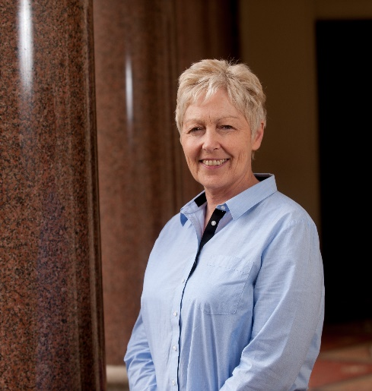
Congratulations to Dr Susan O'Neill who has won this year's School Teaching Award. Students at the School said; “Susan explains concepts clearly and has a relaxed teaching style”, “She is passionate about the topic and this makes her lectures enjoyable” and that Susan is “Approachable, informative, enthusiastic; made lecture enjoyable as she engaged everyone in the topic”
Susan said of the Award "I am delighted to receive this award that recognises teaching quality, something that the School is committed to delivering for our students". The Award consists of a £2,000 grant which Susan will use to study how best to develop and promote research-led teaching practices in the School. We wish her continued success in the rest of the academic year.

Research

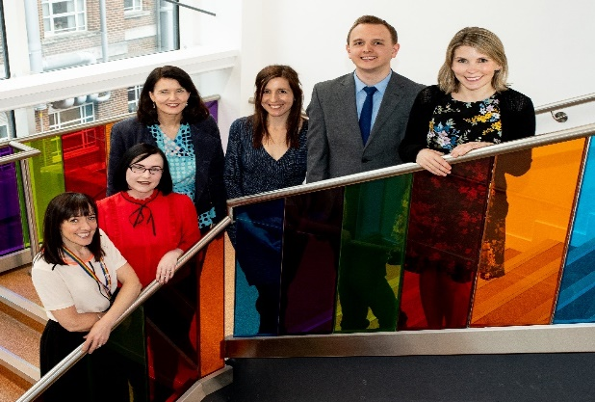

QUEEN’S RECEIVES £500K TO IMPROVE GENDER EQUALITY WITHIN STEM

Queen’s University has received over £500,000 funding for research that aims to improve gender equality within STEM (science, technology, engineering, and mathematics). Despite numerous gender equality initiatives, fewer than 10 per cent of the UK's engineers are women – the lowest percentage in Europe – and the proportion of women studying engineering and physics has remained virtually static since 2012. We aim to address this challenge by carrying out interdisciplinary research to understand and address the attitudes that academics who work in engineering and physical sciences have towards gender equality initiatives.
The Director of Queen’s Gender Initiative commented: “Queen’s Gender Initiative is thrilled that our gold-winning School of Psychology in the Faculty of Engineering and Physical Sciences has obtained this EPSRC award. It is recognition that the School is at the forefront of research on gender bias in engineering science. We look forward to supporting this ground-breaking research and implementing its findings”.
Dr Ioana Latu from Psychology said: “Although gender equality initiatives exist in Engineering and Physical Sciences Schools across the UK, there may be ways that they could be more effective.
Our vision is that in order to improve diversity and inclusion within engineering and physical sciences rapidly, we need to understand academics’ attitudes towards gender equality initiatives.
We hope that by addressing how gender equality initiatives are received on the ground, it will have long term effects by accelerating diversity and culture change within engineering and physical sciences, ultimately creating a more inclusive environment for women who study and work in STEM fields.”

Around the DKB

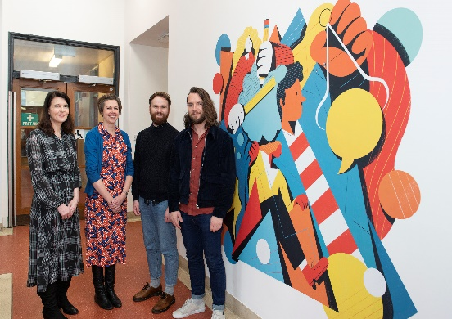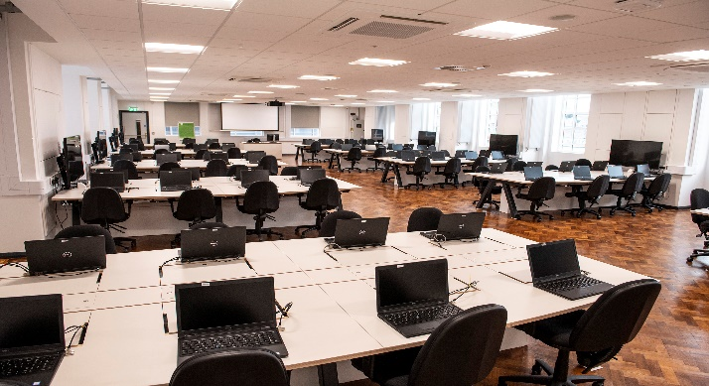

During the Spring and Summer we have undergone extensive refurbishment of our lower levels.

Our new state-of-the-art teaching and learning lab now has a capacity of 80. Importantly we’re delighted to now be able to provide our students with a dedicated area within the School where they can work either individually or in groups. Each learning pod is equipped with a dedicated large screen and state of the art group collaboration software. The lab opened during Welcome Week in September and initial feedback has been really positive from our students and teaching staff.

We were also very excited to unveil a new look in our entrance and ground floor area, where there are now specially-commissioned murals that illustrate our education and research activities. We hope you agree that they make the School a more welcoming place to visit and that they help to demonstrate all of the important activities that are taking place in our School community.

Our final addition is a Nurture Room which will accommodate returning mothers, who may need a space for breastfeeding or expressing milk.

Diary at the ready….

We welcome you to join us at the following events this year:

November:
15 November 2019: Mental Toughness Symposium, Riddel Hall
21 November 2019: Psychology Careers Fair
25 November 2019: Violence Abuse & Mental Health Seminar
27 November 2019: Emerging Minds Kick Off meeting and workshops

December:
5 December 2019: PGR Event at Graduate School

2020:
4-6 March 2020: EPS Regional Interactive Open Days (Across NI)
11 March 2020: Science at Queens

Details of upcoming events are available here

Stay in touch

