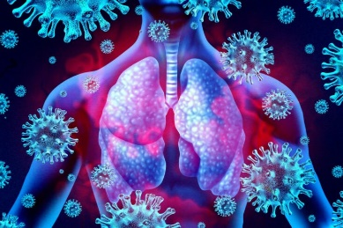
COVID-19/SARS-CoV-2 virus antibody neutralisation study: CALL FOR VOLUNTEERS
Queen’s University Belfast researchers are looking for healthy volunteers aged 18-65 years who would be interested in a research study to determine the effect of the SARS-CoV-2 Omicron variant on neutralising antibodies induced following vaccination and/or prior COVID-19 disease. If you are interested in taking part, please contact Ultan Power at 028 9097 2285 or 07749633244 (u.power@qub.ac.uk) or NICRF for more information: 028 9504 0342, NICRF@qub.ac.uk. Further study details below.
Credit: wildpixel/GettyImages
Neutralising antibodies in the blood are key parts of the immune system induced following either vaccination or infection that protect against COVID-19 disease. However, early evidence suggests that the Omicron variant might be able to evade pre-existing virus neutralising antibody immunity. This study seeks to determine whether antibodies from individuals who received 2 or 3 vaccinations without or without prior infection with the virus retain their ability to neutralise the virus. This study will provide important information about how effective current vaccines are in protecting against the Omicron variant.
The study involves volunteers attending the Northern Ireland Clinical Research Facility (NICRF)- located in the Belfast City Hospital, University (U) Floor, Lisburn Road- for one visit lasting approximately 15 minutes. During the visit, 5 mL (a tablespoon full) of blood will be taken and used for the study. Volunteers should be free from SARS-CoV-2 infection for at least 14 days prior to blood donation. They should be vaccinated 2 or 3 times. We will ask you when you received your vaccines and whether or not you had a PCR-confirmed SARS-CoV-2 infection and the date of the positive test where appropriate.

Details of the various groups that we are seeking:
- Sera from individuals following 2 vaccinations with the Pfizer/BioNTech vaccine.
- Sera from individuals following 2 vaccinations with the Astra Zeneca/Oxford vaccine.
- Sera from individuals following 2 vaccinations with the Moderna vaccine.
- Sera from individuals following 3 vaccinations with the Moderna vaccine.
- Sera from individuals following 2 vaccinations with the Pfizer vaccine and a booster Moderna vaccine.
- Sera from individuals who received 2 or 3 vaccinations with any vaccine and had a confirmed infection with SARS-CoV-2 before December 1st, 2021.
- Convalescent sera from Omicron-infected patients who also received 2 or 3 vaccinations with any vaccine.

NB. Please note that individuals who received 3 Pfizer vaccine doses or 2 doses of Astra Zeneca vaccine with a Pfizer or Moderna booster are no longer being recruited to this study, as we have received sufficient samples for the study. Similarly, individuals who received 3 doses of any vaccine and were infected with the Omicron variant (or confirmed SARS-CoV-2 infection) after December 15th, 2021 are no longer needed for this study.

