Contact information:
Dr Ileana Micu, Advanced Imaging CTU Manager: I.Micu@qub.ac.uk
Mrs Andrena Millar, Advanced Imaging CTU Technician: a.millar@qub.ac.uk
Telephone: +44 (0)28 9097 6120 / QUB internal x 6120

FACULTY ADVANCED IMAGING CTU- USER REGISTRATION FORM
Name:
Staff/Student number:
Position:
PI/Supervisor’s name:
Email:
Phone number:
Centre/Department:
School:
Project Name:
Project Code (for charging purposes) :

Services requested description: (training, microscope type, data analysis, etc.)

EXPECTED DURATION:
START DATE : | END DATE:

Will the work involve: | NO | YES
Live samples requiring containment level 1?
Live samples requiring containment level 2 (submit Biosafety form)?
Drugs or substances that require special disposal or protection (submit Biosafety form)?
**Training is required for all core users prior to independent use of microscopes**

Price /hour for using the microscopes are listed in the table.
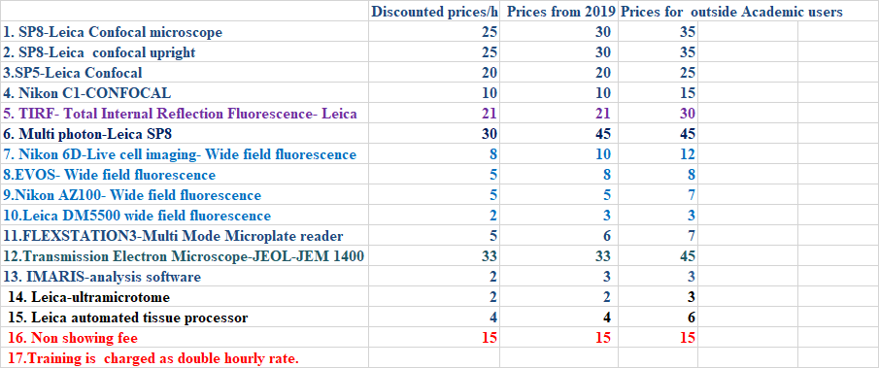
Commercial companies will be charged at x 2.5 existing rates plus VAT.
NB: All grant proposals should be costed using the 2019 rates.

Users are prohibited from training other users. Only staff in the Advanced Imaging_CTU can train new users.
Users can cancel a booking by contacting our staff. Please give 24 hours notice. If users are more than 30 minutes late for a booking, they should contact the unit or the session will be cancelled and instrument time will be charged as normal.
It is forbidden to eat or drink in the microscopy rooms.

I have attended(/will attend the next available) a laser safety course (L.I.M.I.T.S.) YES

I agree to abide by the rules and conditions governing the use of the Advanced Imaging CTU as outlined in the Induction workbook.

Authorized user’s signature: | Date:
PI/Supervisor’s signature: | Date:

The completed and signed form should be forwarded to: Ileana Micu or Andrena Millar

FMHLS Advanced Imaging CTU, Queen’s University Belfast, Wellcome-Wolfson Building, 97 Lisburn Road, BELFAST BT9 7BL

