Stewart Parker Retrospective
28 October – 3 November
QUB Drama, School of Creative Arts

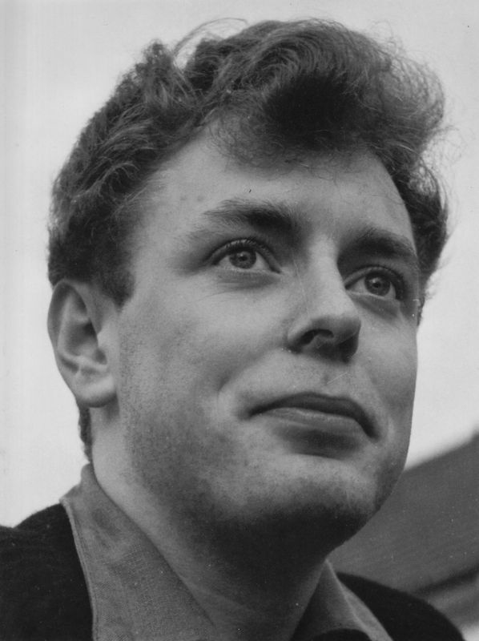
Saturday 2 November 2013 marks the 25th anniversary of Stewart Parker. A scholar, poet, playwright, and music critic, he was a founding member of the Belfast Group and wrote extensively for stage, radio and screen. Like J. M. Synge, he was cut down at a tragically young age whilst at his height of his powers, but he has bequeathed us all a body of work that establishes him as the most innovative and important playwright to have emerged from Belfast, and one of Ireland's greatest twentieth century playwrights.
To commemorate Stewart’s 25th anniversary by celebrating his work, QUB Drama, with the kind support of BBC NI and Literary Belfast, will host a retrospective of Stewart’s work for stage, radio and screen to demonstrate Stewart’s extraordinary artistic achievement

QFT LUNCHTIME SCREENINGS, 1PM
ALL SCREENINGS ARE FREE AND ALL TICKETS AT THE DOOR.
Tuesday 29 Oct 1pm (QFT1) The Kamikaze Ground Staff Reunion Dinner.

Wednesday 30 Oct 1pm (QFT1) Catchpenny Twist.

Thursday 31 Oct 1:00 (QFT1) Iris in the Traffic, Ruby in the Rain

Friday 1 Nov 1pm (QFT1) Joyce in June

Tuesday 29 Oct 1pm (QFT1) The Kamikaze Ground Staff Reunion Dinner.

On August the 15th, 1945, after the official surrender of the Empire of Japan, Admiral Matome Ugaki led the last Special Attack Force pilots across the Pacific, to crash into American ships. Thirty five years later, the men who serviced the aeroplanes are still meeting up for their annual dinner. Now settled into civilian jobs - dentist, baker, taxi-driver, insurance salesman - and with children and grandchildren, they bemoan the decay of traditional Japanese values. Hard liquor is imbibed, toasts raised to the memory of the heroic dead, and old rivalries resurface. The survivors’ dissatisfaction with post-war life comes to a head when, in a moment of drunken inspiration, Tokkotai the airline pilot decides on a symbolic gesture to show that the kamikaze spirit lives on

Wednesday 30 Oct 1pm (QFT1) Catchpenny Twist.

Dismissed from their teaching jobs, two young Belfast musicians pursue alternative careers in the music industry as songwriters, however, their catchpenny tunes which also involve ballads for fallen volunteers of both loyalist and republican paramilitaries leads to live bullets in the post and death threats, so they set off for Dublin and then London and eventually end up in the final of the Eurovision Song Contest! Success seems at hand and Belfast seems very far away... but for how long?

Thursday 31 Oct 1:00 (QFT1) Iris in the Traffic, Ruby in the Rain

Parker later referred to the play as ‘a condensed female variant on the Dedalus-Bloom odyssey’. Ruby the Bloom figure, played by Frances Tomelty, is a vigorous if flu-sodden social worker who journeys the city sneezing and assisting others. Iris the Stephen figure, played by Aingeal Grehan, is a rather passive, incurious character who is regularly and haphazardly caught up in others’ activities. A certain restless agitation governs most of the play’s characters, and the aggressive strains of Stiff Little Fingers sets the tone for Ruby’s odyssey through Belfast. By the play’s conclusion, a trio of responses to the conditions of Belfast life has emerged: the loss of sanity; emigration; or staying on and surviving together. Strikingly, it is the female characters that seem most rooted in the city. Iris in the Traffic, Ruby in the Rain is an unlikely combination of elements. Yet the discreet Joyce reference, the punk gig, and the soundtrack, lend unexpected nuances to the social problem play structure that was emblematic of Play for Today.

Friday 1 Nov 1pm (QFT1) Joyce in June

Parker frequently expressed his deep appreciation of James Joyce’s work and with this play he most explicitly pays tribute to his mentor. Joyce in June is a clever concoction of fact and fiction combining a double narrative, citations from Joyce’s biography and work, with a typically incisive comic perspective. The framing storyline follows Joyce and his companions shortly after Joyce began walking out with Nora Barnacle. The embedded storyline is imagined by Joyce while he poses for fellow student, Constantine Curran, who is taking his photograph — an iconic image of the young Joyce.

Parker’s “television postscript to Ulysses” features Molly Bloom, Blazes Boylan and an assortment of Dublin singers on a concert tour that begins, fatefully, in Belfast. Northern piety clashes with Southern frivolity resulting in a dramatic breakdown of decorum and raucous laughter at the play’s finale. Joyce in June is a remarkable tribute to Joyce, though as Parker admits “there’s a tiny motive of revenge as well for those invariably unpleasant portraits of Northerners in the Joyce canon, the likes of Mr Alleyne in “Counterparts,” MacAlister of the oblong skull in A Portrait, the headmaster Deasy in Ulysses.”

