

20th May each year marks International Clinical Trials day, and to mark the day, this year we will be hosting an open day at the Northern Ireland Clinical Research Facility (NICRF) on U-floor on the Belfast City Hospital site.

Clinical Research Facilities are part of a network of centres across the UK which aim to drive forward translational medicine. The Northern Ireland Clinical Research Facility (NICRF) is a joint venture involving Queen’s University Belfast, Ulster University, the Belfast Health and Social Care Trust (BHSCT) and the Health and Social Care Research and Development (HSC R&D), a division of the Public Health Agency. The NICRF has been functioning since 2013 and provides a wide range of clinical and scientific resources, as well as patient facilities, to enable high-quality research ultimately leading to new treatments.

The aim of our open day is for us to have the opportunity to showcase our facilities to you and enable you to find out more about the type of clinical research carried out at our dedicated research facility.

Patients, carers and health professionals are particularly welcome, and refreshments will be available throughout the day (see agenda for more details) .

For further details please call 02895040342 or e-mail [NICRF@belfasttrust.hscni.net](mailto:NICRF@belfasttrust.hscni.net)

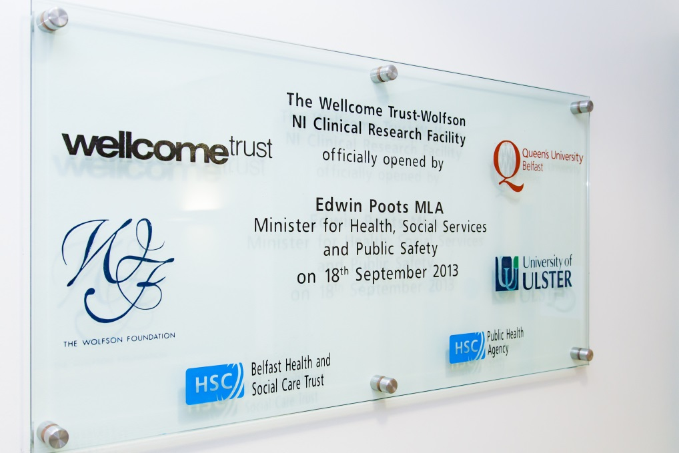

Master NICRF logo.eps

**N. Ireland Clinical Research Facility**

**Open Day**

**20th May - 1100 - 1430**

**U Floor, Belfast City Hospital**

|  |  |
| --- | --- |
| **TIME** | **EVENT** |
| 11.00  12.00  13.00 | **Tour of the N. Ireland Clinical Research Facility**   * **Professor Judy Bradley** |
| 11.30  12.30  13.30 | **Attend a cardiac demonstration including, ECG, exercise stress test and ECHO**   * **Lead - Paschal Browne** |
| 11.00-14.00 | **Pop in for a Health Check (including BMI, Blood Pressure and Lung Function)**   * **Lead - Julie Wilson** |
| 12.00-14.00 | **Poster viewing with Researchers**  **Meet the N.Ireland Research Infrastructure (NICRF, NICTU, NICRN, HSC R&D, BHSCT Research Office) tbc**  **Brown bag lunch – tea/coffee** |

**Please RSVP attendance** [**nicrf@belfasttrust.hscni.net**](mailto:nicrf@belfasttrust.hscni.net) **or telephone 02895049363 (to facilitate numbers for catering).**