Three-way consulting

The student could be conducting the consultation and the tutor could be supervising (preferable)
The tutor/teacher could be conducting the consultation and the student could be ‘observing’.
There could be an interactive three-way consultation between patient, student and tutor (preferable)
Educational Triad : ‘Observing provides breadth, rehearsing provides depth, contributing confers legitimacy’
Face-to-face consulting with student and tutor in the same room

To ensure everybody’s safety consider using a Perplex screen in the room. The Perplex screen can be ‘mobile’ and ‘follow the student’.
If the student is examining the patient he/she should wear PPE as per Government’s advice https://www.gpni.co.uk/putting-on-personal-protective-equipment-ppe/

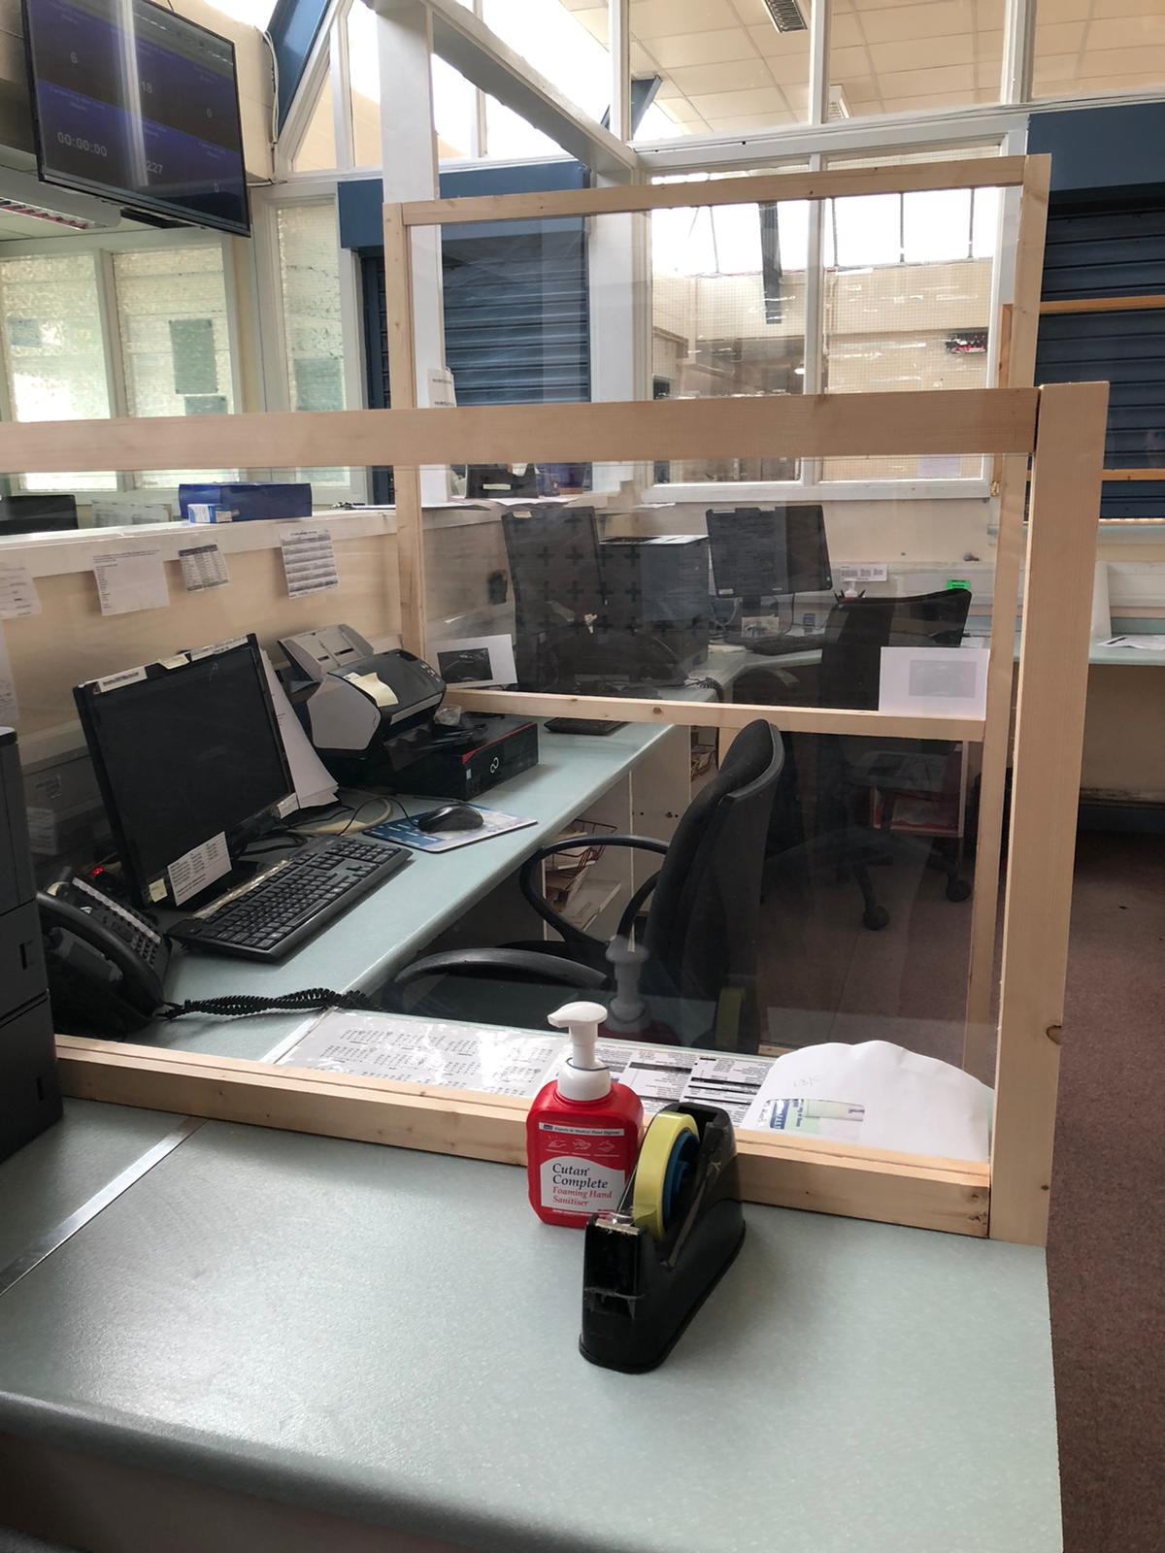

Three -way telephone consulting
The student could be sitting in the room using the Perplex screen
The student could be sitting in another room on or off site. The student could be using their own mobile device if they have unlimited credit. The student could be using a landline or a mobile of the practice.
The student should ensure he/she respects confidentiality at all times.

Withholding your number:
Landline number of practice should already withhold the number
If not or when using Mobile put 141 in front of the number.

Overview: https://www.wikihow.com/3-Way-Call-a-Person

Landline
Ask your first caller to hold.
Press your receiver, link or flash button for one second.
Listen for three short beeps, followed by a dial tone.
Dial the number of the third person.
When he or she answers, press your receiver, link or flash (or R) button followed by 3 to establish your three-way connection.
https://www.youtube.com/watch?v=6f0LnLB7D6Y

!Phone
Dial the first person and wait for the call to connect.
Tap add call .
Dial the second person, and wait for the call to connect.
Tap merge calls .
The two calls merge into a conference call. To add additional people, repeat steps 2-4.

https://www.youtube.com/watch?v=5E2ctB9oXtI

Android
Call one of the participants, or have them call you.
Tap Add Call and call another participant.
Tap Merge to combine the calls.
Repeat steps 2 and 3 to add more participants.
Tap Manage to unmerge or disconnect a participant on the call.
https://www.youtube.com/watch?v=8vMqu7_y9Hg

Whatsapp
https://www.youtube.com/watch?v=qwixsEIQ7eY

3-way Video consulting

Check eGPlearning You tube
General information on Video consulting to share with students:
https://bjgplife.com/wp-content/uploads/2020/03/Video-consultations-a-guide-for-practice.pdf

AccuRx
The Link you send to the patient can be copied and pasted into a message to the mobile phone the student is using.

https://support.accurx.com/en/articles/3776579-how-to-do-video-consultations-with-your-mobile-at-a-gp-practice

https://support.accurx.com/en/articles/3779225-can-i-do-video-consultations-from-my-desktop-comput

Zoom
Zoom is free if used < 40 minutes at the time and with maximum 5 people.
https://zoom.us/

Whatsapp
As per 3 way telephone consulting

